Unit 6 Lesson 4: Interpret Measurement Data on Line Plots

WU Notice and Wonder: A List and a Line Plot (Warm up)

Student Task Statement
What do you notice? What do you wonder?
Lengths in Inches
3 | 5 | 4 | 4 | 5 | 6 | 7 | 5
3 | 4 | 4 | 5 | 6 | 6 | 4

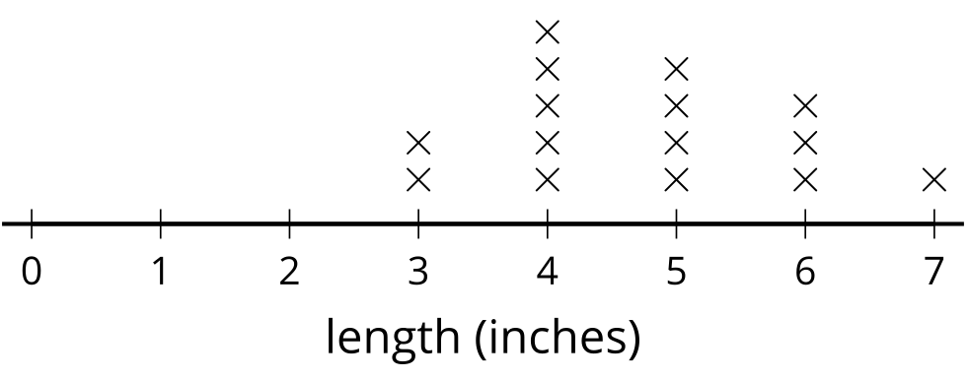

1 A Set of Seedlings

Student Task Statement
heights of seedlings (in inches)
$\frac{1}{2}$ | 1 | 1 | $\frac{1}{2}$ | $1\frac{1}{2}$ | $2\frac{1}{2}$ | 4 | $\frac{1}{2}$
3 | $1\frac{1}{2}$ | 5 | $1\frac{1}{2}$ | $1\frac{1}{2}$ | $2\frac{1}{2}$ | 3 | $\frac{1}{2}$
$2\frac{1}{2}$ | $1\frac{1}{2}$ | 1 | $1\frac{1}{2}$ | 4 | 2

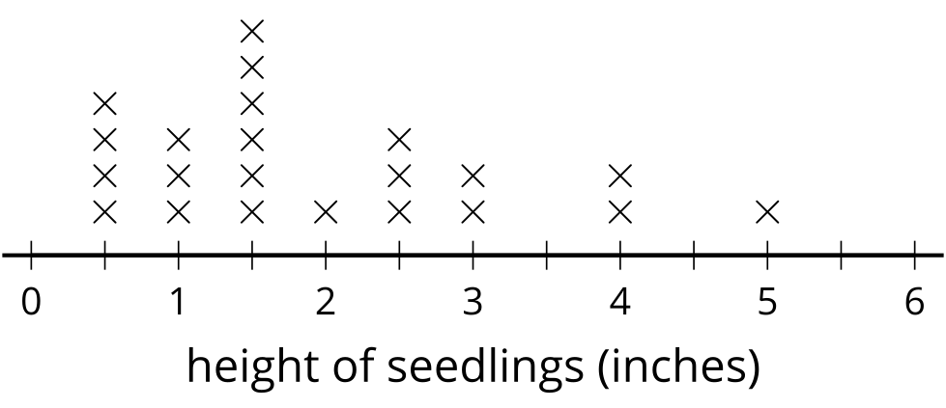
- Write 3 statements about the measurements represented in the line plot.
- What questions could be answered more easily with the line plot than the list? Write at least 2 questions.

2 All About Twigs

Student Task Statement
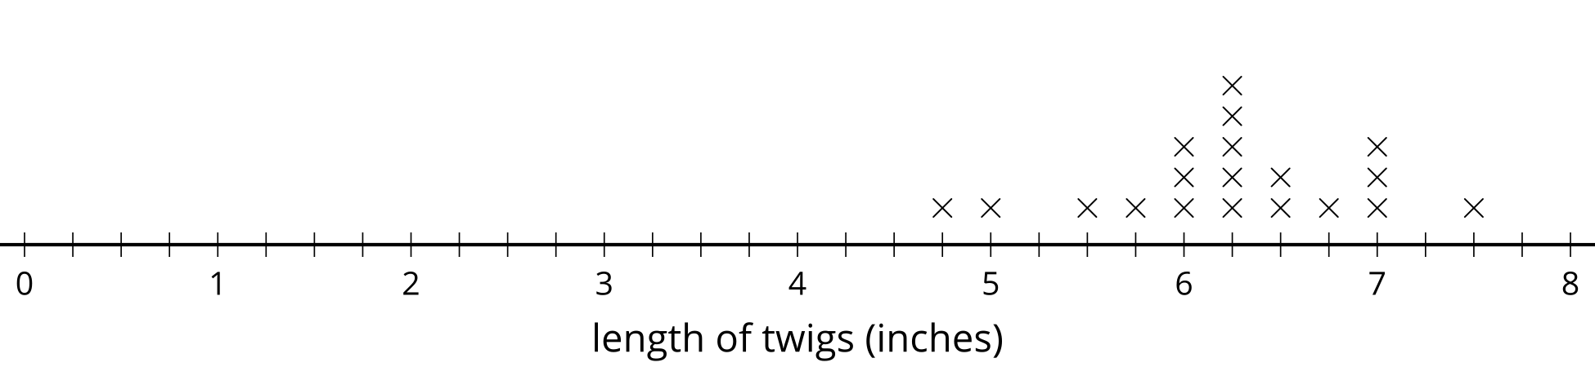
- How many twig lengths are represented in the line plot?
- How many of the twigs are $6\frac{1}{2}$ inches long?
- How many of the twigs are less than 6 inches long?
- How many of the twigs are more than 6 inches long?
- What is the length of the shortest twig?
- What is the length of the longest twig?
- What is the most common twig length?
- Add an “x” to the line plot that would represent a twig with a length between 3 and 4 inches.
- What is the length of the twig you added to the line plot?
- 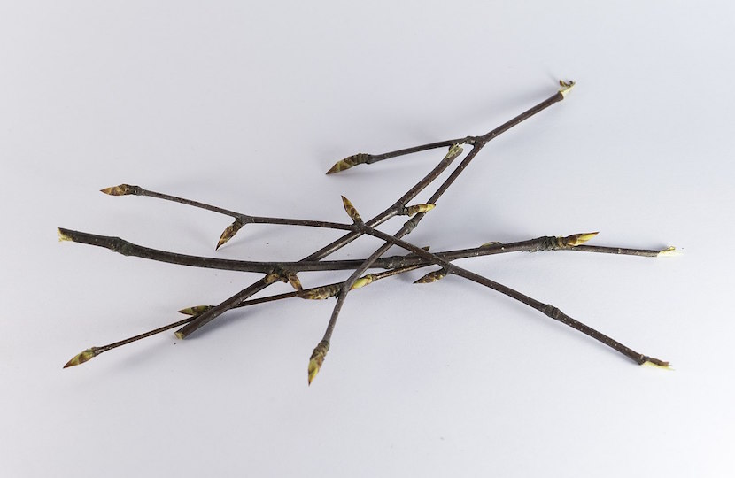
© CC BY 2021 Illustrative Mathematics®

