Unit 3 Lesson 18: Lots of Fractions to Add

WU Number Talk: A Bunch of Numbers (Warm up)

Student Task Statement
Find the value of each expression mentally.
- $54+2+18$
- $61+104+39$
- $25+63+75+7$
- $50+106+19+101$

1 Stack Centavos and Pesos

Student Task Statement
Diego and Lin each have a small collection of Mexican coins.
The table shows the thickness of different coins in centimeters (cm) and how many of each Diego and Lin have.
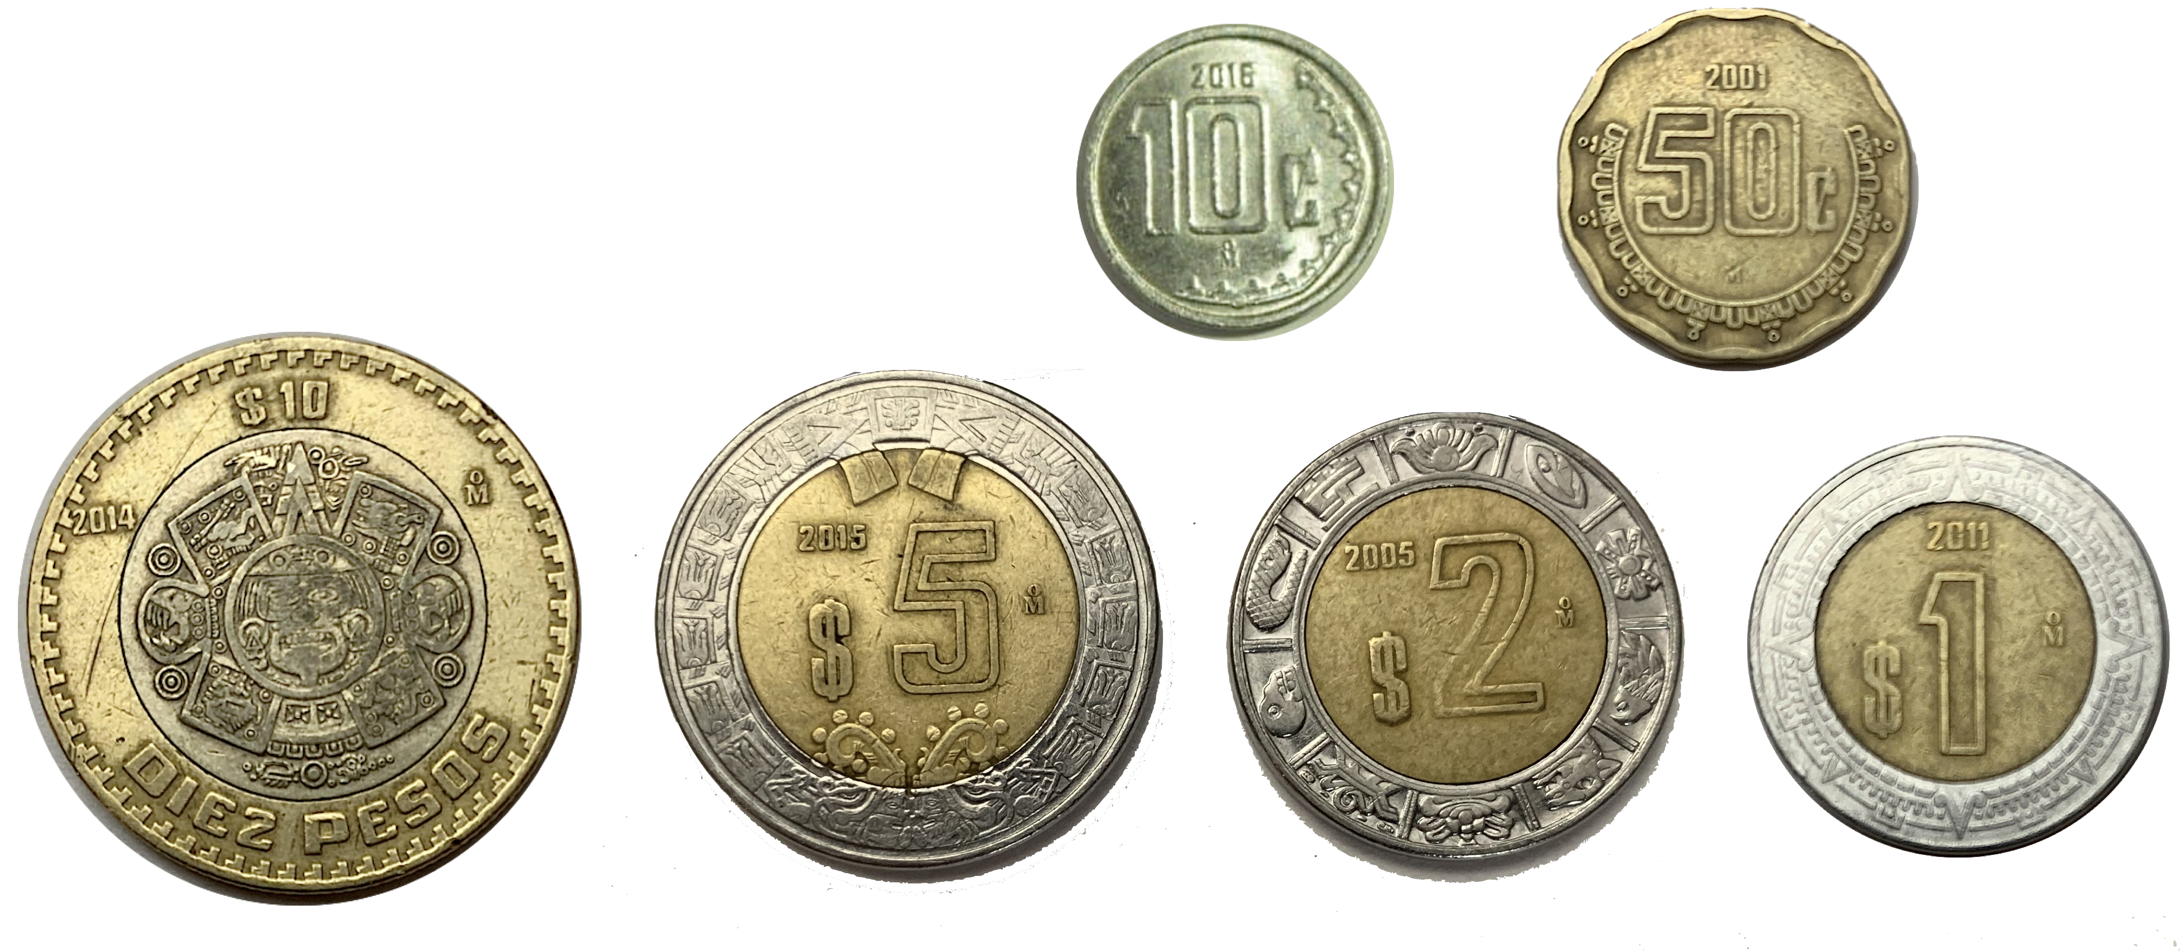
coin value | thickness in cm | Diego | Lin
1 centavo | $\frac{12}{100}$ | 3 | 1
10 centavos | $\frac{22}{100}$ | 0 | 1
1 peso | $\frac{16}{100}$ | 0 | 1
2 pesos | $\frac{14}{100}$ | 0 | 1
5 pesos | $\frac{2}{10}$ | 1 | 1
20 pesos | $\frac{25}{100}$ | 2 | 1
- If Diego and Lin each stack their centavo coins, whose stack would be taller? Show your reasoning.
- If they each stack their peso coins, whose stack would be taller? Show your reasoning.
- If they each stack all their coins, whose stack would be taller? Show your reasoning.
- If they combine their coins to make a single stack, would it be more than 2 centimeters tall? Show your reasoning.

2 More Than Two Fractions

Student Task Statement
Find the value of at least 3 of the expressions. Show your reasoning.
- $\frac{2}{100}+\frac{13}{10}+\frac{1}{10}+\frac{8}{100}$
- $\frac{50}{10}+\frac{16}{100}+\frac{2}{10}$
- $\frac{3}{10}+\frac{4}{100}+\frac{7}{10}+\frac{26}{100}$
- $\frac{4}{100}+3\frac{2}{10}+1\frac{5}{10}$
- $1\frac{1}{10}+5\frac{2}{100}+\frac{78}{100}$
- $2\frac{7}{10}+\frac{2}{100}+\frac{8}{10}$
© CC BY 2021 Illustrative Mathematics®

