Unit 3 Lesson 8: Cubes and Cube Roots

1 Put Your Arm(s) Up (Warm up)

Student Task Statement
How are these graphs the same? How are they different?
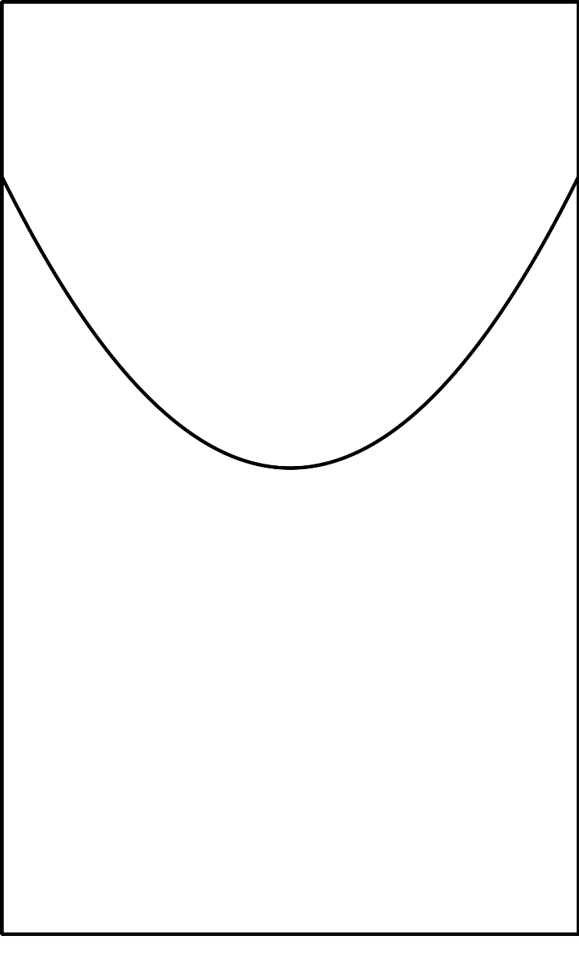
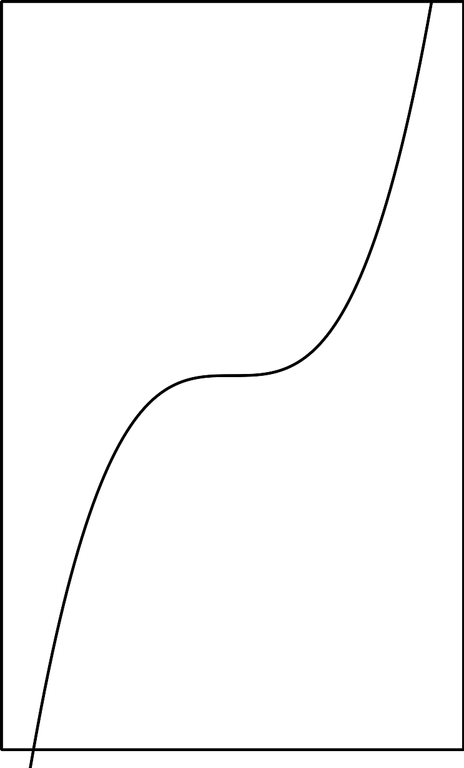
​​​​​​

2 Finding Cube Roots with a Graph

Student Task Statement
How many solutions are there to each of the following equations? Estimate the solution(s) from the graph of $y=x^{3}$. Check your estimate by substituting it back into the equation.
- $x^{3}=8$
- $x^{3}=2$
- $x^{3}=0$
- $x^{3}=\text{-}8$
- $x^{3}=\text{-}2$
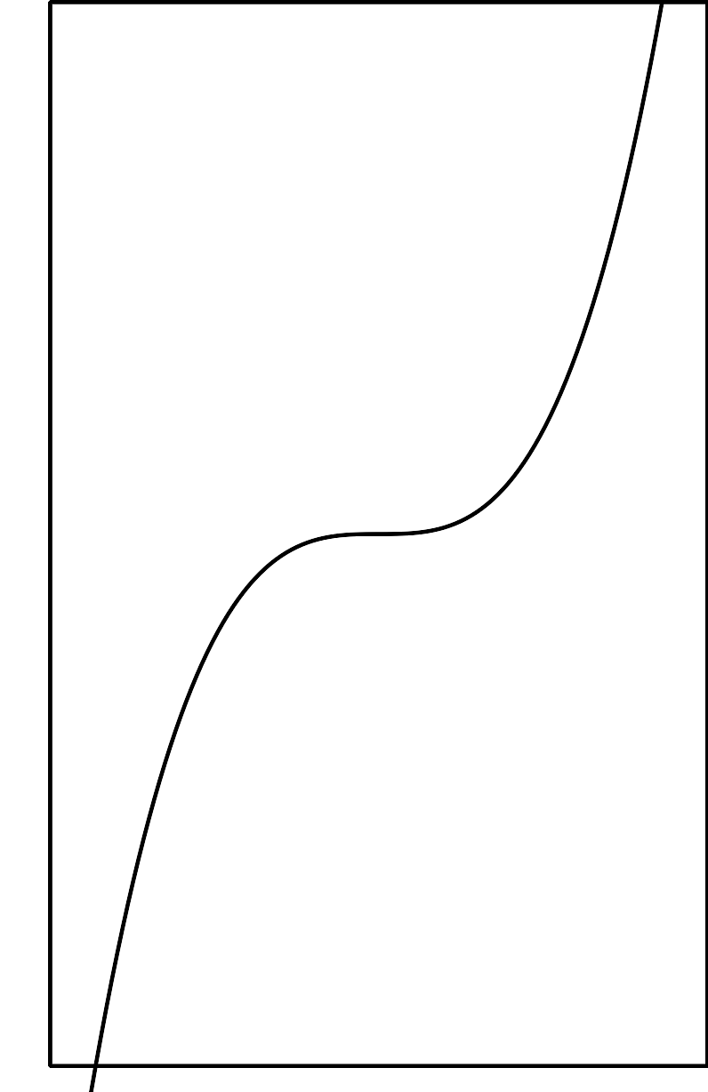

3 Cube Root Equations (Optional)

Student Task Statement
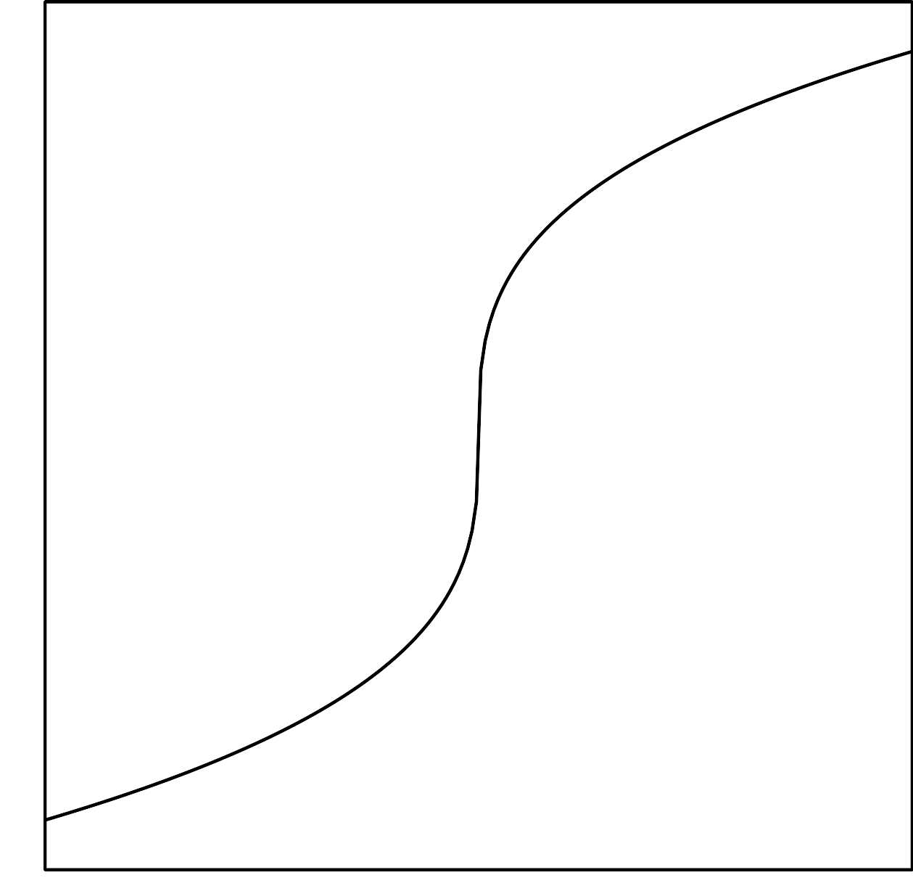
- Use the graph of $y=\sqrt[3]{x}$ to estimate the solution(s) to $\sqrt[3]{x}=\text{-}4$.
- Use the meaning of cube roots to find an exact solution to the equation $\sqrt[3]{x}=\text{-}4$. How close was your estimate?
- Find the solution of the equation $\sqrt[3]{x}=3.5$ using the meaning of cube roots. Use the graph to check that your solution is reasonable.

4 Solve These Equations With Cube Roots in Them

Student Task Statement
Here are a lot of equations:
- $\sqrt[3]{t+4}=3$
- $\text{-}10=\text{-}\sqrt[3]{a}$
- $\sqrt[3]{3−w}−4=0$
- $\sqrt[3]{z}+9=0$
- $\sqrt[3]{r^{3}−19}=2$
- $5−\sqrt[3]{k+1}=\text{-}1$
- $\sqrt[3]{p+4}−2=1$
- $6−\sqrt[3]{b}=0$
- $\sqrt[3]{2n}+3=\text{-}5$
- $4+\sqrt[3]{\text{-}m}+4=6$
- $\text{-}\sqrt[3]{c}=5$
- $\sqrt[3]{s−7}+3=0$
- Without solving, identify 3 equations that you think would be the least difficult to solve and 3 equations that you think would be the most difficult to solve. Be prepared to explain your reasoning.
- Choose 4 equations and solve them. At least one should be from your “least difficult” list and at least one should be from your “most difficult” list.
© CC BY 2019 by Illustrative Mathematics®

