Unit 7 Lesson 12: Constructing the Coordinate Plane

1 English Winter (Warm up)

Student Task Statement
The following data were collected over one December afternoon in England.
time after  noon (hours) | temperature  ($​^{∘}\text{C}$)
0 | 5
1 | 3
2 | 4
3 | 2
4 | 1
5 | -2
6 | -3
7 | -4
8 | -4
- Which set of axes would you choose to represent these data? Explain your reasoning.
- Explain why the other two sets of axes did not seem as appropriate as the one you chose.
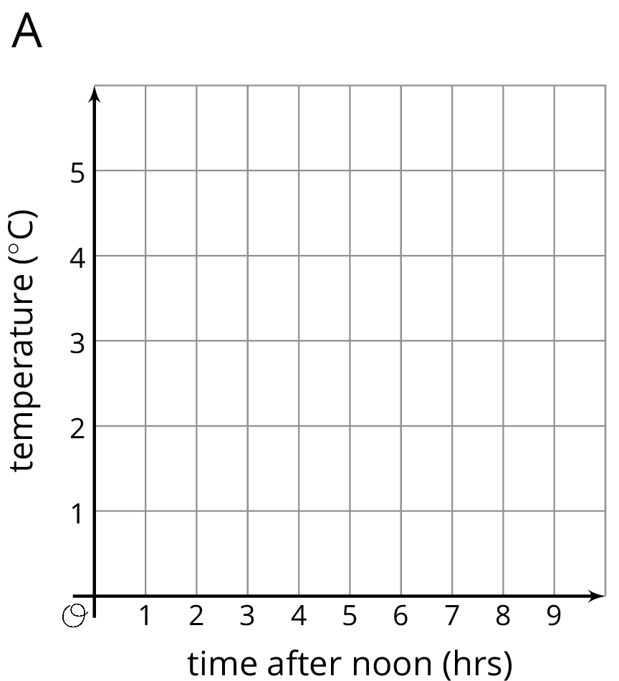
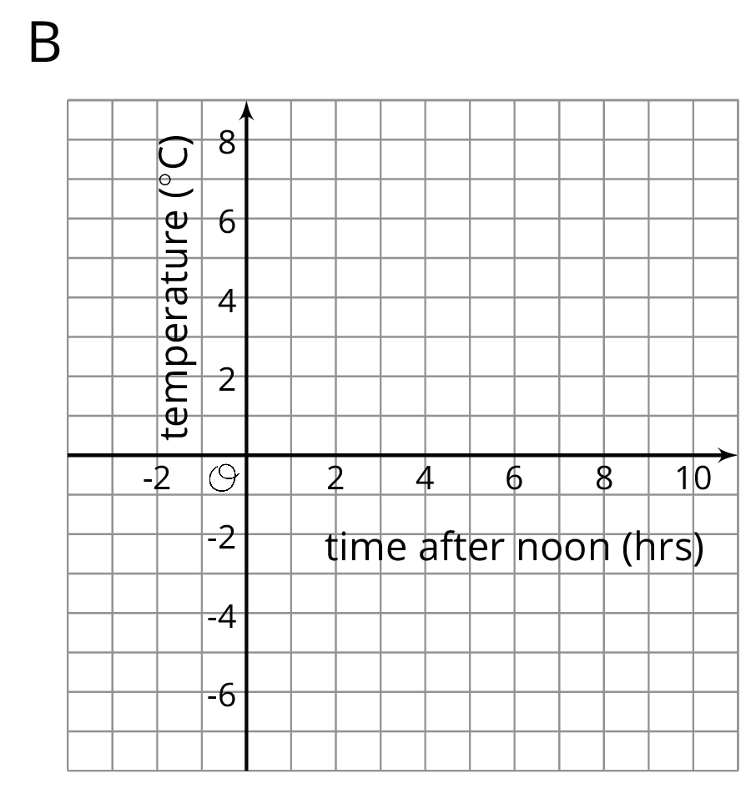
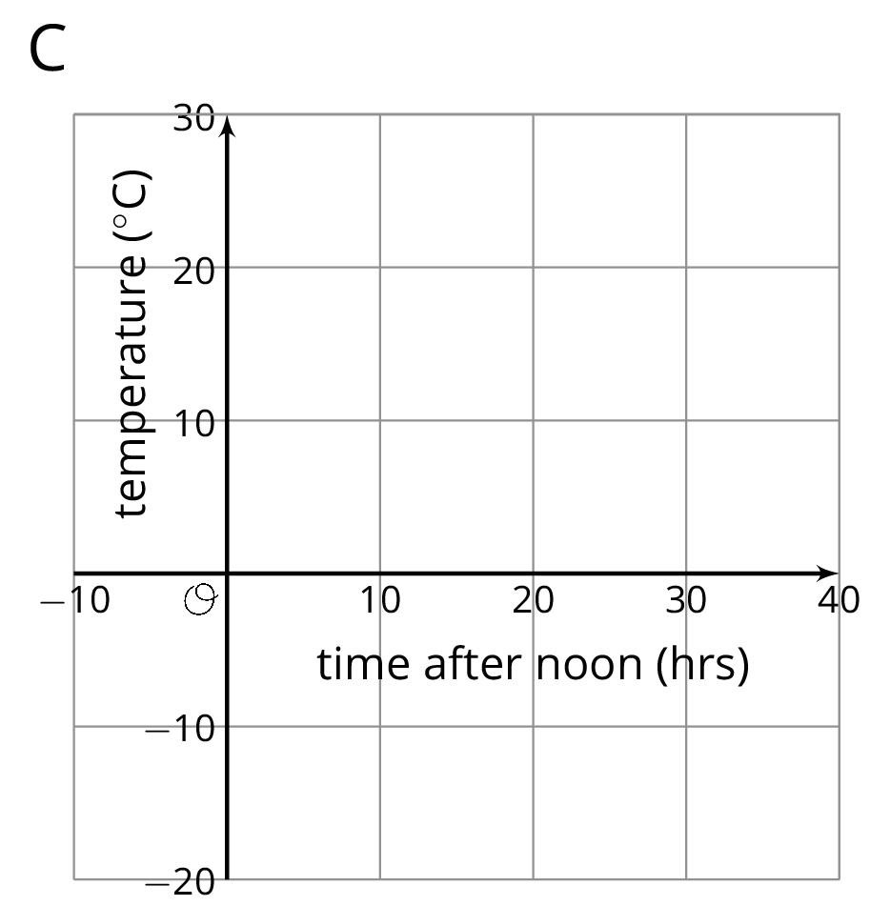

2 Axes Drawing Decisions

Student Task Statement
- Here are three sets of coordinates. For each set, draw and label an appropriate pair of axes and plot the points.
  - $\left(1,2\right),\left(3,\text{-}4\right),\left(\text{-}5,\text{-}2\right),\left(0,2.5\right)$
  - $\left(50,50\right),\left(0,0\right),\left(\text{-}10,\text{-}30\right),\left(\text{-}35,40\right)$
  - $\left(\frac{1}{4},\frac{3}{4}\right),\left(\frac{\text{-}5}{4},\frac{1}{2}\right),\left(\text{-}1\frac{1}{4},\frac{\text{-}3}{4}\right),\left(\frac{1}{4},\frac{\text{-}1}{2}\right)$
- Discuss with a partner:
  - How are the axes and labels of your three drawings different?
  - How did the coordinates affect the way you drew the axes and label the numbers?

3 Positively A-maze-ing (Optional)

Student Task Statement
Here is a maze on a coordinate plane. The black point in the center is (0, 0). The side of each grid square is 2 units long.
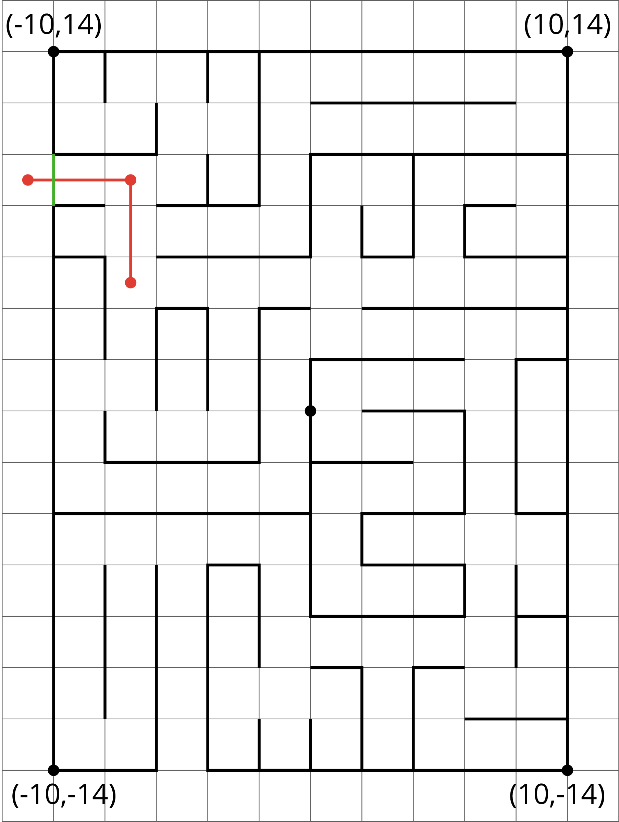
​
- Enter the above maze at the location marked with a green segment. Draw line segments to show your way through and out of the maze. Label each turning point with a letter. Then, list all the letters and write their coordinates.
- Choose any 2 turning points that share the same line segment. What is the same about their coordinates? Explain why they share that feature.
© CC BY Open Up Resources. Adaptations CC BY IM.

