Lesson 11: Create Groups of Images
- Let’s make groups that have more, fewer, or the same number of images.

11.1: Draw Groups of Images
my group | my partner's group

my group | my partner's group

11.3: Centers: Choice Time
Choose a center.
Less, Same, More
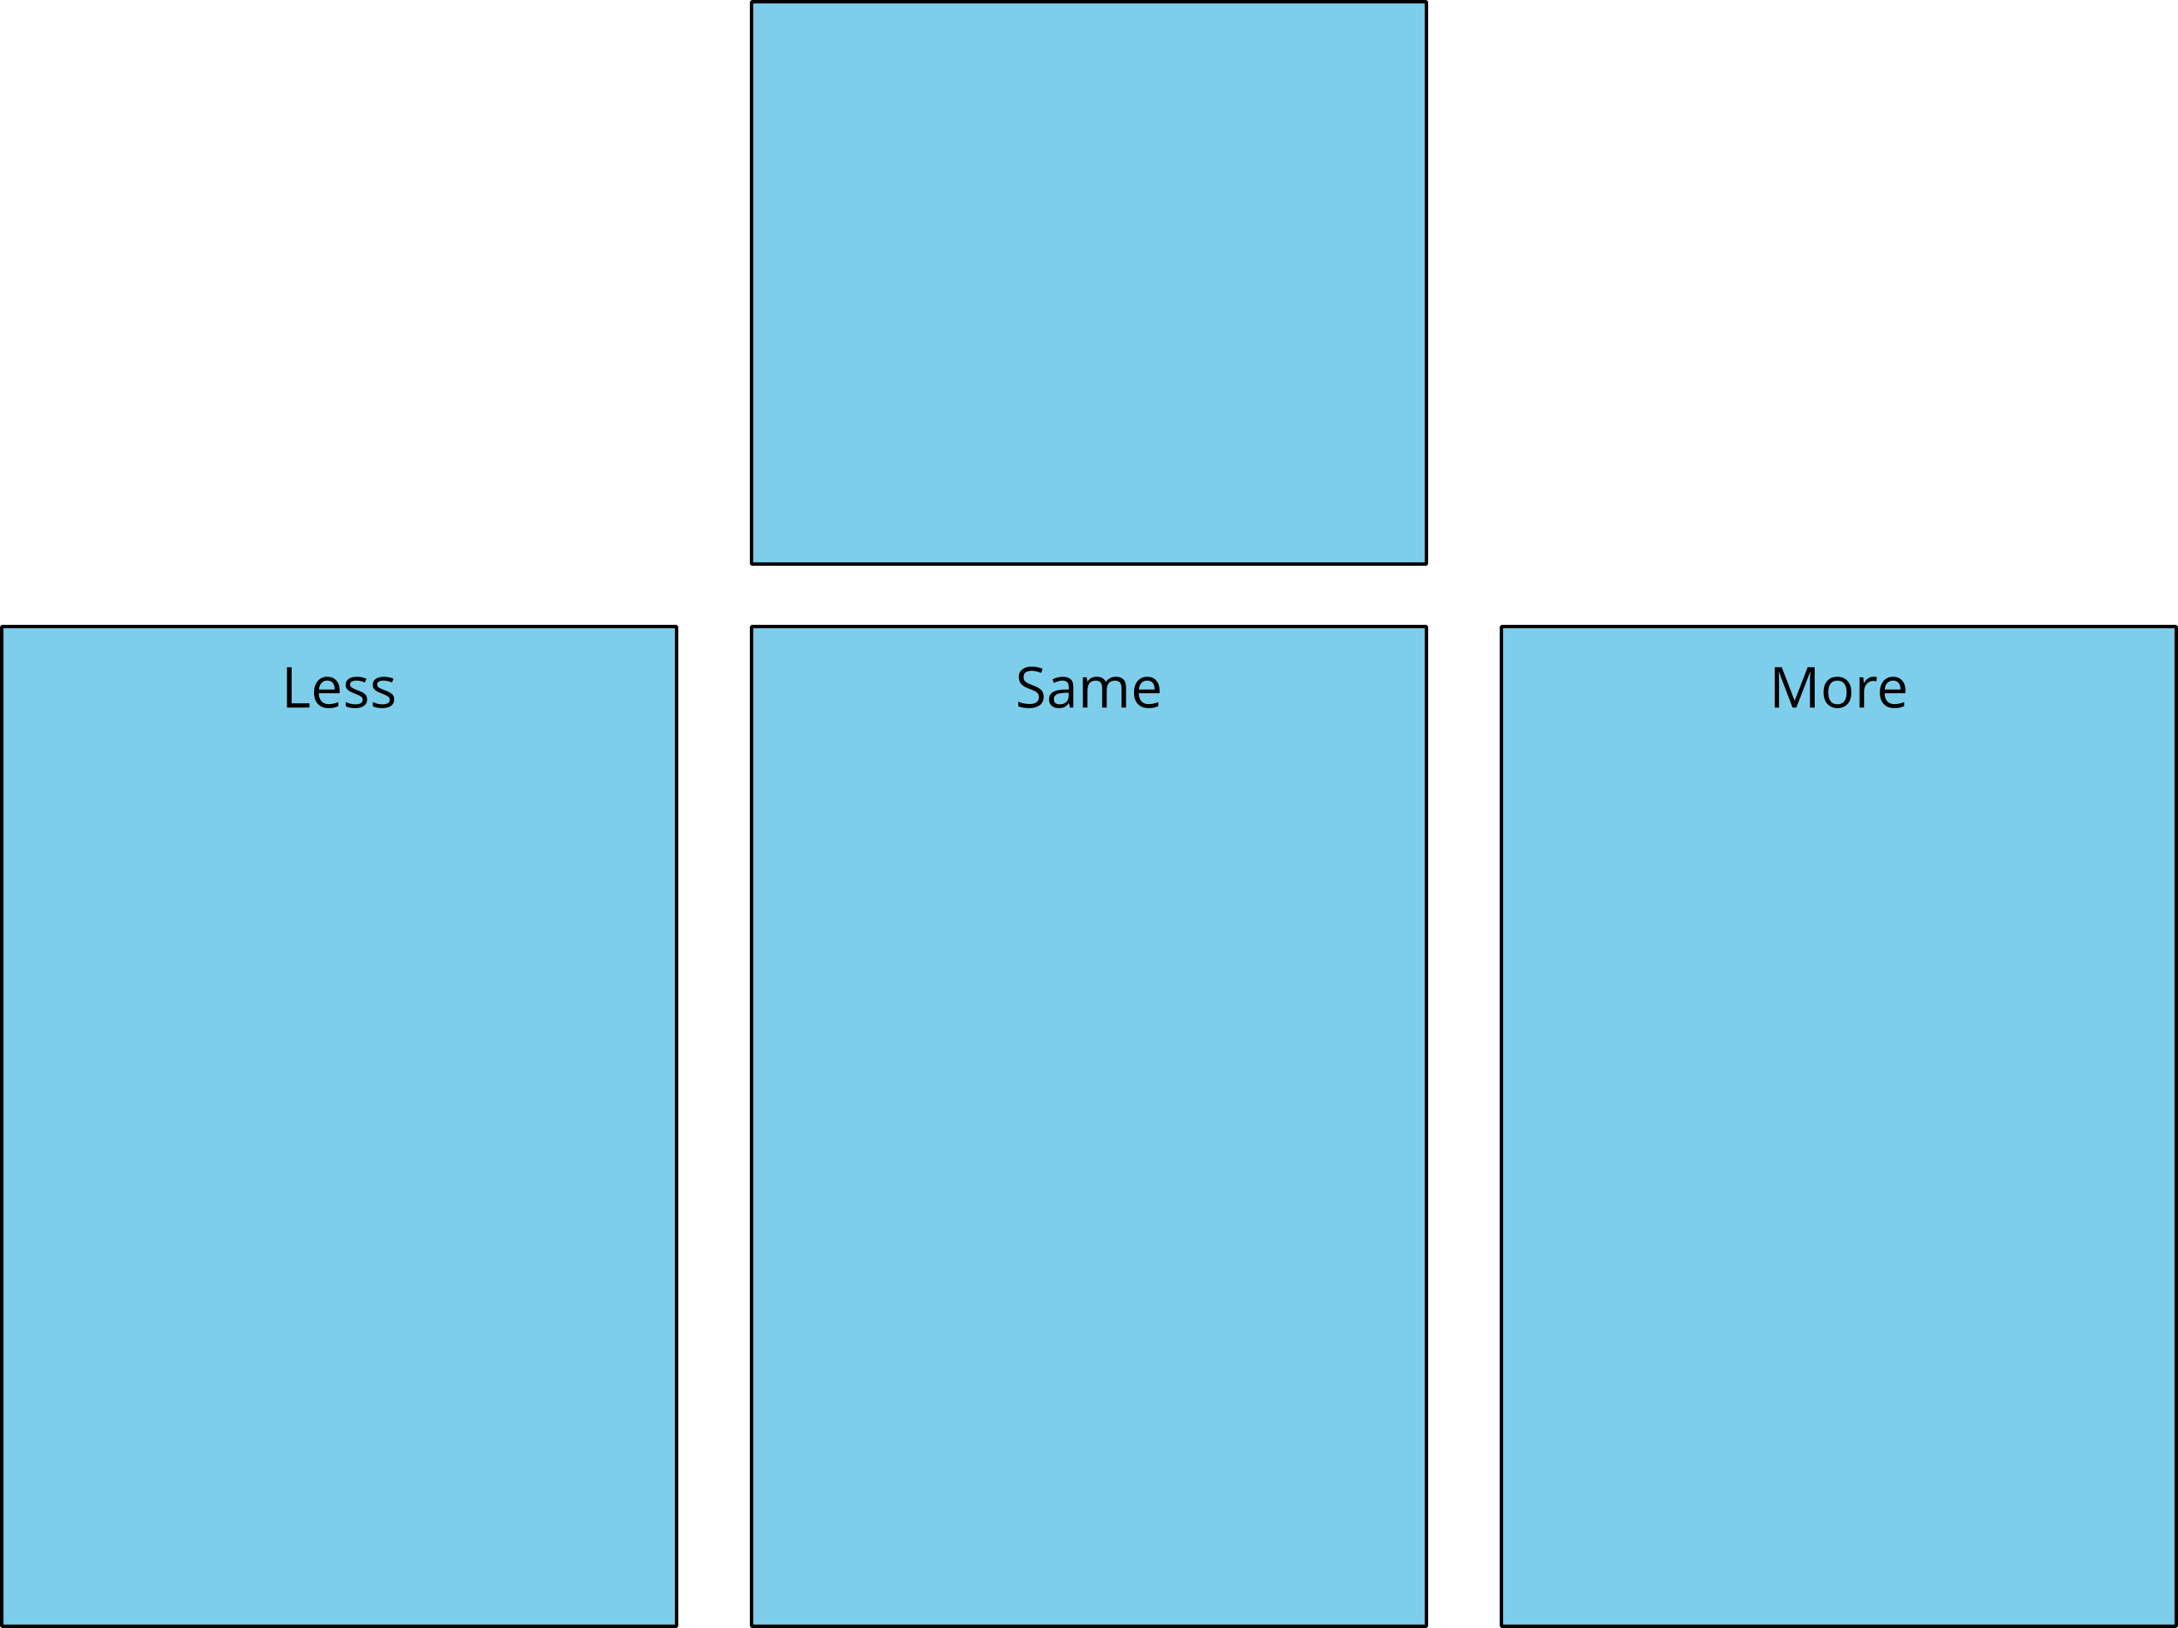
Bingo
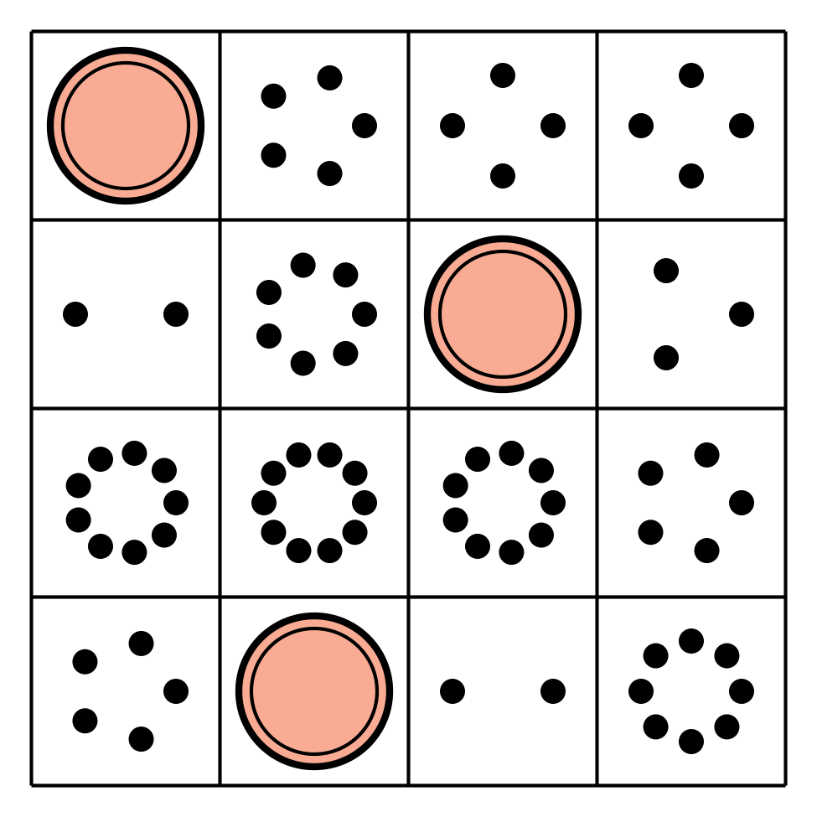
Math Stories
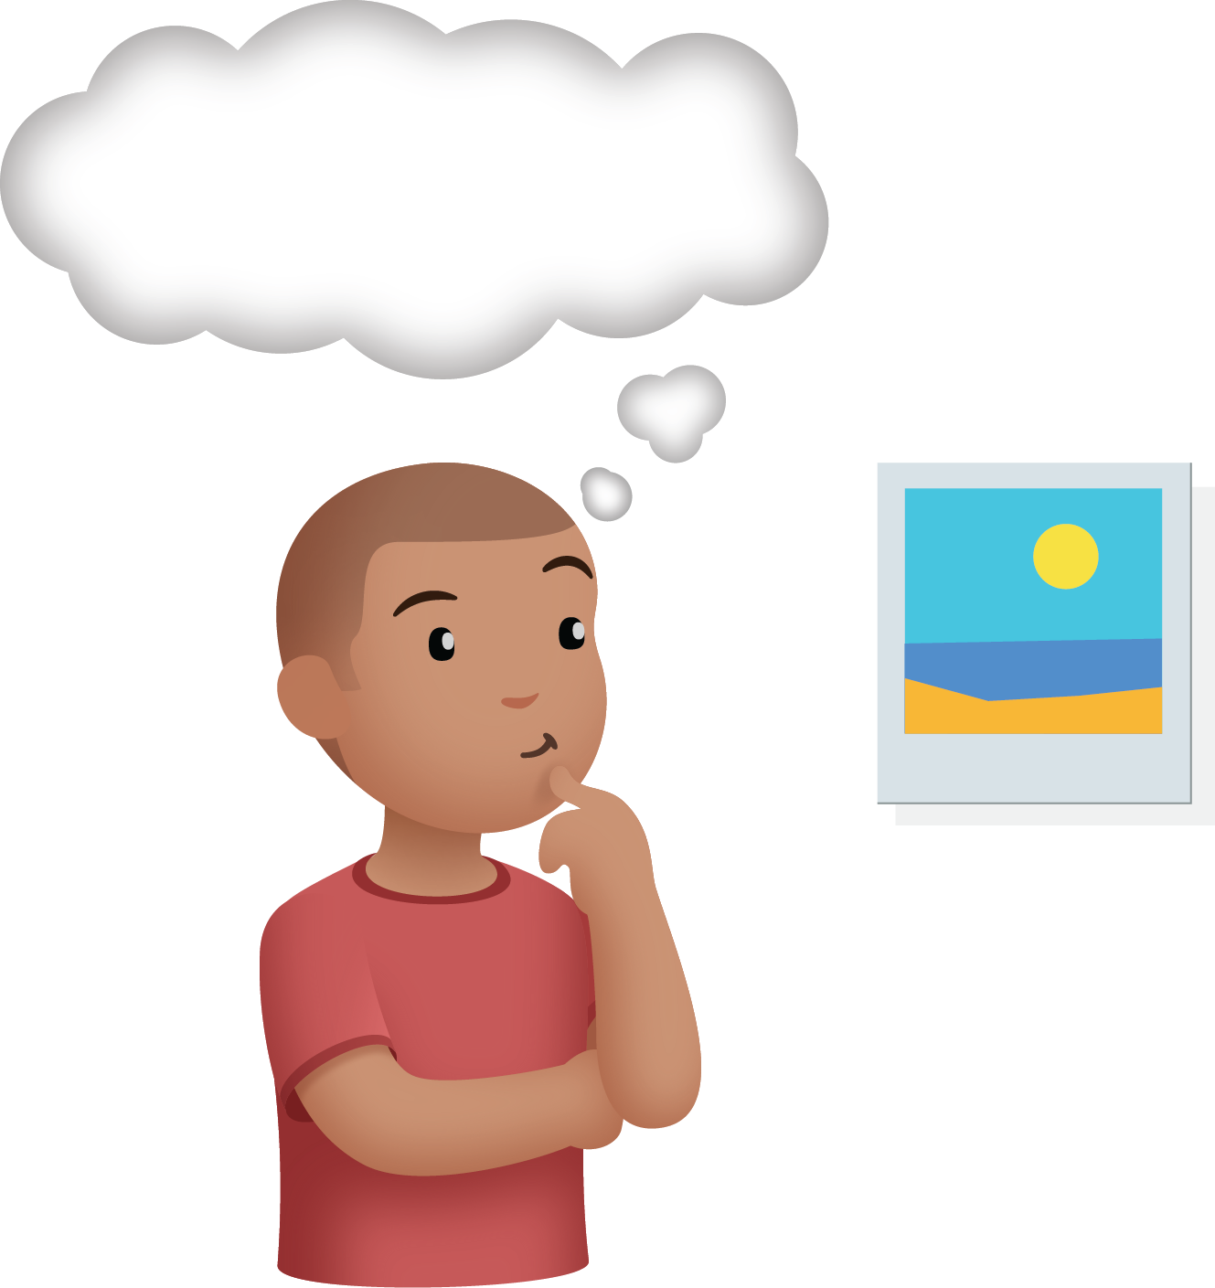
Connecting Cubes
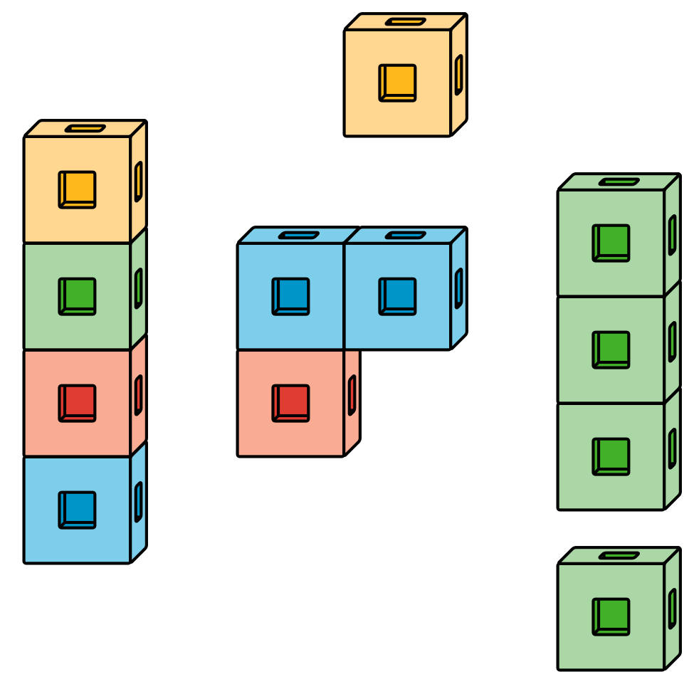
Number Race
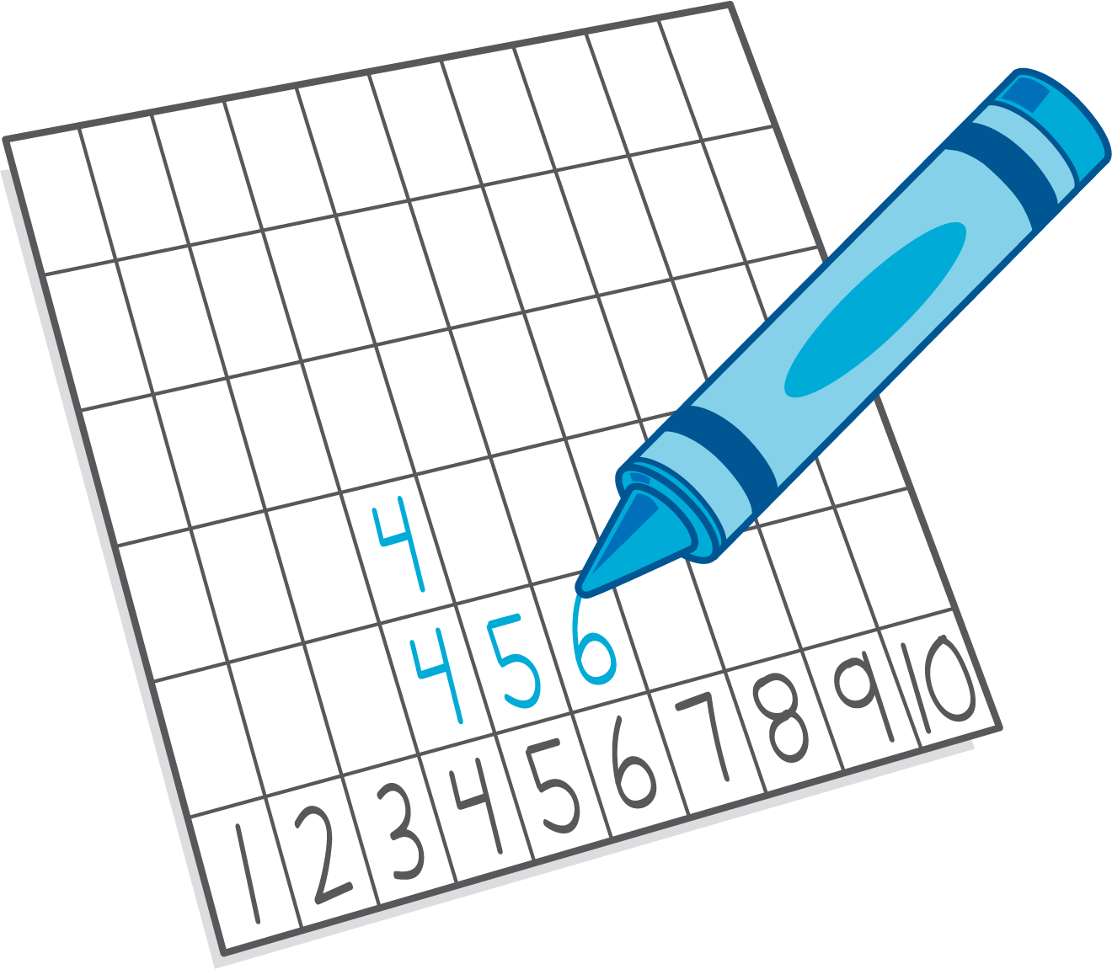

Section Summary
Section Summary
In this section, we counted many different groups of things.
We kept track of which ones we counted to make sure that we only counted each thing one time.
We also compared the number of things in groups using “more”, “fewer”, and “the same number.”
Sometimes we could just see that there were more.
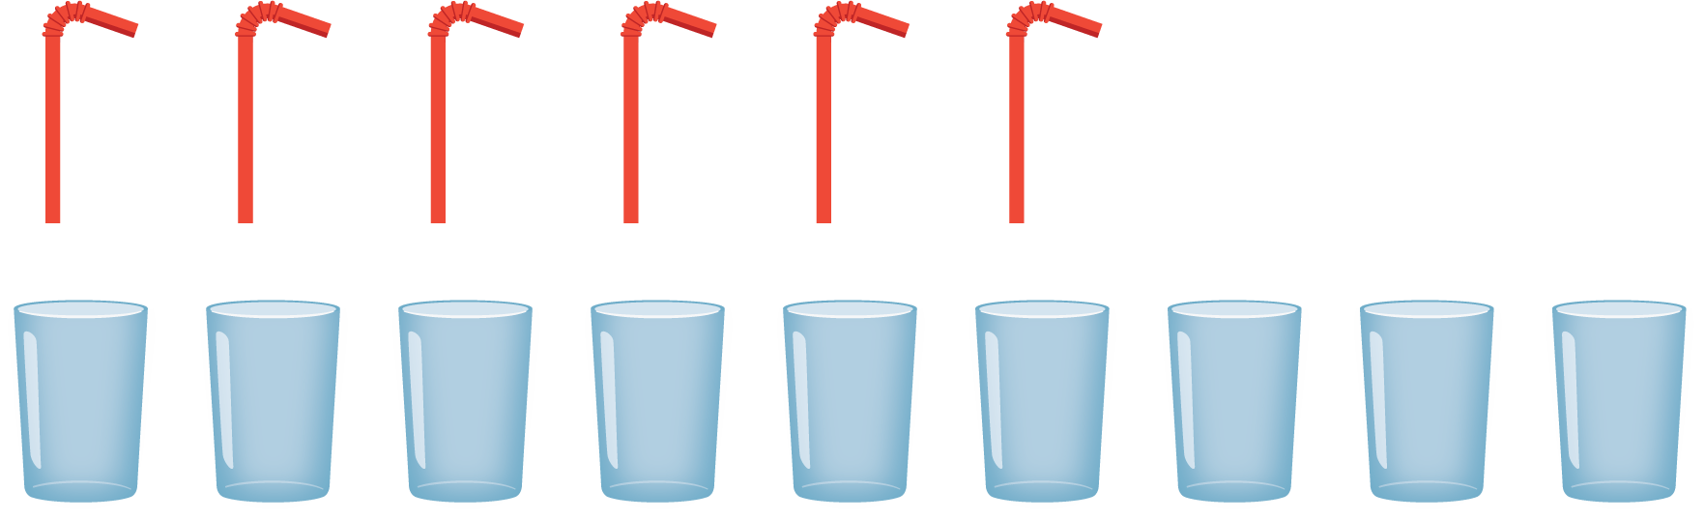
There are more cups than straws.
Sometimes we had to match or count to figure out which group had fewer.
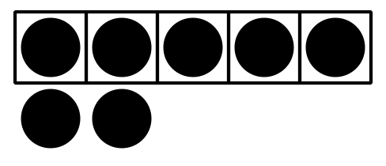
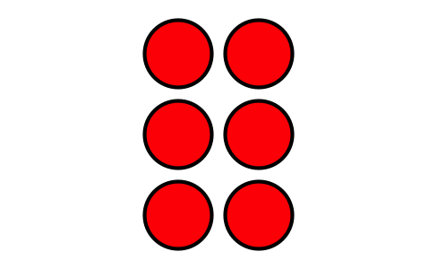
6 dots is fewer than 7 dots.
© CC BY 2021 Illustrative Mathematics®

