Unit 6 Lesson 5: How Many Fingers? How Many Dots?

WU Estimation Exploration: Connecting Cubes (Warm up)

Student Task Statement
How many cubes are there?
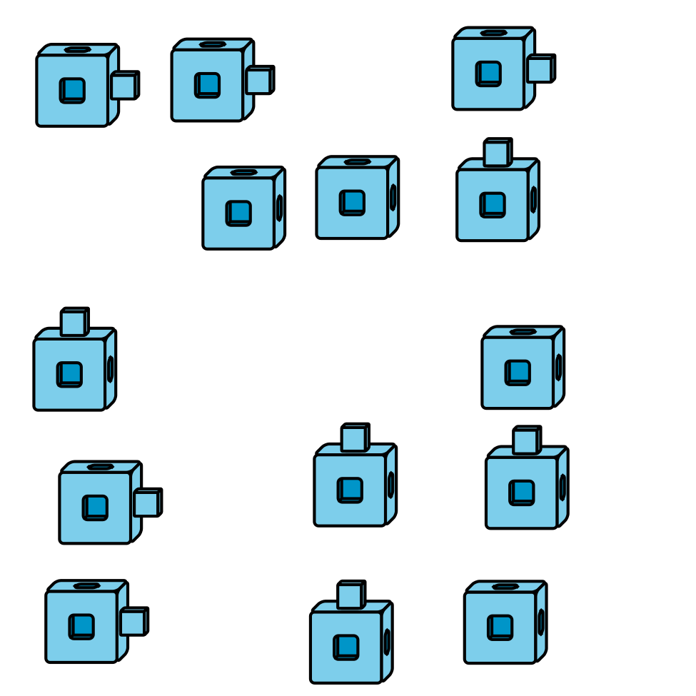
Record an estimate that is:
too low | about right | too high
How many cubes are there?
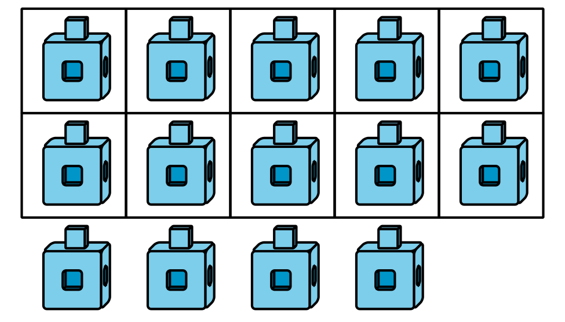
Record an estimate that is:
too low | about right | too high

1 How Many Fingers?

Student Task Statement
- 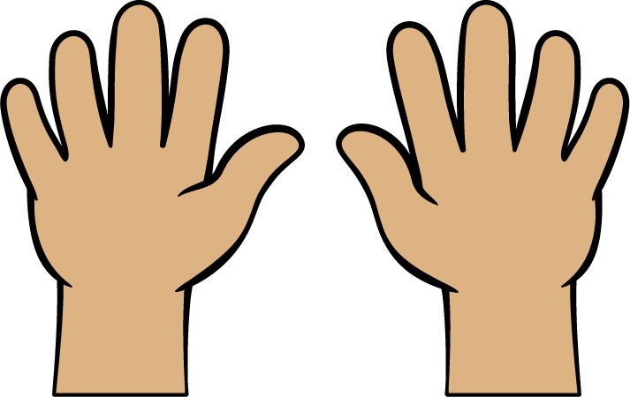
- 14
- 17
- 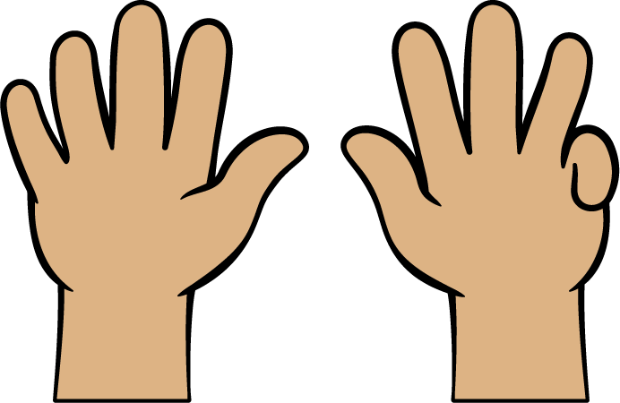
- 13
- 19
- 16

2 How Many Dots in 10-frames?

Student Task Statement

- 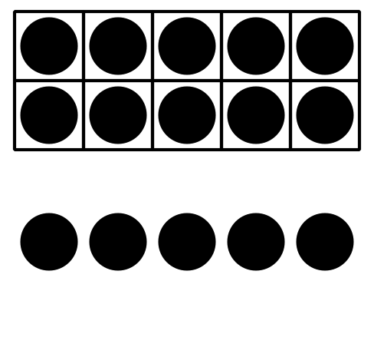
- 10 12 15

- 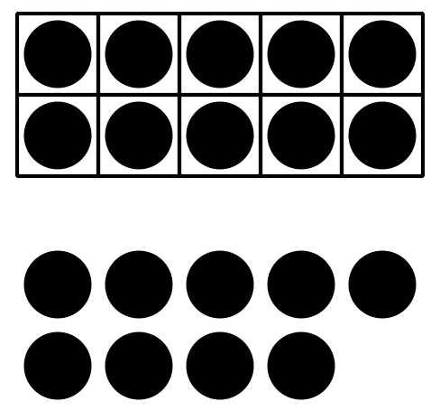
- 19 11 14

- 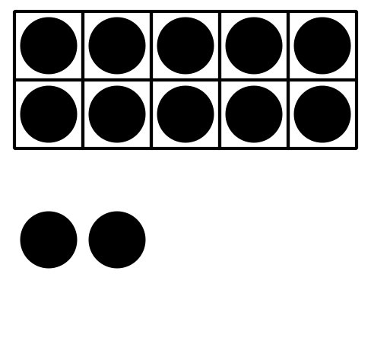
- 13 15 12

- 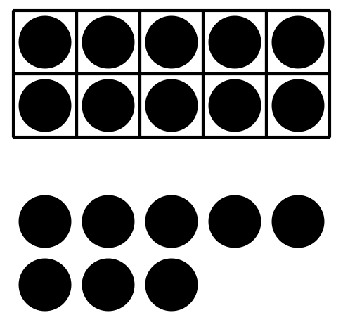
- 18 14 17

- 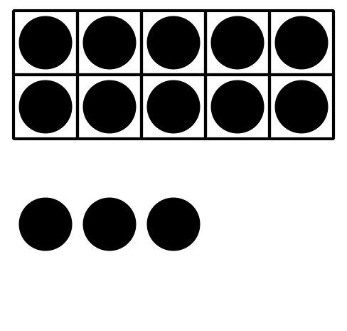
- 15 13 11

3 Introduce Grab and Count, Pattern Blocks

Student Task Statement
Choose a center.
Grab and Count
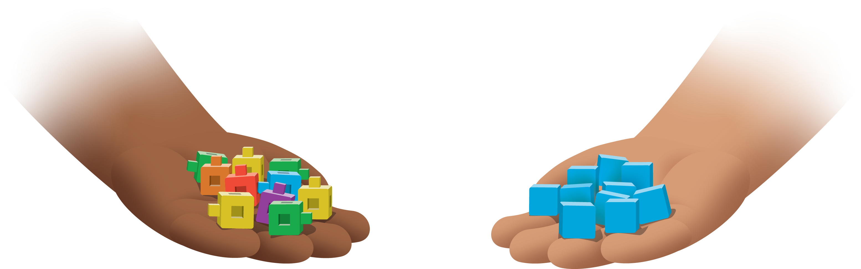
Find the Pair
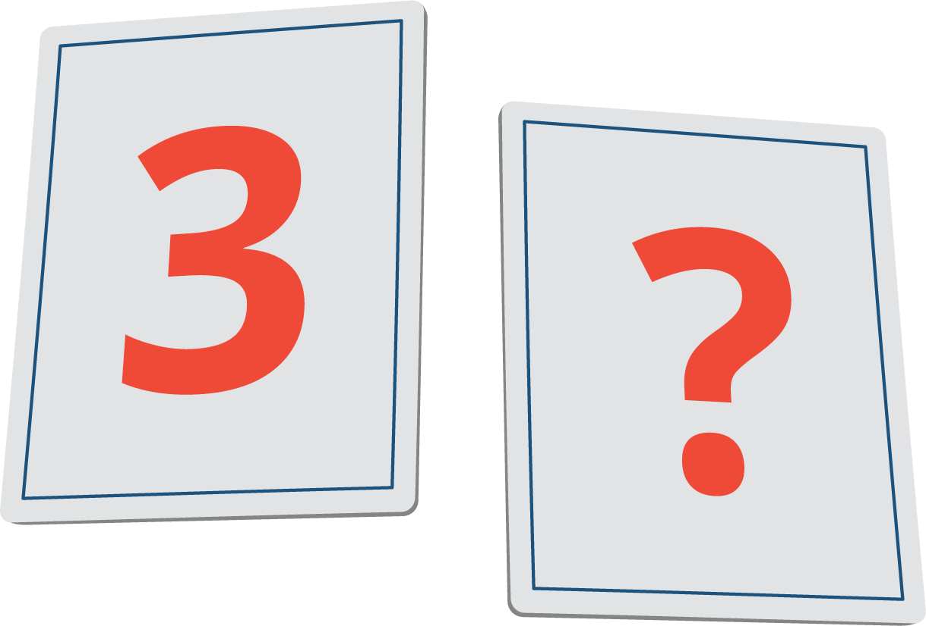
Tower Build
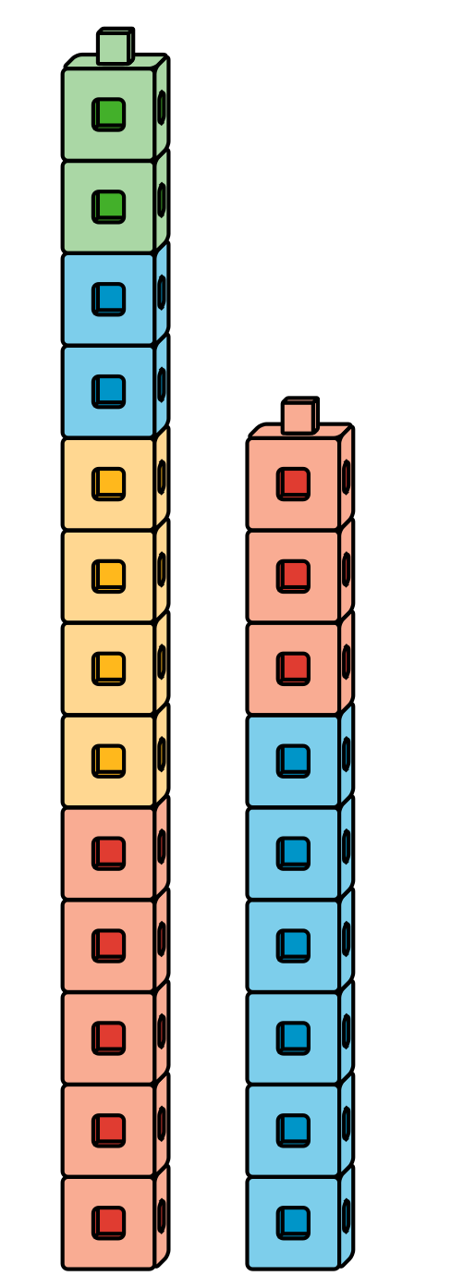
© CC BY 2021 Illustrative Mathematics®

