Unit 7 Lesson 4: Describing Distributions

1 Which One Doesn't Belong: Cracking Glass (Warm up)

Student Task Statement
Four different kinds of glass are hit with a hammer and the length of the longest crack formed is recorded. The process is repeated 150 times for each type of glass.
Which one doesn’t belong?

A
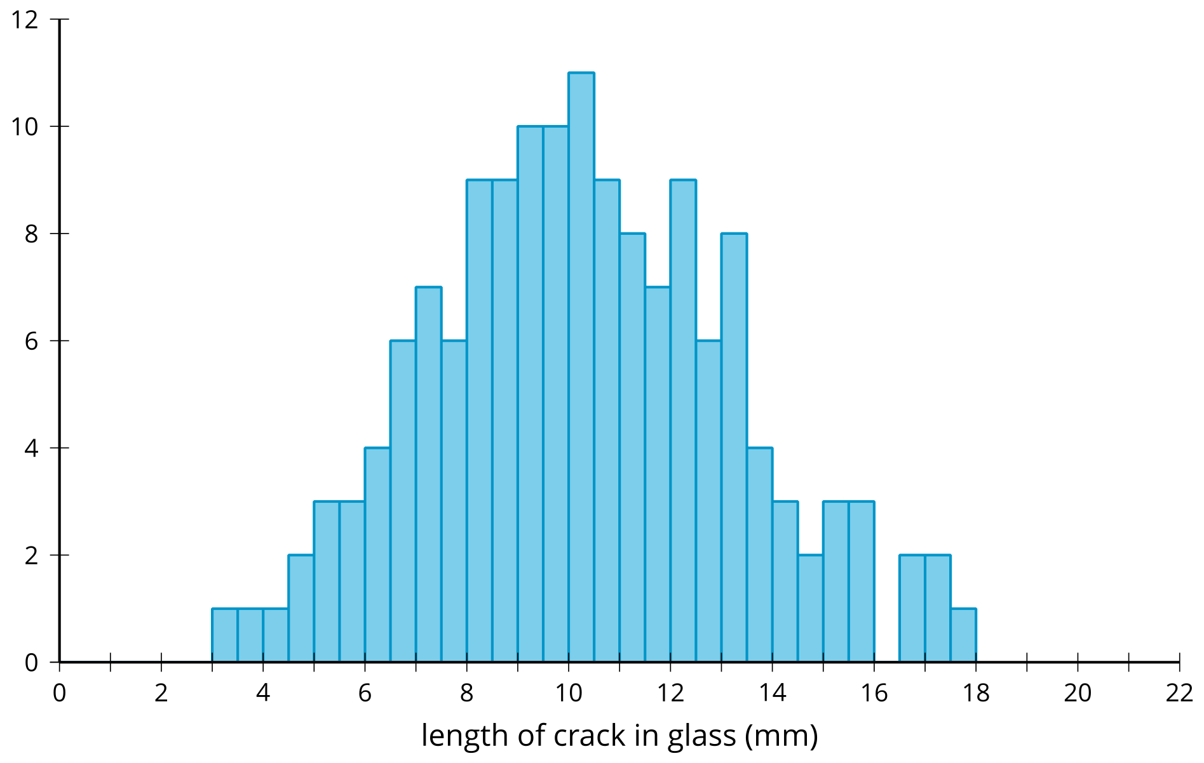

B
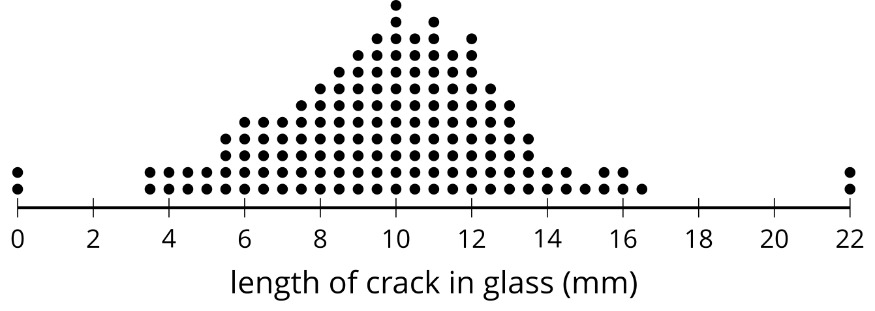

C
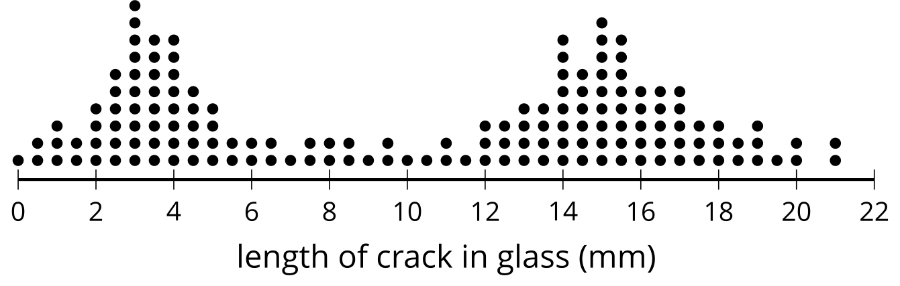

D
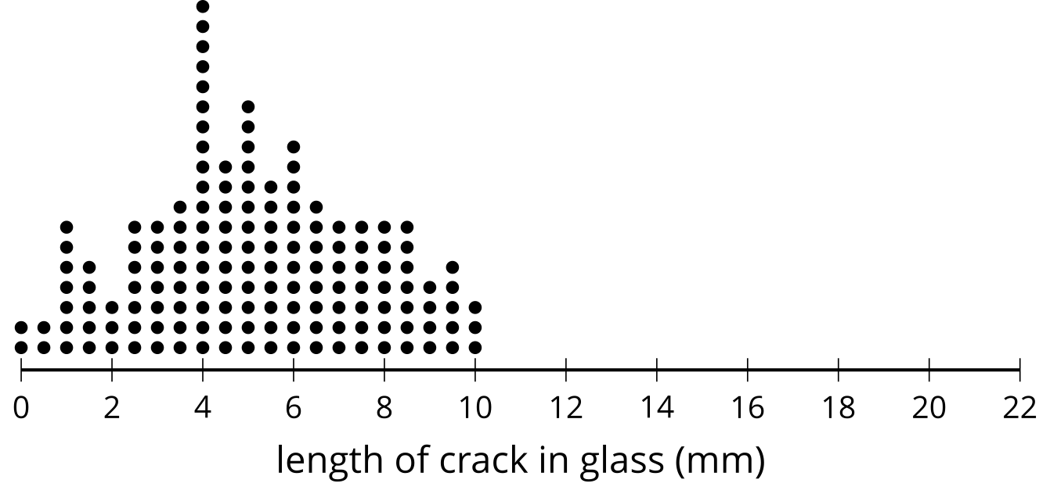

2 Name That Distribution Shape (Optional)

Student Task Statement
Take turns with your partner to select a dot plot and describe the distribution.
- For each distribution you describe, use the terms symmetric, skewed, bell-shaped, uniform, and bimodal where appropriate.
- For each distribution your partner describes, listen carefully to their description. If you disagree, discuss your thinking and work to reach an agreement.
- Each student in the class measures the length of their step in centimeters, then walks across the room counting the number of steps to estimate the length of the classroom in centimeters.
- 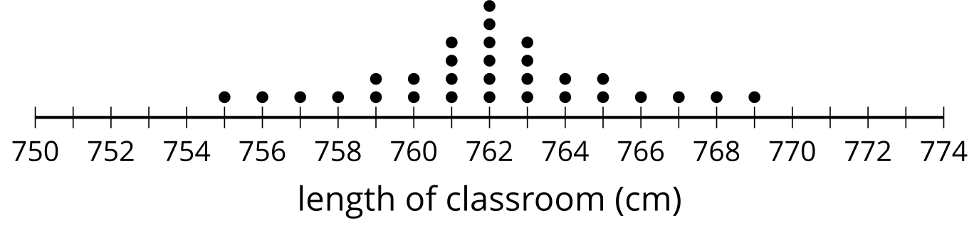
- As a test for fitness, students are asked to do as many push-ups as they can without stopping.
- 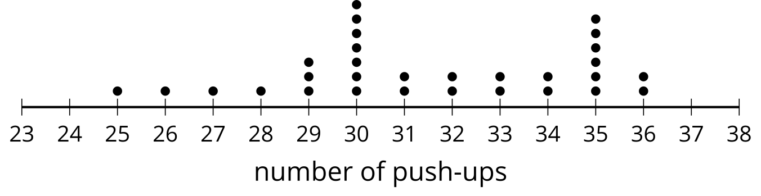
- A group of 30 students are asked how many times they eat a meal not made at home each week.
- 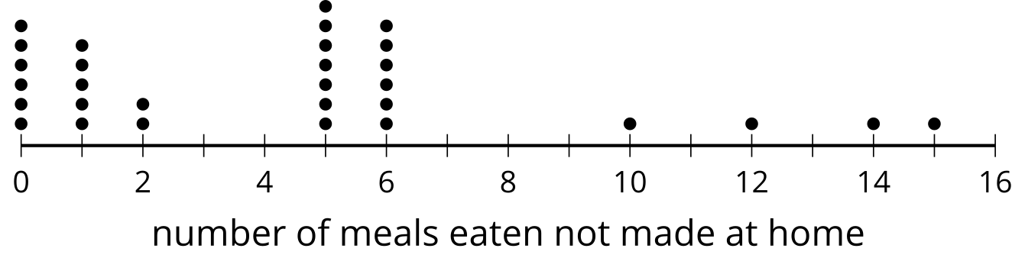
- A company sells small colored erasers in packages of 24 erasers. Thirty packages are inspected, and the number of red erasers in the package are counted.
- 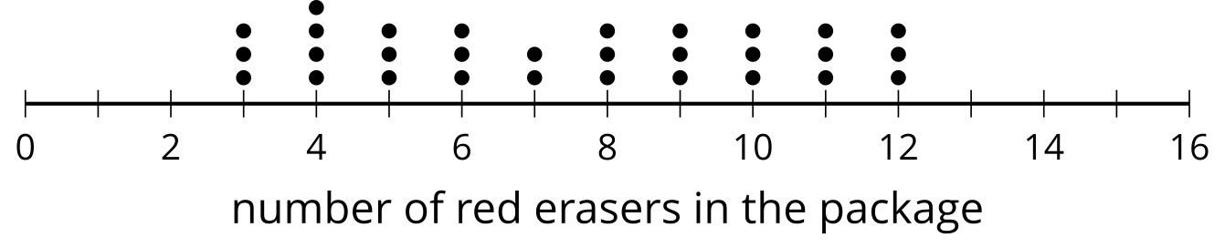

3 Matching Distributions and Statistics (Optional)

Student Task Statement
Take turns with your partner to match a dot plot with the summary statistics for the data shown.
- For each match you find, explain to your partner how you know it’s a match.
- For each match your partner finds, listen carefully to their explanation. If you disagree, discuss your thinking and work to reach an agreement.
- Mean: 3, median: 2, standard deviation: 2.91
- Mean: 5, median: 5, standard deviation: 2.19
- Mean: 5, median: 5, standard deviation: 3.74
- Mean: 7.13, median: 8, standard deviation: 2.79

A
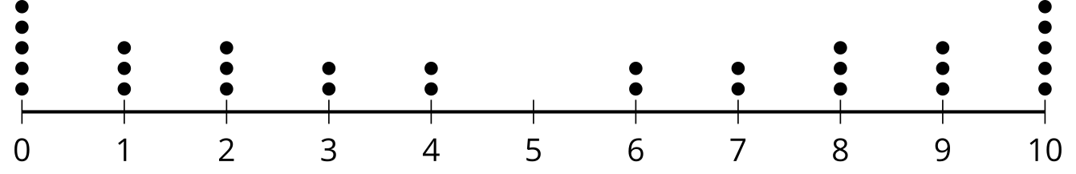

B
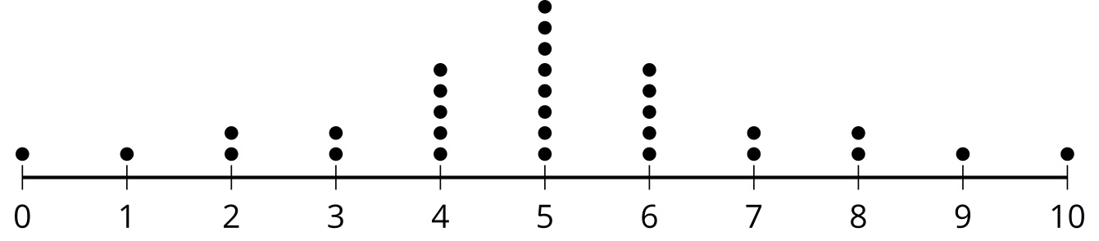

C
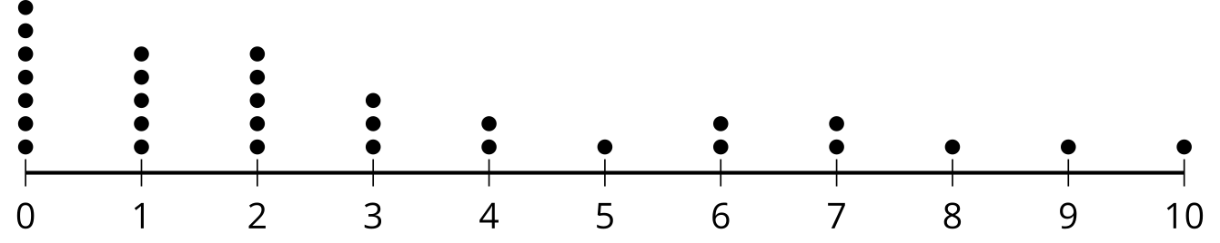

D
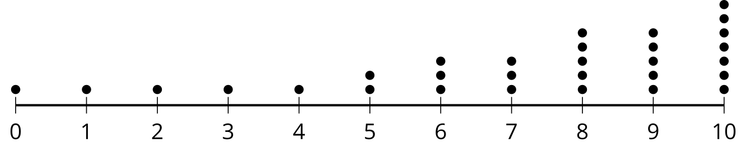

Images for Activity Synthesis
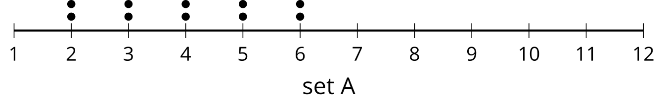
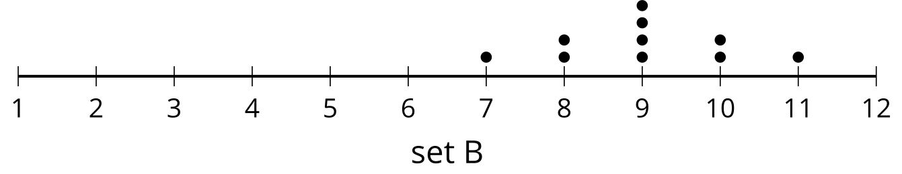
© CC BY 2019 by Illustrative Mathematics®

