Lesson 2: Slicing Solids
- Let’s analyze cross sections by slicing three-dimensional solids.

2.1: Slice This
Imagine slicing a cylinder with a straight cut. The flat surface you sliced along is called a cross section. Try to sketch all the possible kinds of cross sections of a cylinder.

2.2: Slice That
Your teacher will give your group a three-dimensional solid to analyze.
- Sketch predictions of all the kinds of cross sections that could be created from your solid.
- Slice your solid to confirm your predictions. Sketch any new cross sections you find after slicing.

2.3: Stack ‘Em Up
Each question shows several parallel cross-sectional slabs of the same three-dimensional solid. Name each solid.
- 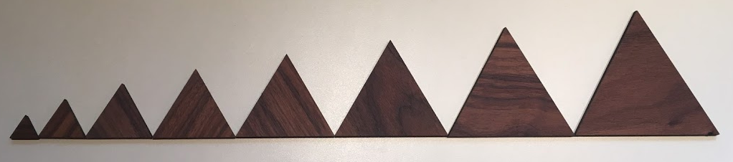
- 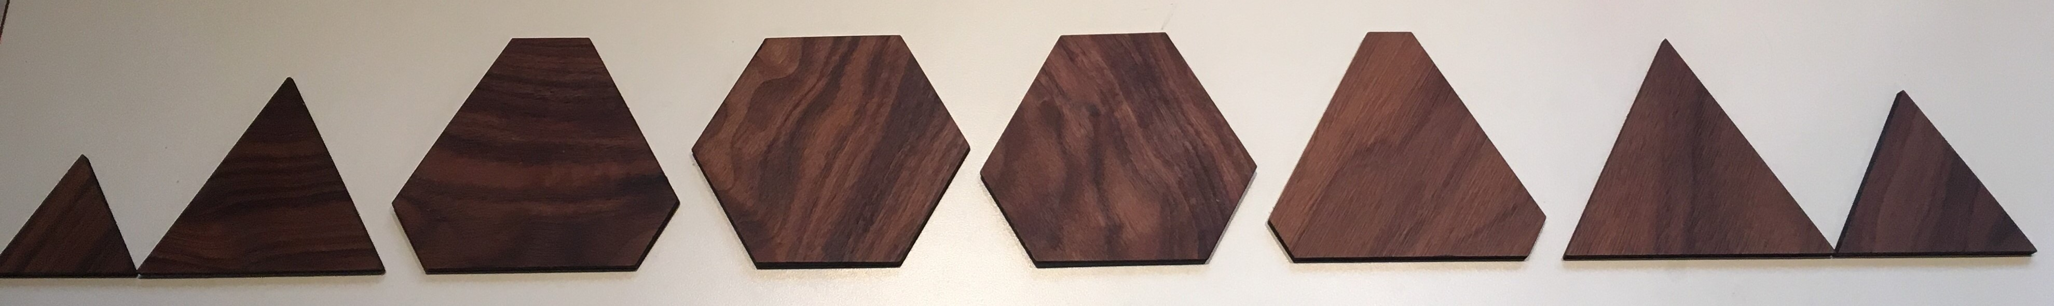
- 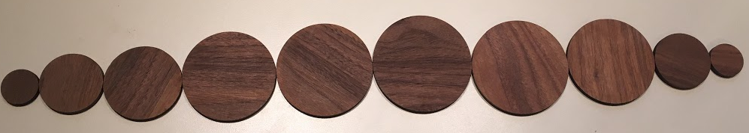

Are you ready for more?
3D-printers stack layers of material to make a three-dimensional shape. Computer software slices a digital model of an object into layers, and the printer stacks those layers one on top of another to replicate the digital model in the real world.
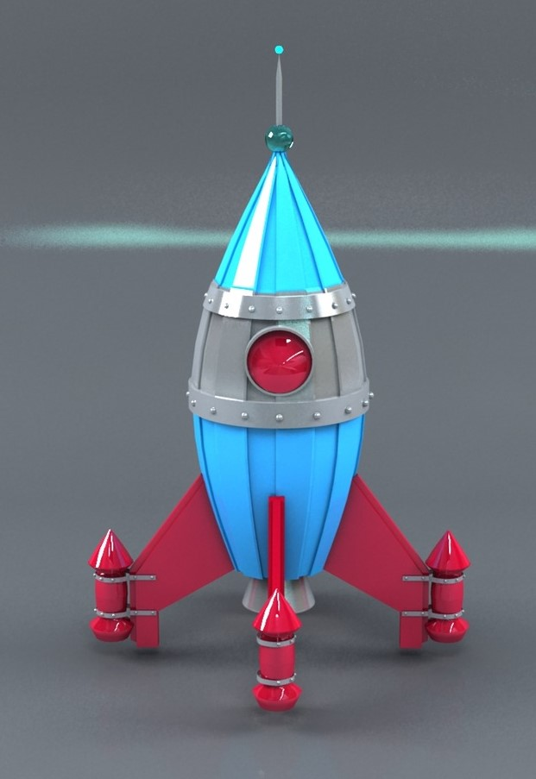
- Draw 3 different horizontal cross sections from the object in the image.
- The layers can be printed in different thicknesses. How would the thickness of the layers affect the final appearance of the object?
- Suppose we printed a rectangular prism. How would the thickness of the layers affect the final appearance of the prism?

Lesson 2 Summary
In earlier grades, you learned some vocabulary terms about solid geometry: A sphere is the set of points in three-dimensional space the same distance from some center. A prism has two congruent faces (or sides) that are called bases. The bases are connected by parallelograms. A cylinder is like a prism except the bases are circles. A pyramid has one base. The remaining faces are triangles that all meet at a single vertex. A cone is like a pyramid except the base is a circle.
We often analyze cross sections of solids. A cross section is the intersection of a solid with a plane, or a two-dimensional figure that extends forever in all directions. For example, some cheese is sold in cylindrical blocks. If you stand the cheese on end and slice vertically, you will get a rectangle, as shown. This rectangle is a cross section of the cylinder.
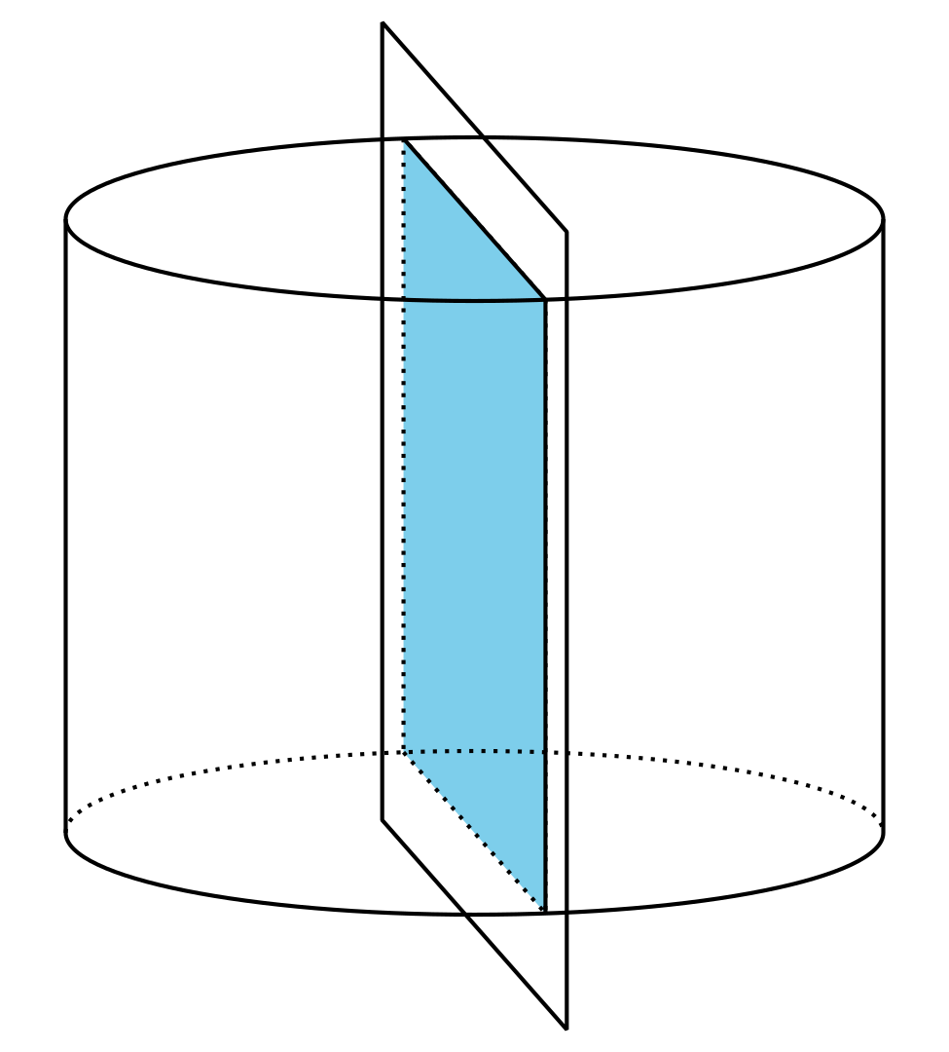
Here are 3 more examples of cross sections created by intersecting a plane and a cylinder.
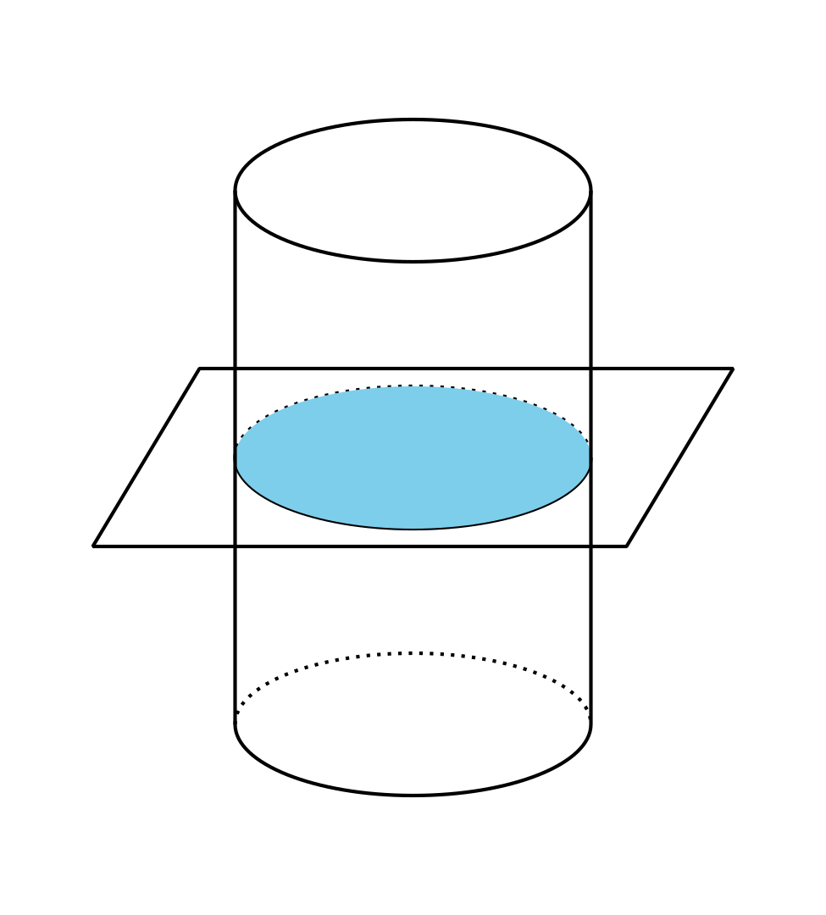
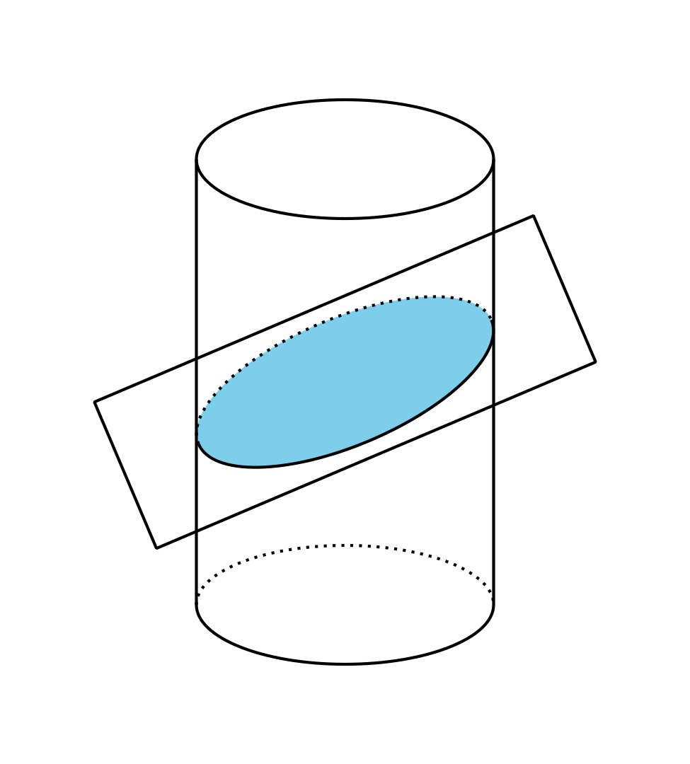
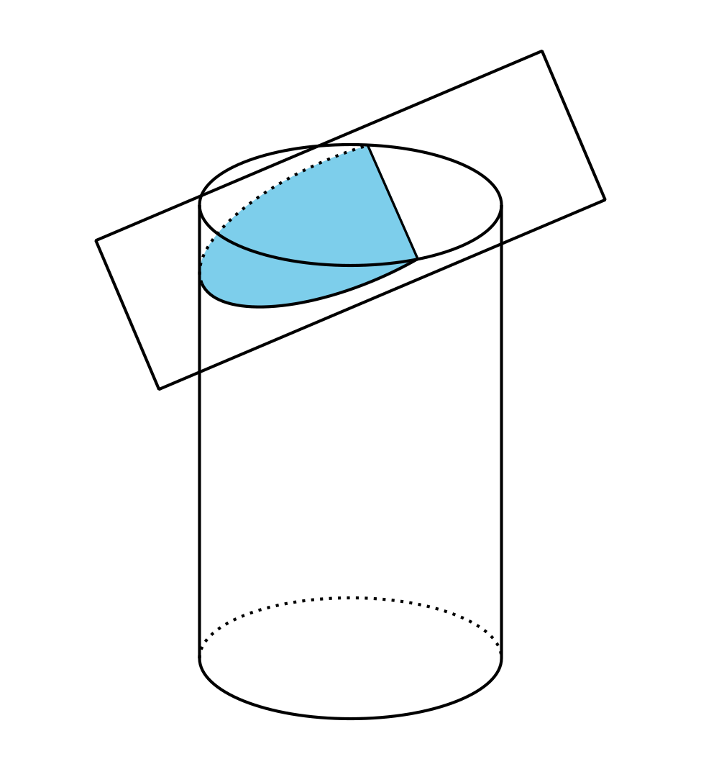
If you wanted to serve your cylindrical cheese at a party, you might cut it into several pieces, like this. The pieces are thin cylinders. They are like cross sections, but they are three-dimensional. All the cuts were made parallel to one another. By looking at the slices, or by stacking them up, you could figure out that the original shape of the cheese was a cylinder.
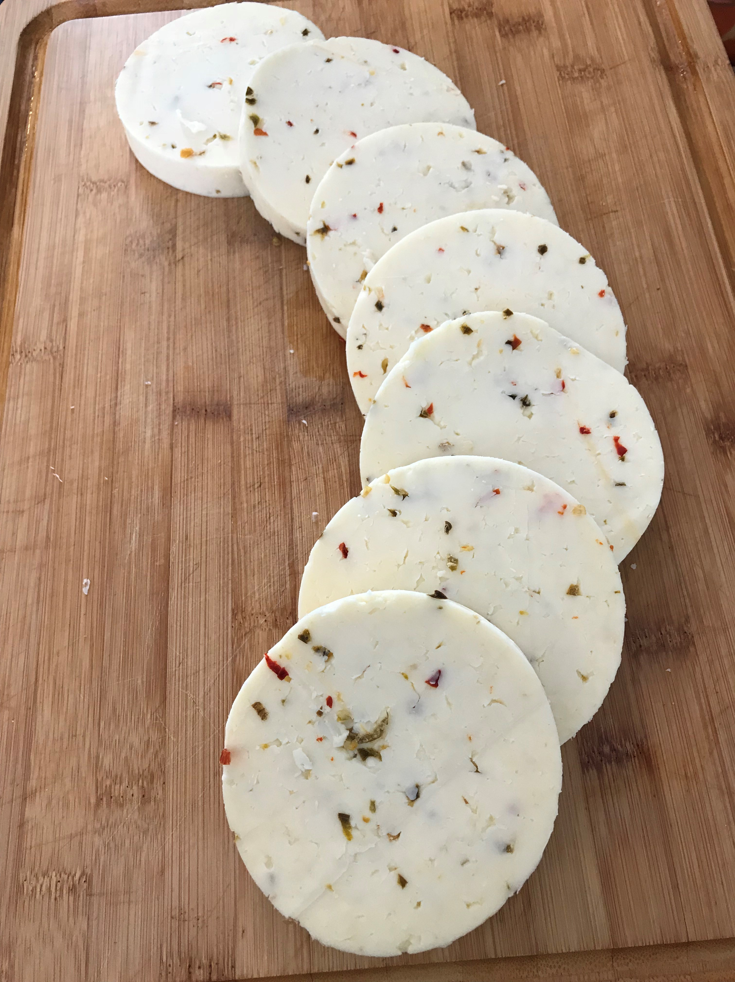
What if another cheese plate contained slices whose radii got bigger to a maximum size and then got smaller again? The cheese was probably in the shape of a sphere. A sphere has circular cross sections. The size of the circular cross sections increases as you get closer to the center of the sphere, then decreases past the center.
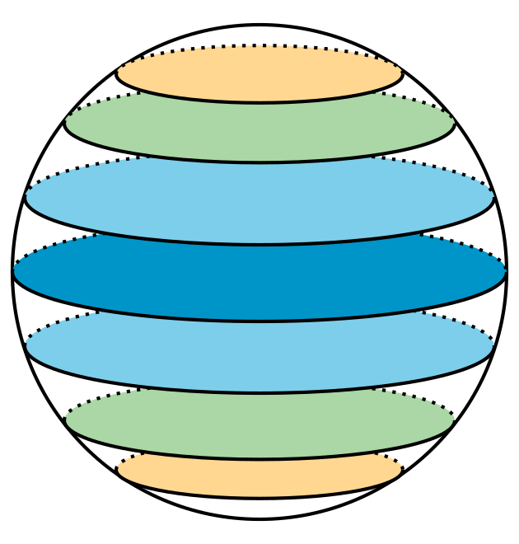
© CC BY 2019 by Illustrative Mathematics®

