Unit 4 Lesson 6: Standard Algorithm: Multi-digit Numbers with Composing

WU Number Talk: Three Factors (Warm up)

Student Task Statement
Find the value of each product mentally.
- $\left(2×3\right)×10$
- $\left(2×40\right)×10$
- $\left(2×200\right)×10$
- $\left(2×243\right)×10$

1 Compose a New Unit

Student Task Statement
- Find the value of $241×23$ .
- Lin used the standard algorithm to find the value of $241×23$. Here is her work:
- 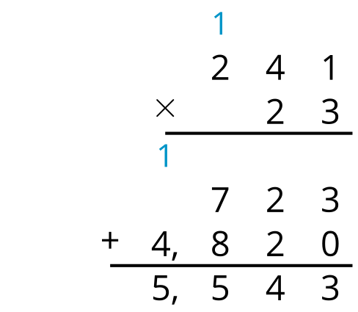
  - Where do you see $241×3$ in Lin’s work?
  - Where do you see $241×20$ in Lin’s work?
  - What does the 1 above 241 represent in Lin’s calculation?
- Use the standard algorithm to find the value of $182×41$.
- Use the standard algorithm to find the value of $304×23$.

2 All the Products

Student Task Statement
Find the value of each product using the standard algorithm.
- $647×9$
- $647×50$
- $647×59$
- $264×38$

Images for Activity Synthesis
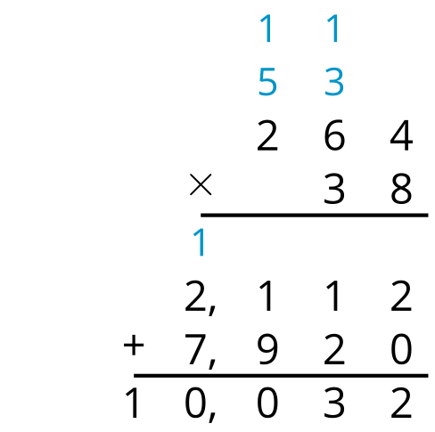
© CC BY 2021 Illustrative Mathematics®

