Unit 5 Lesson 20: Products in the Hundredths Place

WU What do you know about $1×0.1$ and $0.1×0.1$? (Warm up)

Student Task Statement
What do you know about these expressions?
- $1×0.1$
- $0.1×0.1$

1 Products of Tenths

Student Task Statement
- Find the value of each expression. Explain or show your reasoning. Use the grids if they are helpful.
  - $2×0.3$
  - 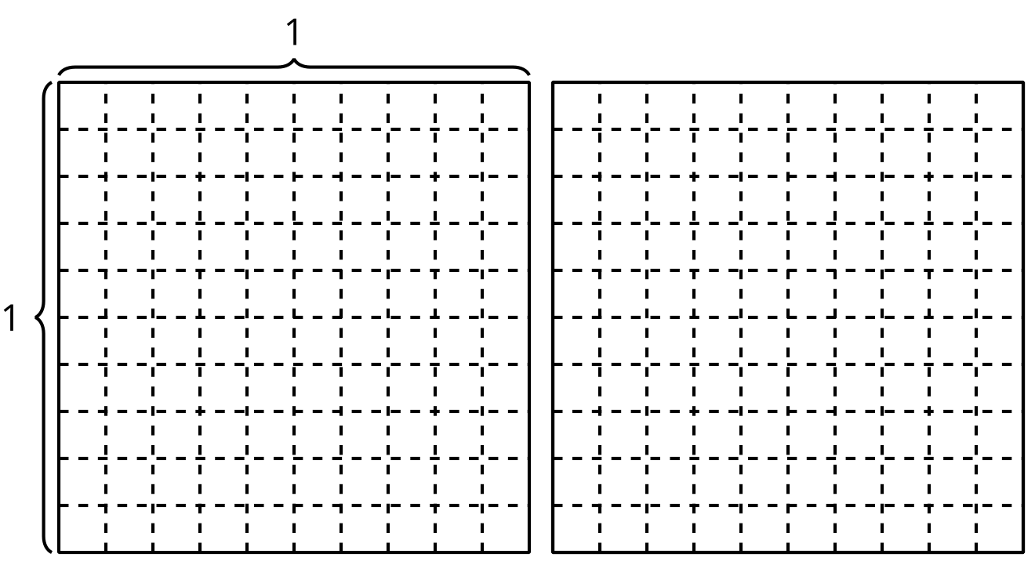
  - $0.2×0.3$
- Kiran says $0.2×0.4=0.8$. Do you agree with Kiran? Explain or show your reasoning.

2 Multiply Tenths

Student Task Statement
- Find the value of each expression. Explain or show your reasoning.
  - $1.8×0.4$
  - $2.5×0.6$
  - $3.8×0.7$
- How are these products the same? How are they different?
  - $74×6$
  - $7.4×6$
  - $7.4×0.6$
© CC BY 2021 Illustrative Mathematics®

