Lesson 10: Measure with a Torn Tape

Standards Alignments
Building On | 1.OA.D.7
Addressing | 2.MD.B.5, 2.OA.B.2
Building Towards | 2.MD.B.6

Teacher-facing Learning Goals
- Determine the measurement of an object with a measuring tool when the endpoint does not line up with 0.

Student-facing Learning Goals
- Let’s measure without starting at 0.

Lesson Purpose
The purpose of this lesson is for students to measure objects without lining up the end with the 0 mark.
In earlier lessons, students used rulers, measuring tapes, yardsticks, and meter sticks to measure lengths in inches, feet, centimeters, and meters. They learned that length units are represented on these tools as the length between tick marks. They learned that if they line up the edge of an object with zero on their tools, they can easily read the measurement from the tool without counting each length unit.
In this lesson, students extend their experiences with measurement to include situations when they can not use a tool to measure from 0. They know from prior experience that simply moving an object in space does not change its length (conservation of length). However, this understanding is challenged when students see an object that is not lined up with 0 on a measuring tool. Throughout the lesson, students are encouraged to make sense of and use equations that represent the measuring problems in each task (MP2). This understanding will support learning in future units with representing addition and subtraction on the number line.

Access for:

Students with Disabilities
- Action and Expression (Activity 1)

English Learners
- MLR2 (Activity 2)

Instructional Routines
True or False (Warm-up)

Materials to Gather
- Objects of various lengths: Activity 1
- Rulers (inches): Activity 1

Lesson Timeline
Warm-up | 10 min
Activity 1 | 15 min
Activity 2 | 20 min
Lesson Synthesis | 10 min
Cool-down | 5 min

Teacher Reflection Question
What connections did students make between the different methods shared? What questions did you ask to help make the connections more visible?

Cool-down
(to be completed at the end of the lesson) 5min
Torn Tape

Standards Alignments
Addressing | 2.MD.B.5

Student-facing Task Statement
- How long is the picture frame? Show your thinking.
- 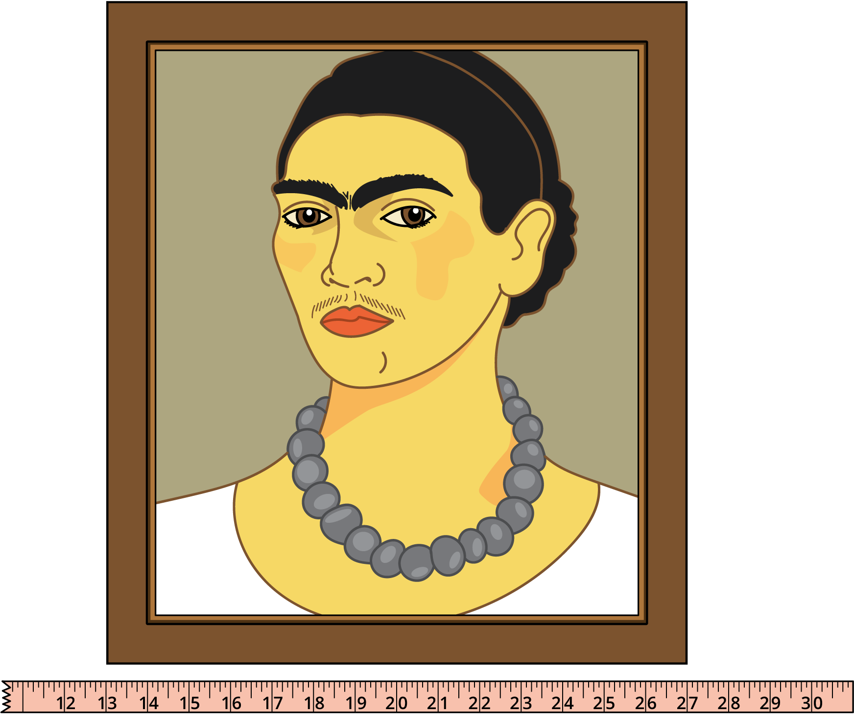
- The picture frame is ____________ inches long.
- Write an equation to represent the length of the picture frame.

Student Responses
- 14 inches long. Sample response: I know because the frame starts at 13 in and ends at 27 in, so I found the difference to see how many inches. I counted on from 13 until I got to 27.
- $27−13=?$ or $13+?=27$

