Lesson 4: Introduction to Addition Algorithms

Standards Alignments
Addressing | 3.NBT.A.2

Teacher-facing Learning Goals
- Add within 1,000.
- Relate base-ten diagrams to written algorithms for addition.

Student-facing Learning Goals
- Let’s learn new ways to add.

Lesson Purpose
The purpose of this lesson is for students to use their knowledge of base-ten diagrams to make sense of two written addition algorithms.
In a previous lesson, students revisited addition within 1,000 using strategies based on place value, and properties of operations. An algorithm is different from a strategy because it is a set of steps that works every time as long as the steps are carried out correctly. The algorithms introduced in this lesson draw on the grade 2 work within 1,000 in that they show the addition of ones to ones, tens to tens, and hundreds to hundreds. Students should have access to base-ten blocks if they choose to use them.

Access for:

Students with Disabilities
- Engagement (Activity 2)

English Learners
- MLR7 (Activity 1)

Instructional Routines
MLR3 Clarify, Critique, Correct (Activity 2), Which One Doesn’t Belong? (Warm-up)

Materials to Gather
- Base-ten blocks: Activity 1, Activity 2

Lesson Timeline
Warm-up | 10 min
Activity 1 | 20 min
Activity 2 | 15 min
Lesson Synthesis | 10 min
Cool-down | 5 min

Teacher Reflection Question
In grade 2, students spent significant time working with place value. How did students’ work with place value prepare them for the move to using algorithms to add?

Cool-down
(to be completed at the end of the lesson) 5min
Choose an Algorithm

Standards Alignments
Addressing | 3.NBT.A.2

Student-facing Task Statement
A diagram of the base-ten blocks that represent $138+425$ is shown.
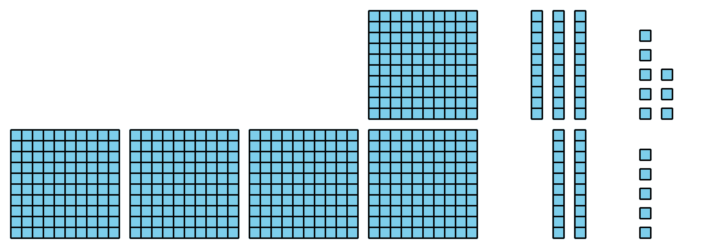
Use an algorithm you learned in today's lesson to find the value of the sum.

Student Responses
563 or $500+50+13$. Students can use either algorithm from the lesson.

