Lesson 14: Making More New, True Equations
- Let’s practice combining like terms and working with horizontal and vertical lines.

14.1: Criss Cross'll Make You Jump
Match each equation with its graph.
$x=7$ | $y=7$ | $x+y=7$

A

B

C
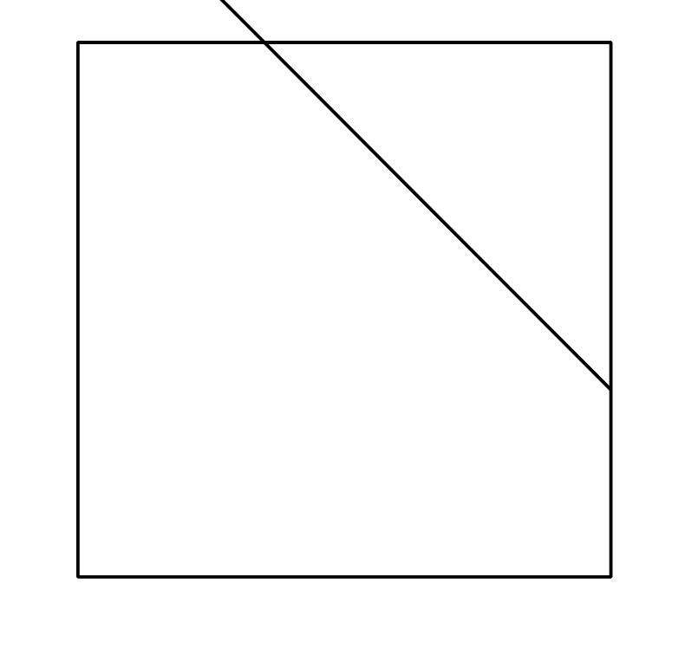

D

14.2: They're Like Terms, Man
Rewrite each expression by combining like terms.
- $11s−2s$
- $5t+3z−2t$
- $23s−(13t+7t)$
- $7t+18r+(2r−5t)$
- $\text{-}4x+6r−(7x+2r)$
- $3(c−5)+2c$
- $8x−3y+(3y−5x)$
- $5x+4y−(5x+7y)$
- $9x−2y−3(3x+y)$
- $6x+12y+2(3x−6y)$

14.3: Finding More Lines
For each system of equations:
- Solve the system of equations by graphing. Write the solution as an ordered pair.
- Write an equation that would represented by a vertical or horizontal line that also passes through the solution of the system of equations.
- Graph your new equation along with the system.
- $\left\{\begin{matrix}\begin{matrix}y=3x+5 \\ y=\text{-}x+1\end{matrix}\end{matrix}\right.$

- The line representing $y=3x+5$ is shown
- $\left\{\begin{matrix}\begin{matrix}y=\frac{1}{3}x−2 \\ y=x−6\end{matrix}\end{matrix}\right.$

- The line representing $y=\frac{1}{3}x−2$ is shown
- 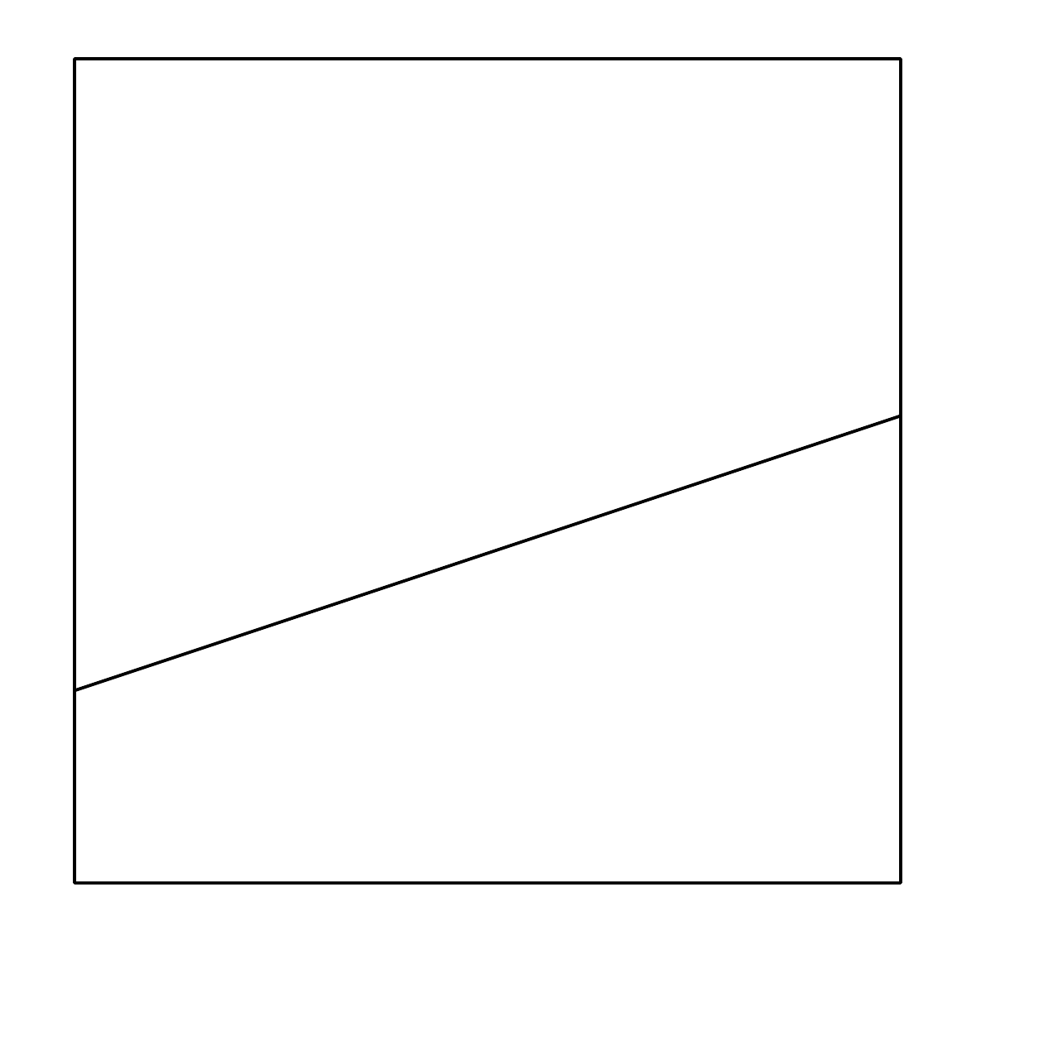
- $\left\{\begin{matrix}\begin{matrix}2x+3y=10 \\ x+y=3\end{matrix}\end{matrix}\right.$

- The line representing $2x+3y=10$ is shown
- 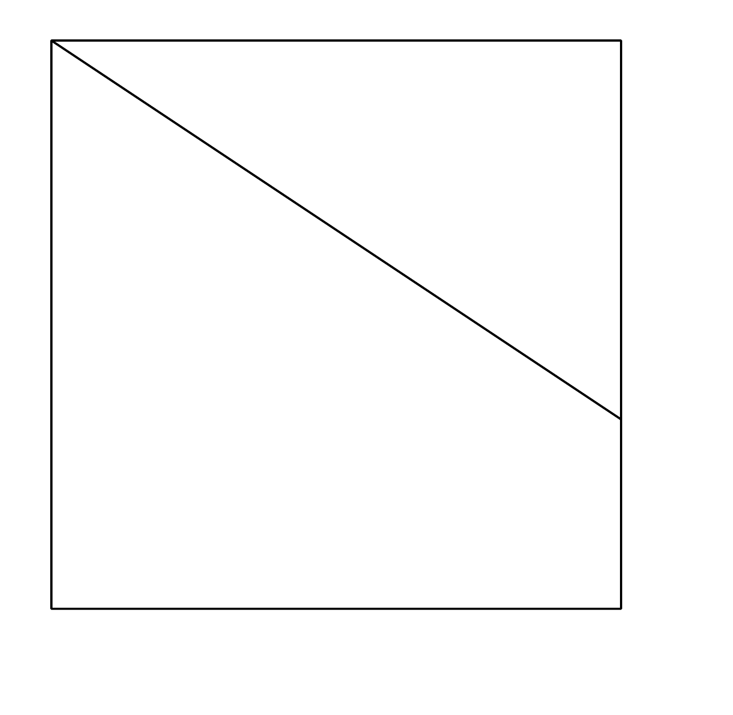
© CC BY 2019 by Illustrative Mathematics®

