Unit 3 Lesson 19: Flexible with Fractions

WU Notice and Wonder: Sticky Notes (Warm up)

Student Task Statement
What do you notice? What do you wonder?
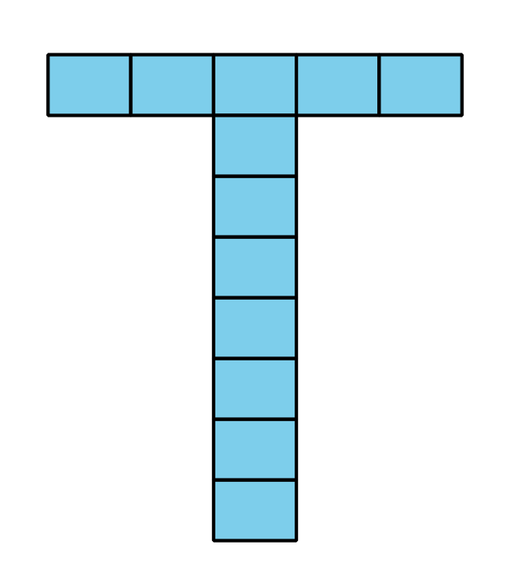
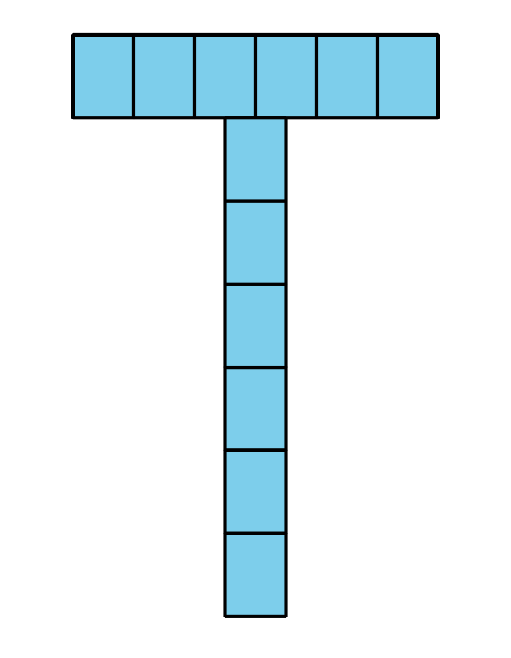
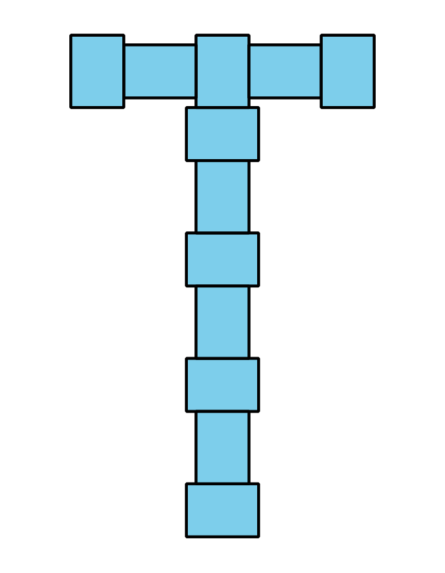

1 Sticky-note Designs

Student Task Statement
Tyler is using small sticky notes to make a T shape to decorate a folder.
The longer side of the sticky note is $\frac{15}{8}$ inches. The shorter side is $\frac{11}{8}$ inches. The folder is 9 inches wide and 12 inches tall.
Here are three ways he could arrange the sticky notes.
Is the folder tall enough and wide enough for his designs? If so, which design(s) would fit? Show your reasoning.

2 Hiking Trails

Student Task Statement
Jada and Noah’s class are hiking at a park. Here is a map of the trails. The length of each trail is shown.
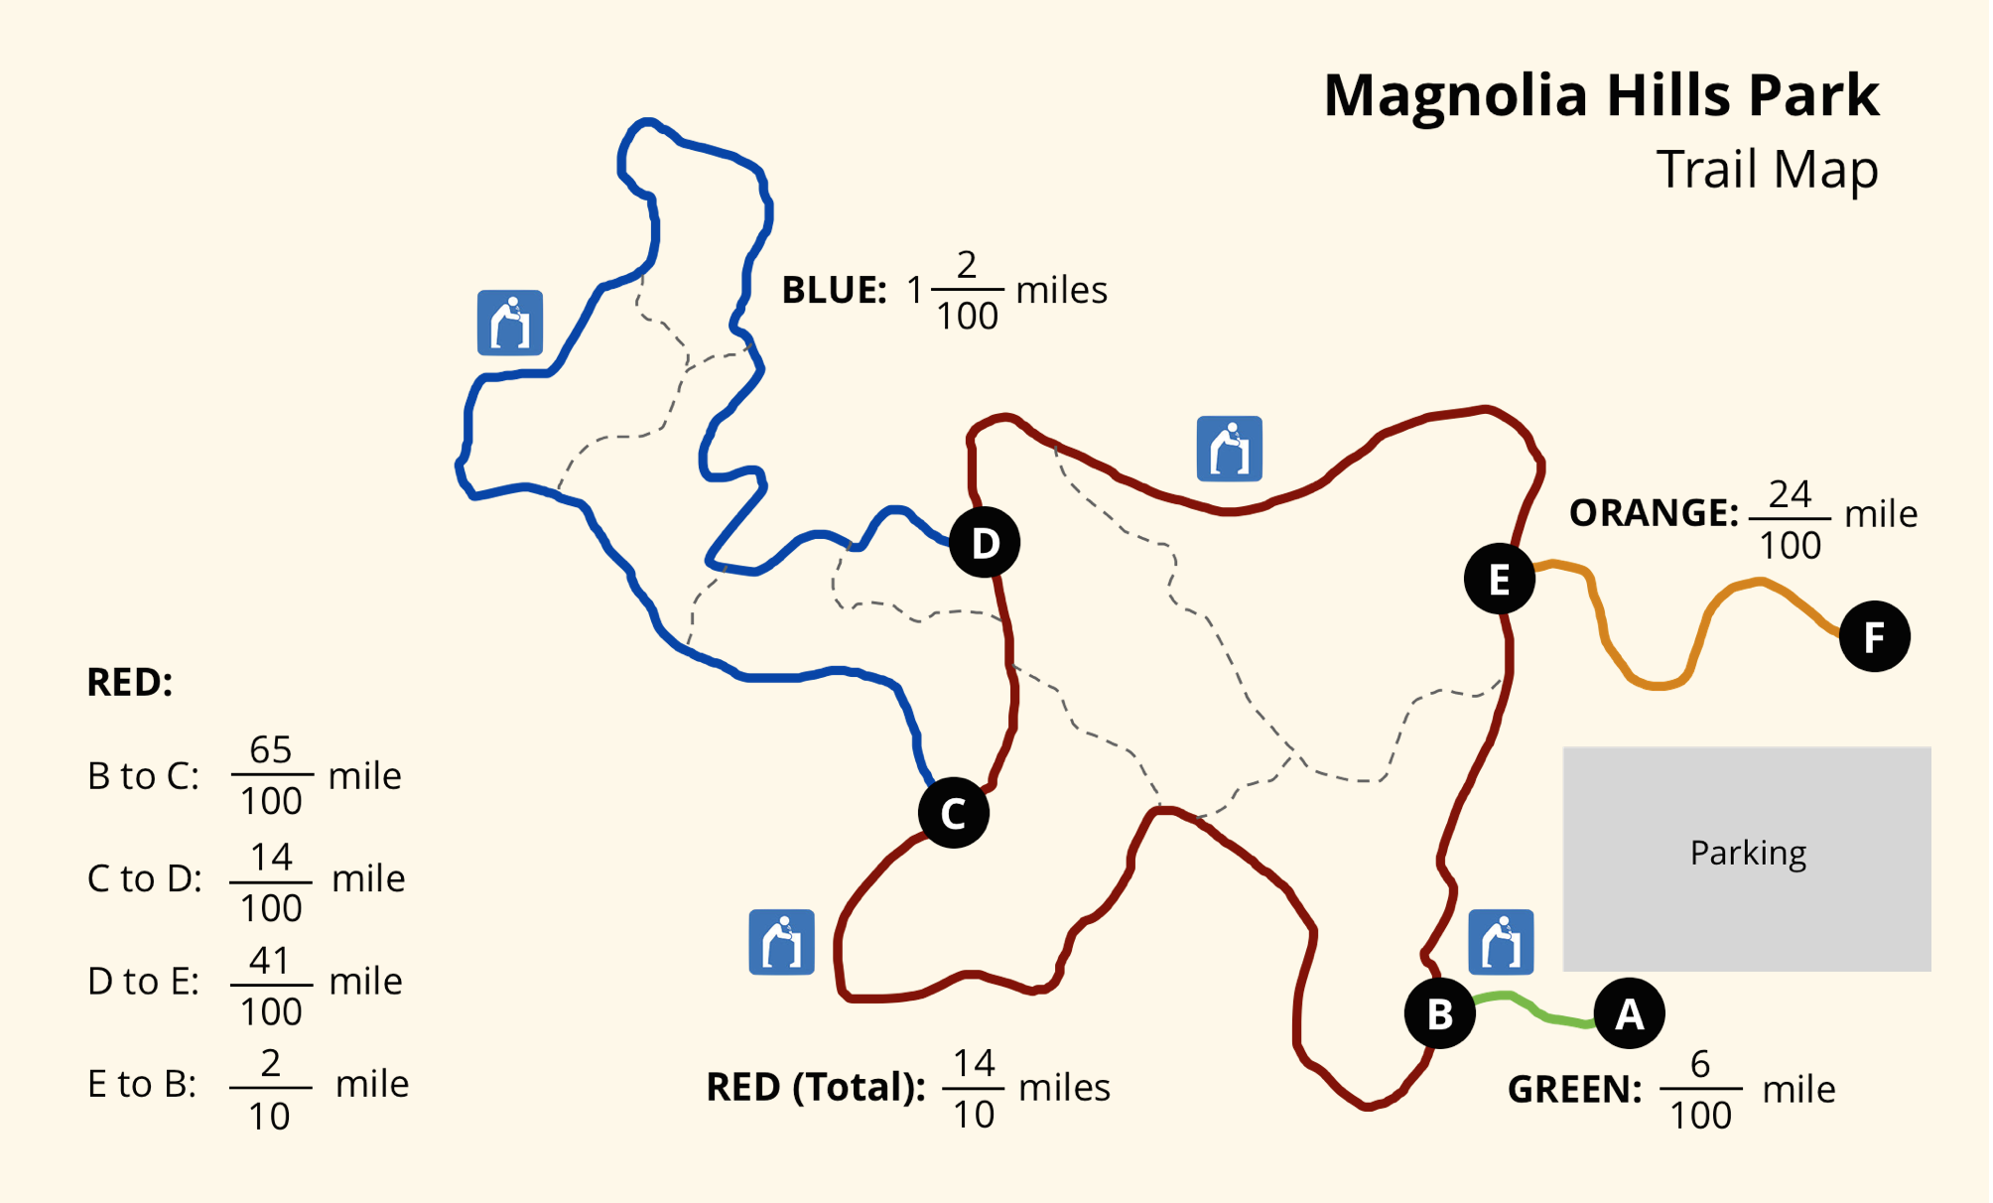
- Jada and Noah hike the orange trail from point F to point E, make one full loop on the red trail back to point E, and then hike from E back to F.
- How many miles do they hike? Show your reasoning.
- Here are two expressions that represent some hiking situations and can help to answer two questions. What question might each expression help to answer? Write the question and the answer.
  - $\frac{6}{100}+\frac{65}{100}+1\frac{2}{100}+\frac{41}{100}+\frac{24}{100}$
  - $\left(2×\frac{14}{10}\right)+\left(2×\frac{6}{100}\right)$
- Use the distances on the map to write a new question and find its answer. Then, trade questions with a partner and answer one another's question.

3 Find a Match

Student Task Statement
Your teacher will give you one card with an expression on it.
- Find the value of the expression.
- Find a classmate whose card also has the same value. Prove to each other that you’re a match.
- Work with your partner to find at least two features that your expressions share (other than the fact that they have the same value.)
- Write one more expression that has the same value but uses a different operation.
© CC BY 2021 Illustrative Mathematics®

