Lesson 11: Using an Algorithm to Divide Fractions

11.1: Multiplying Fractions
Evaluate each expression.
- $\frac{2}{3}⋅27$
- $\frac{1}{2}⋅\frac{2}{3}$
- $\frac{2}{9}⋅\frac{3}{5}$
- $\frac{27}{100}⋅\frac{200}{9}$
- $\left(1\frac{3}{4}\right)⋅\frac{5}{7}$

11.2: Dividing a Fraction by a Fraction
Work with a partner. One person works on the questions labeled “Partner A” and the other person works on those labeled “Partner B.”
- Partner A: Find the value of each expression by completing the diagram.

  - $\frac{3}{4}÷\frac{1}{8}$
  - How many $\frac{1}{8}$s in $\frac{3}{4}$?
  - 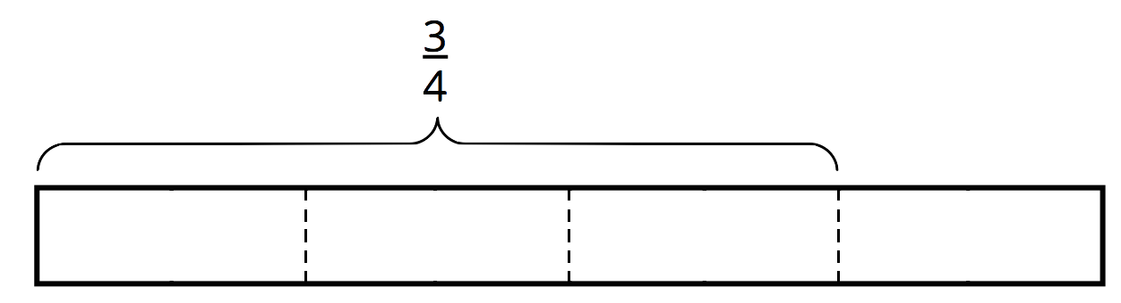

  - $\frac{9}{10}÷\frac{3}{5}$
  - How many $\frac{3}{5}$s in $\frac{9}{10}$?
  - 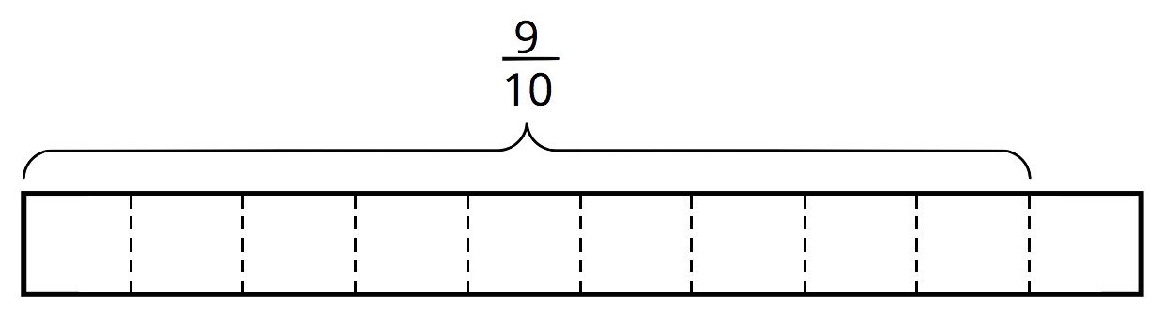
- Partner B:
- Elena said, “If I want to divide 4 by $\frac{2}{5}$, I can multiply 4 by 5 and then divide it by 2 or multiply it by $\frac{1}{2}$.”
- Find the value of each expression using the strategy Elena described.
  - $\frac{3}{4}÷\frac{1}{8}$
  - $\frac{9}{10}÷\frac{3}{5}$
- What do you notice about the diagrams and expressions? Discuss with your partner.
- Complete this sentence based on what you noticed:
- To divide a number $n$ by a fraction $\frac{a}{b}$, we can multiply $n$ by ________ and then divide the product by ________.
- Select all the equations that represent the sentence you completed.
  - $n÷\frac{a}{b}=n⋅b÷a$
  - $n÷\frac{a}{b}=n⋅a÷b$
  - $n÷\frac{a}{b}=n⋅\frac{a}{b}$
  - $n÷\frac{a}{b}=n⋅\frac{b}{a}$

11.3: Using an Algorithm to Divide Fractions
Calculate each quotient. Show your thinking and be prepared to explain your reasoning.
- $\frac{8}{9}÷4$
- $\frac{3}{4}÷\frac{1}{2}$
- $3\frac{1}{3}÷\frac{2}{9}$
- $\frac{9}{2}÷\frac{3}{8}$
- $6\frac{2}{5}÷3$
- After biking $5\frac{1}{2}$ miles, Jada has traveled $\frac{2}{3}$ of the length of her trip. How long (in miles) is the entire length of her trip? Write an equation to represent the situation, and then find the answer.

Are you ready for more?
Suppose you have a pint of grape juice and a pint of milk. You pour 1 tablespoon of the grape juice into the milk and mix it up. Then you pour 1 tablespoon of this mixture back into the grape juice. Which liquid is more contaminated?

Lesson 11 Summary
The division $a÷\frac{3}{4}=?$ is equivalent to $\frac{3}{4}⋅?=a$, so we can think of it as meaning “$\frac{3}{4}$ of what number is $a$?” and represent it with a diagram as shown. The length of the entire diagram represents the unknown number.
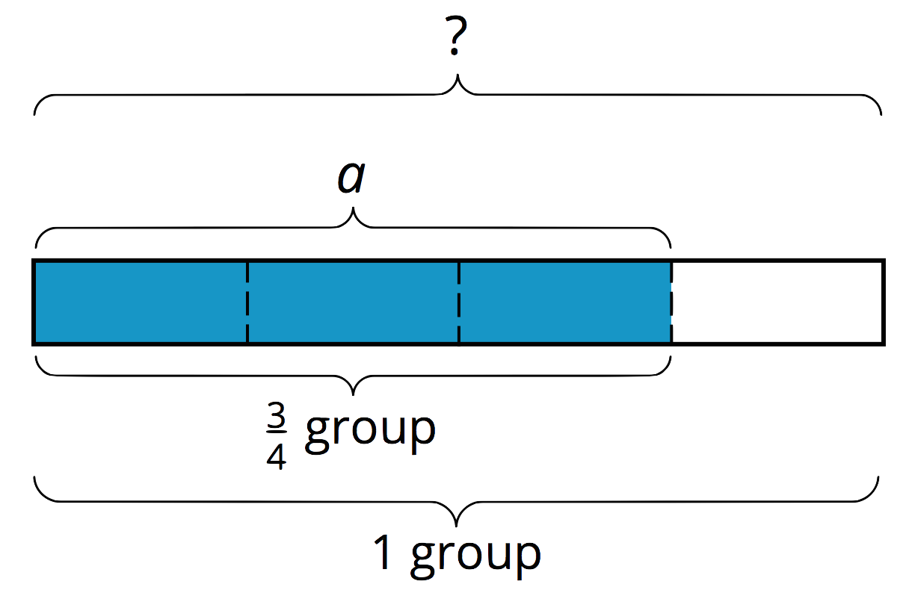
If $\frac{3}{4}$ of a number is $a$, then to find the number, we can first divide $a$ by 3 to find $\frac{1}{4}$ of the number. Then we multiply the result by 4 to find the number.
The steps above can be written as: $a÷3⋅4$. Dividing by 3 is the same as multiplying by $\frac{1}{3}$, so we can also write the steps as: $a⋅\frac{1}{3}⋅4$.
In other words: $a÷3⋅4=a⋅\frac{1}{3}⋅4$. And $a⋅\frac{1}{3}⋅4=a⋅\frac{4}{3}$, so we can say that: $a÷\frac{3}{4}=a⋅\frac{4}{3}$
In general, dividing a number by a fraction $\frac{c}{d}$ is the same as multiplying the number by $\frac{d}{c}$, which is the reciprocal of the fraction.
© CC BY Open Up Resources. Adaptations CC BY IM.

