Unit 8 Lesson 1: The Areas of Squares and Their Side Lengths

1 Two Regions (Warm up)

Student Task Statement
Which shaded region is larger? Explain your reasoning.
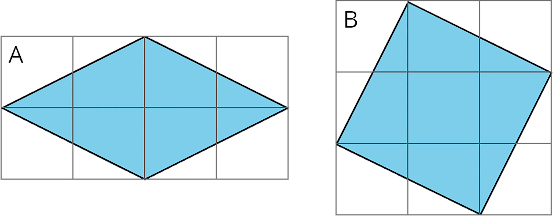

2 Decomposing to Find Area

Student Task Statement
Find the area of each shaded square (in square units).
- 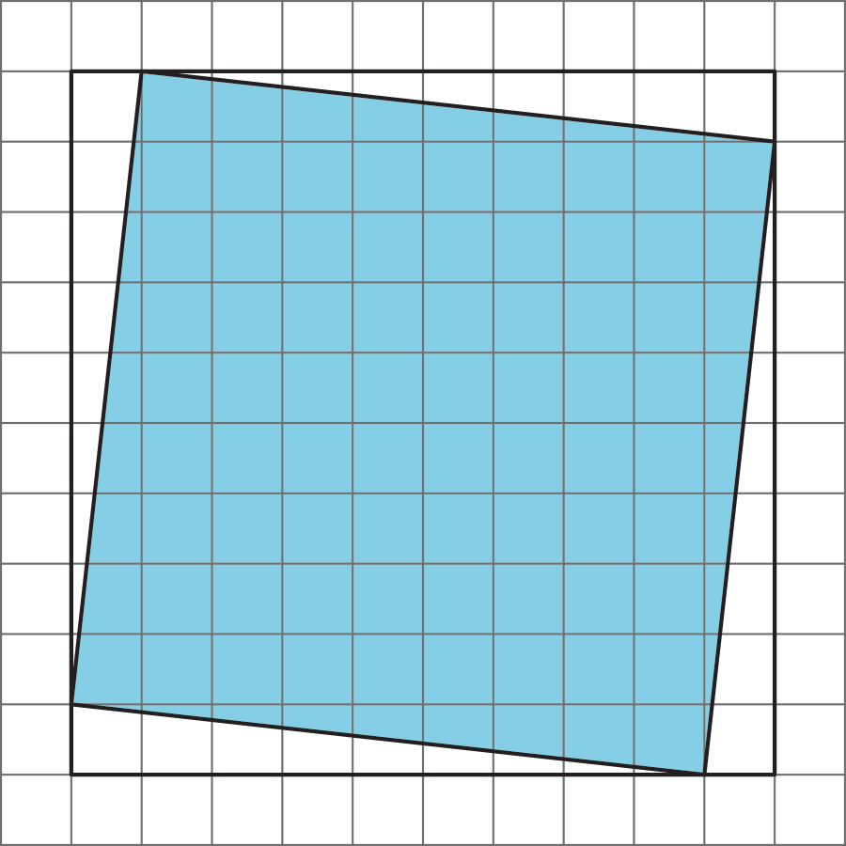
- 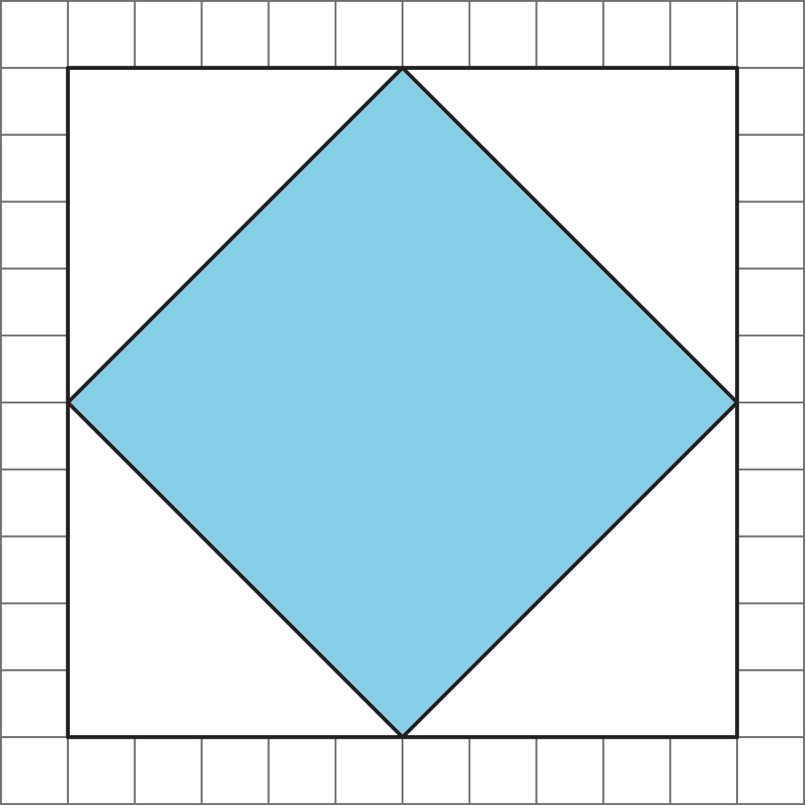
- 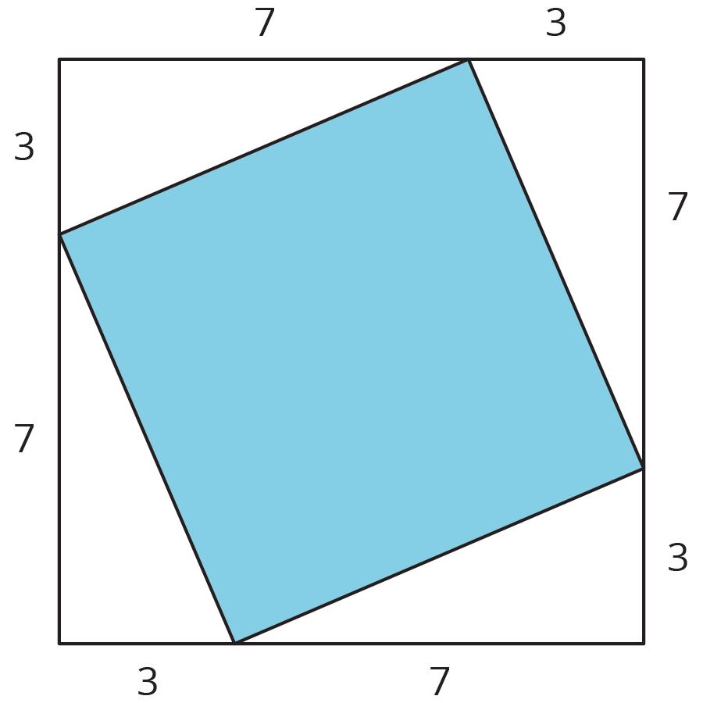

3 Estimating Side Lengths from Areas

Student Task Statement
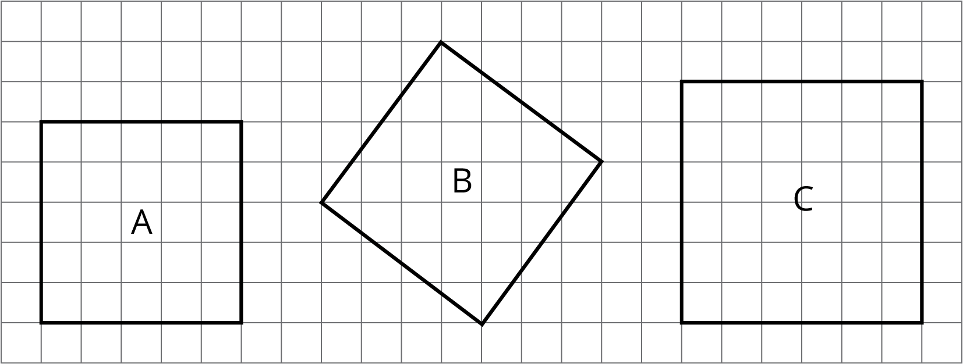
- What is the side length of square A? What is its area?
- What is the side length of square C? What is its area?
- What is the area of square B? What is its side length? (Use tracing paper to check your answer to this.)
- Find the areas of squares D, E, and F. Which of these squares must have a side length that is greater than 5 but less than 6? Explain how you know.
- 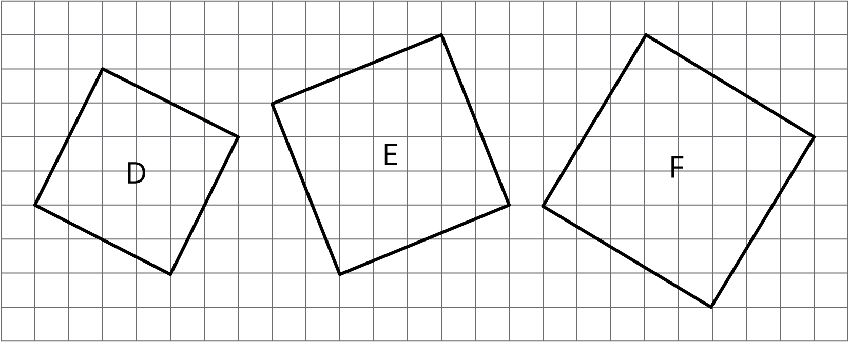

4 Making Squares (Optional)

Images for Launch
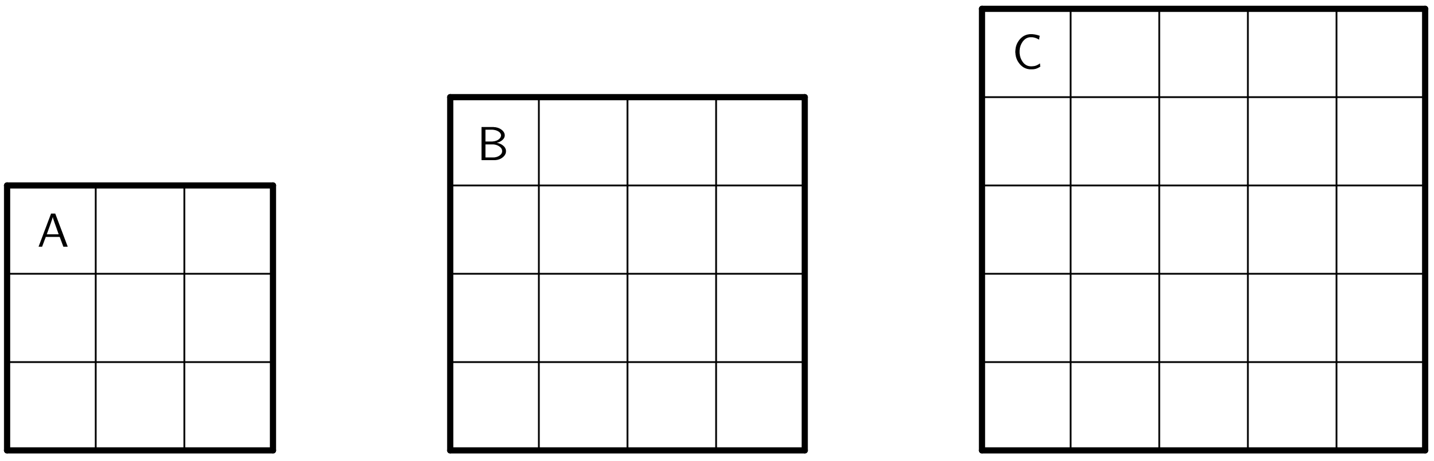

Student Task Statement
Your teacher will give your group a sheet with three squares and 5 cut out shapes labeled D, E, F, G, and H. Use the squares to find the total area of the five shapes. Assume each small square is equal to 1 square unit.
© CC BY Open Up Resources. Adaptations CC BY IM.

