Lesson 12: Connect Quantities and Numbers
- Let’s figure out which groups of objects go with which numbers.

Warm-up: How Many Do You See: Image Flash
How many do you see?
How do you see them?
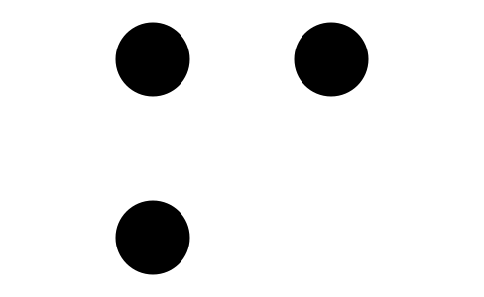
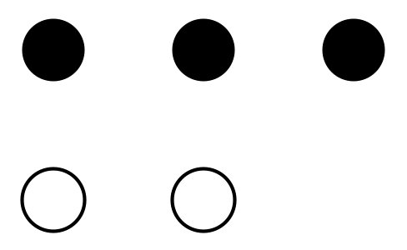

12.2: Counting Stations
number of objects | bag name
1
2
3
4
5
6
7
8
9
10

12.3: Revisit Number Race, Numbers 1–10
Choose a center.
Number Race
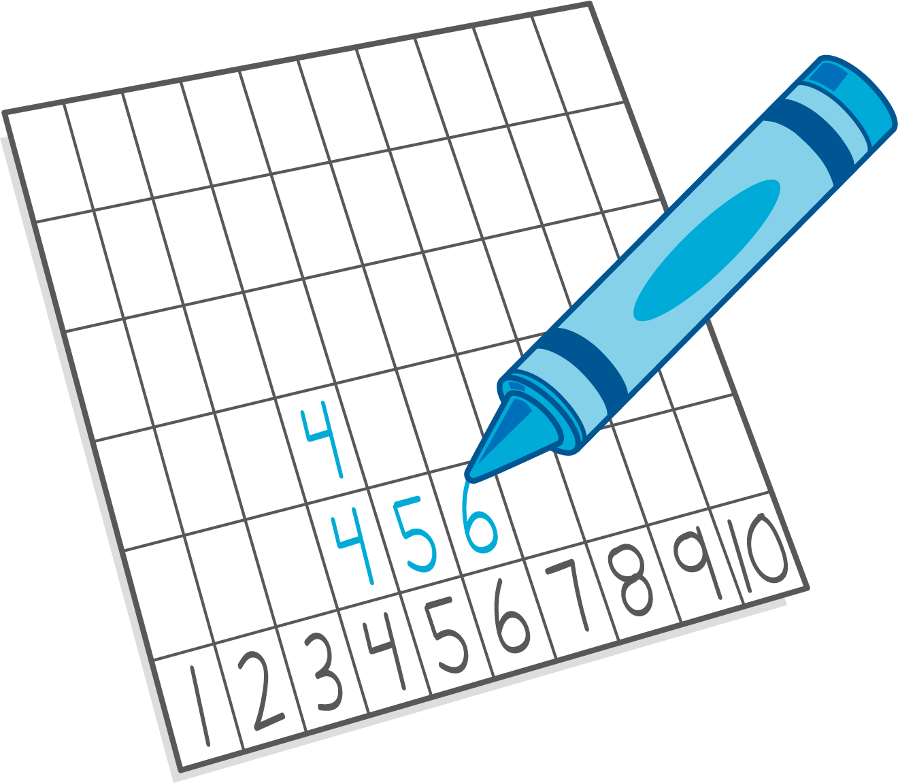
Geoblocks
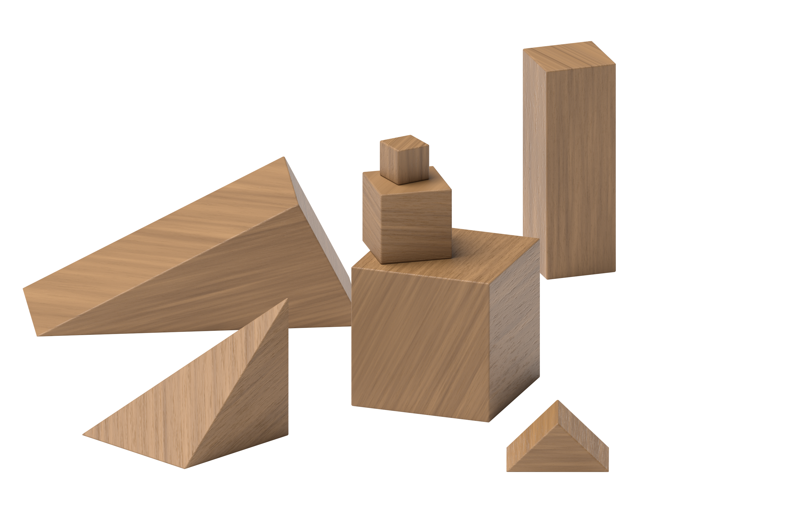
Math Fingers
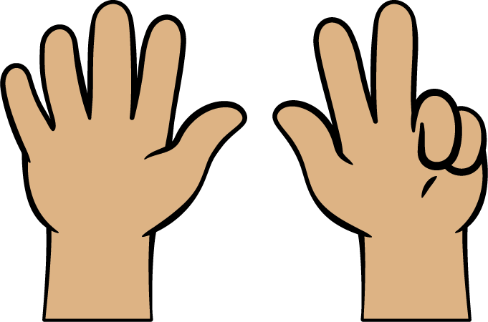
© CC BY 2021 Illustrative Mathematics®

