## Unit 6 Lesson 6: Fingers and 10-frames

### WU How Many Do You See: 5 and Some More (Warm up)

#### Student Task Statement

How many do you see?  
How do you see them?









### 1 Lots of Fingers

#### Student Task Statement

### 2 Fingers to 10-frames

#### Student Task Statement

|  |
| --- |
| Fingers showing 5. |
| Fingers showing 2. |
| Fingers showing 7. |
| Fingers showing 4. |

#### Activity Synthesis

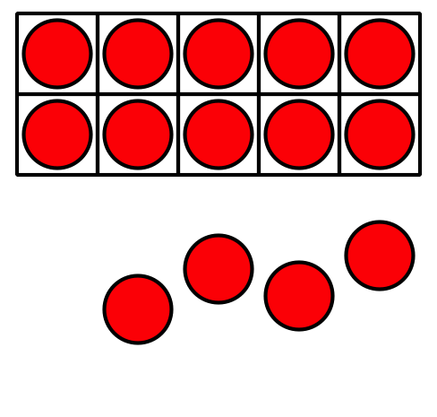

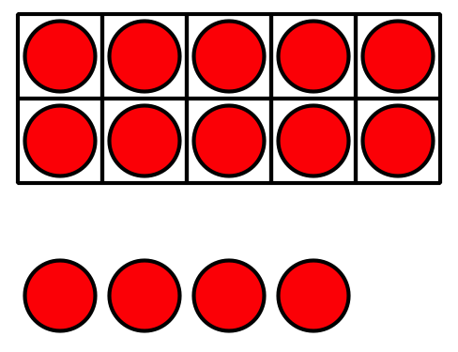

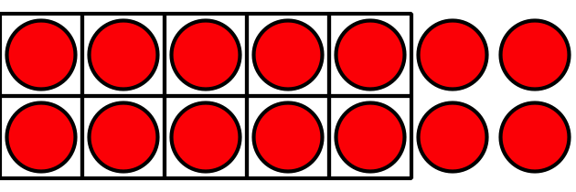

### 3 Revisit Number Race, Numbers 11–20

#### Student Task Statement

Choose a center.

Number Race

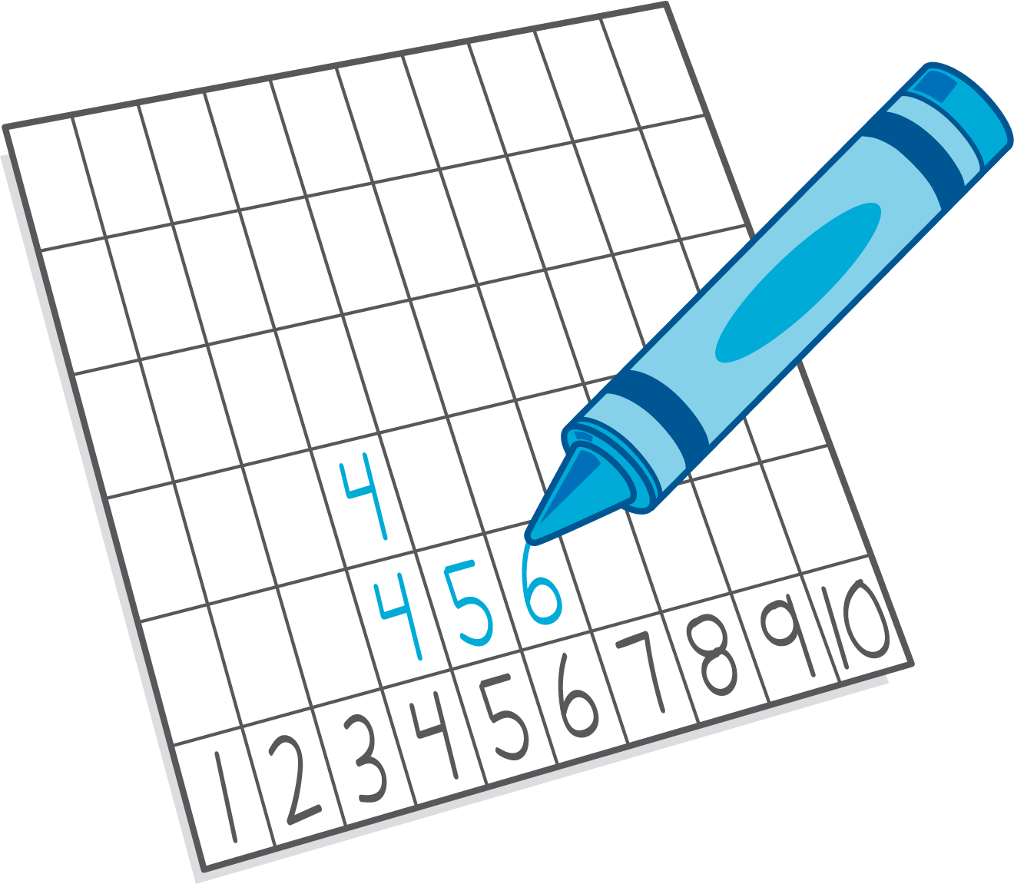

Grab and Count



Find the Pair

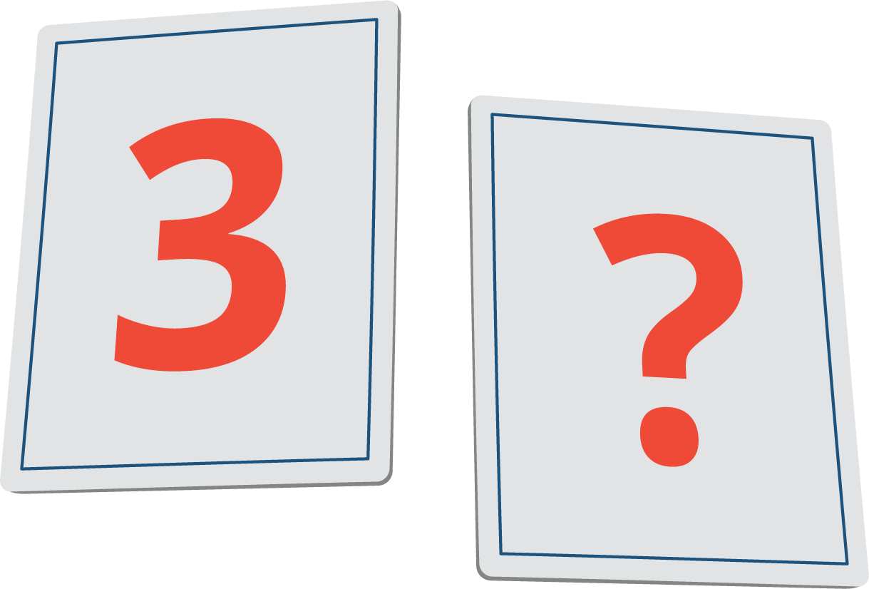

Tower Build

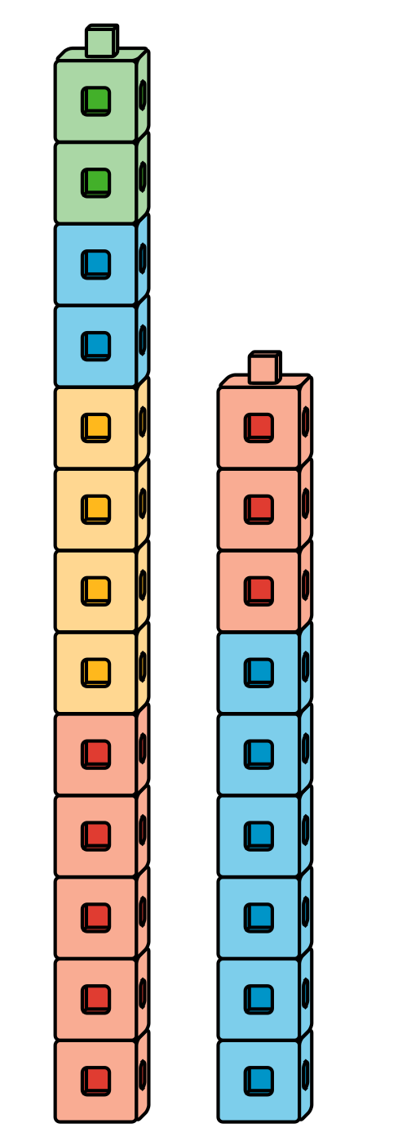



© CC BY 2021 Illustrative Mathematics®