Unit 7 Lesson 5: Normal Distributions

1 Body Temperature (Warm up)

Student Task Statement
Each histogram represents a group of 500 healthy people who had their temperature taken. Three histograms represent examples of data that approximate a normal distribution and three histograms represent non-examples, or data that do not approximate a normal distribution. What do you think the elements are of a definition of normal distribution?
Examples:
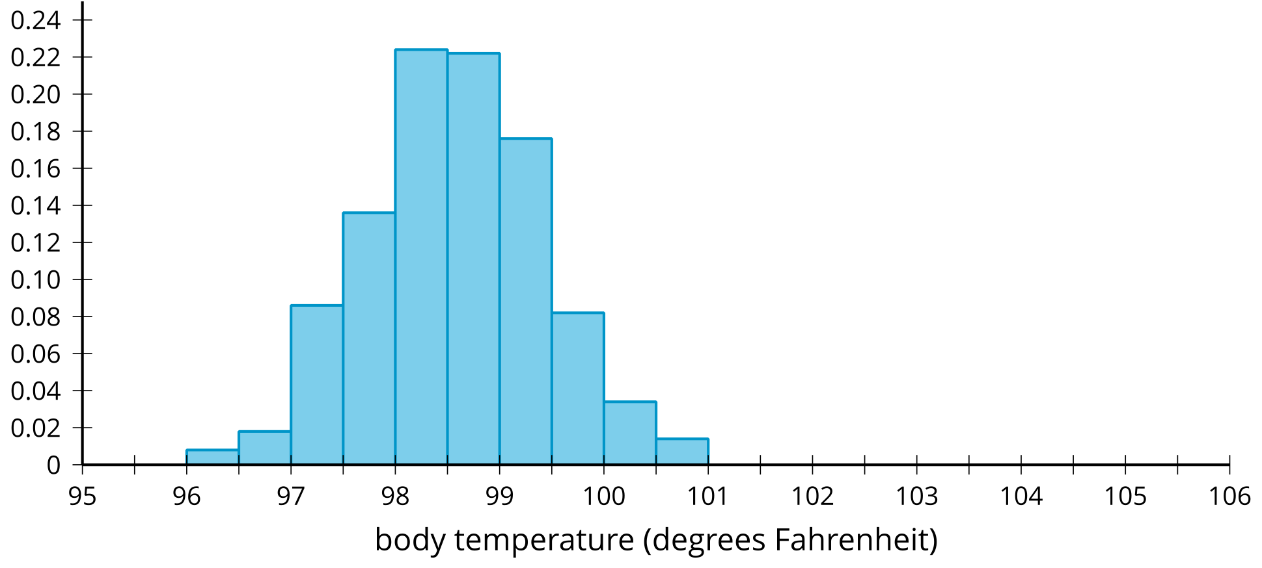
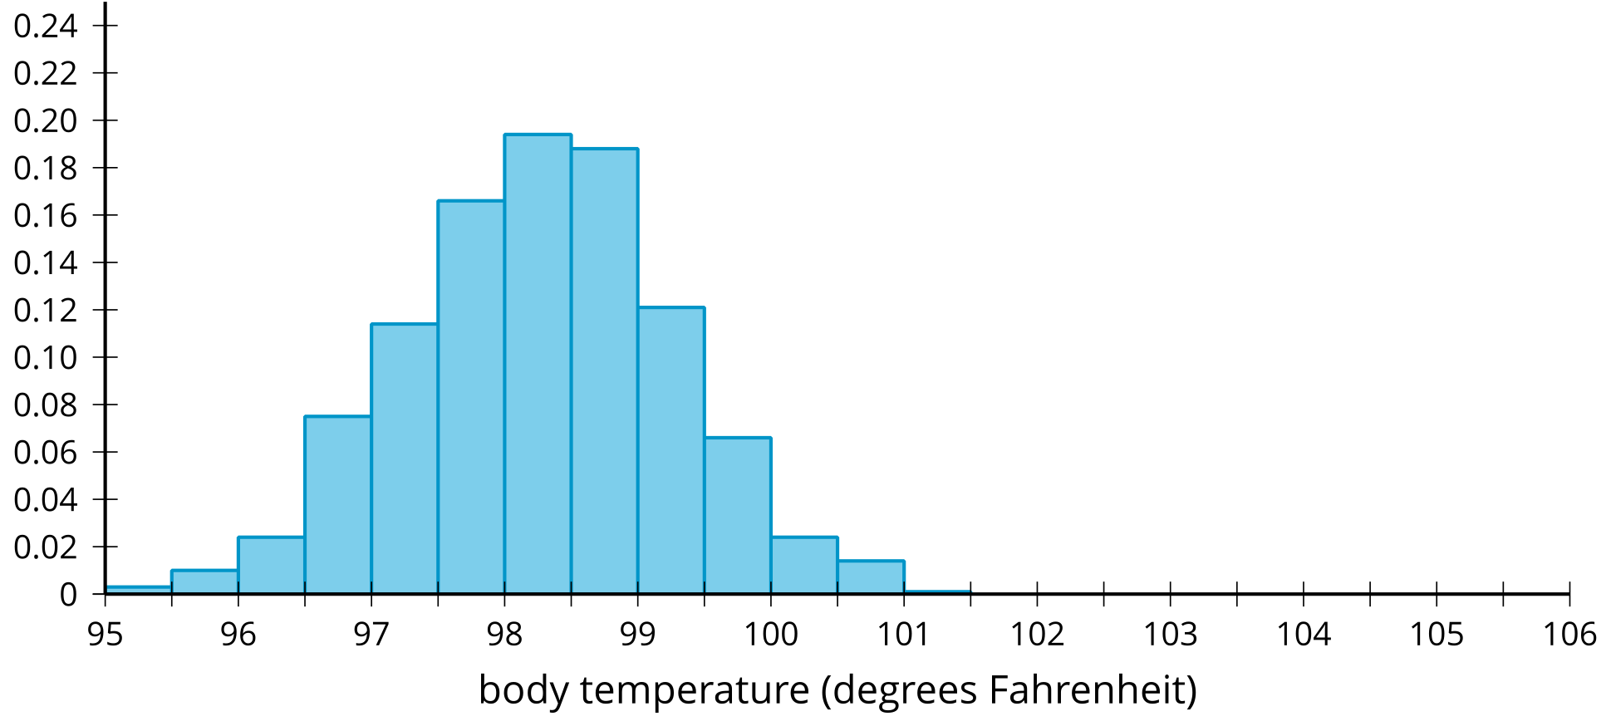
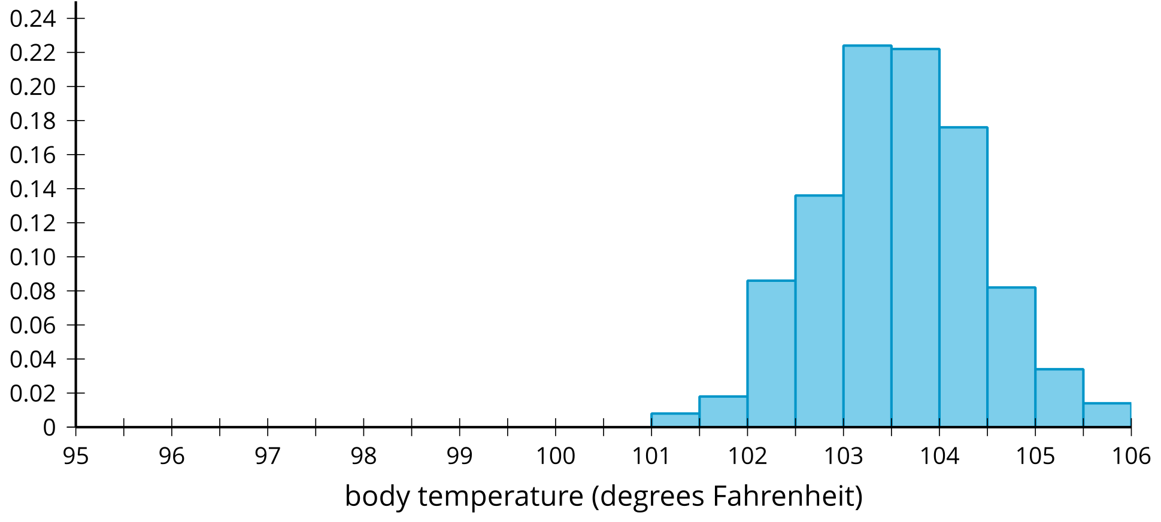
Non-examples:
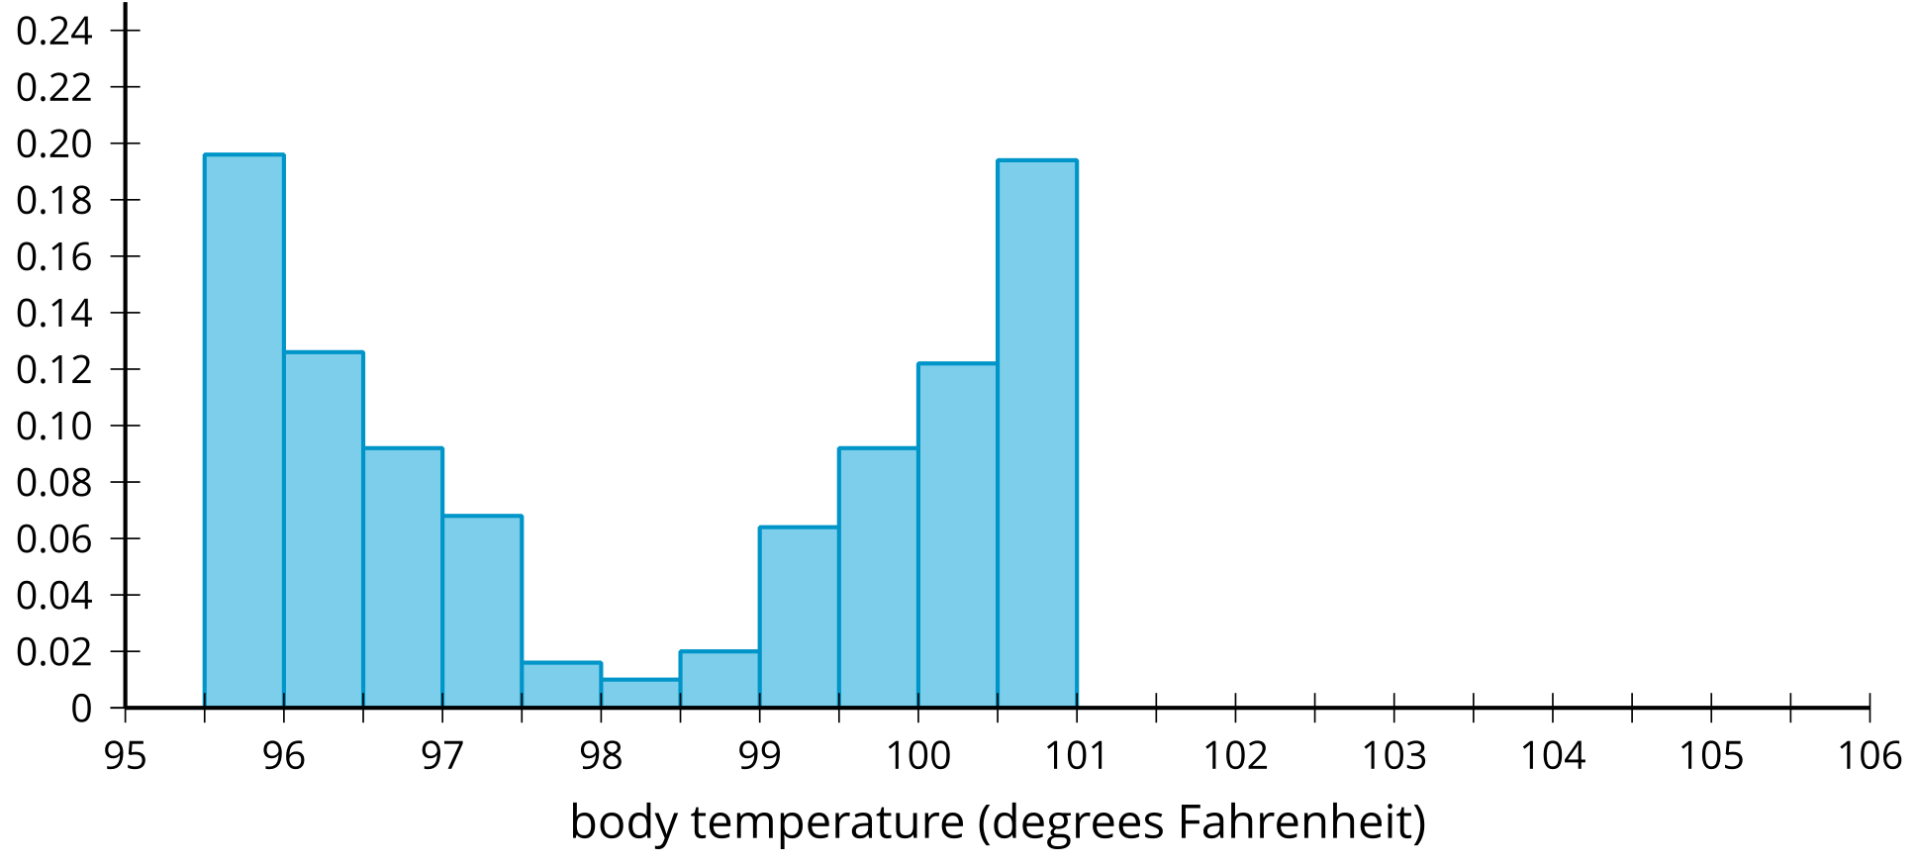
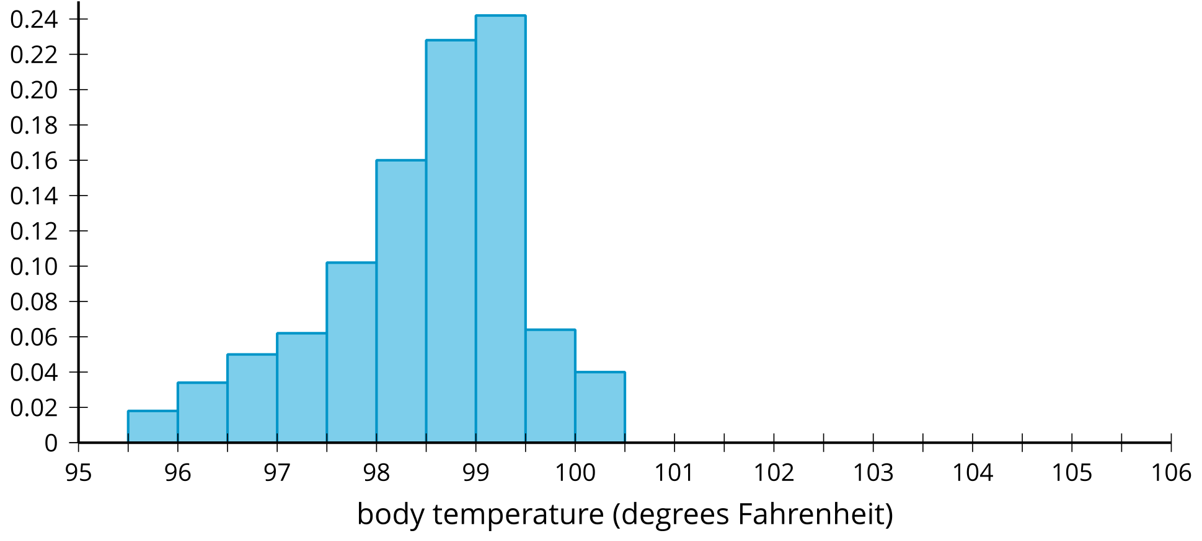
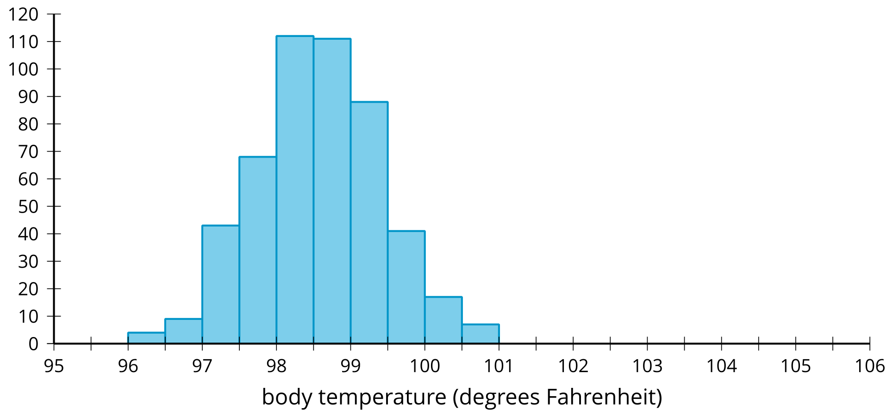

Activity Synthesis
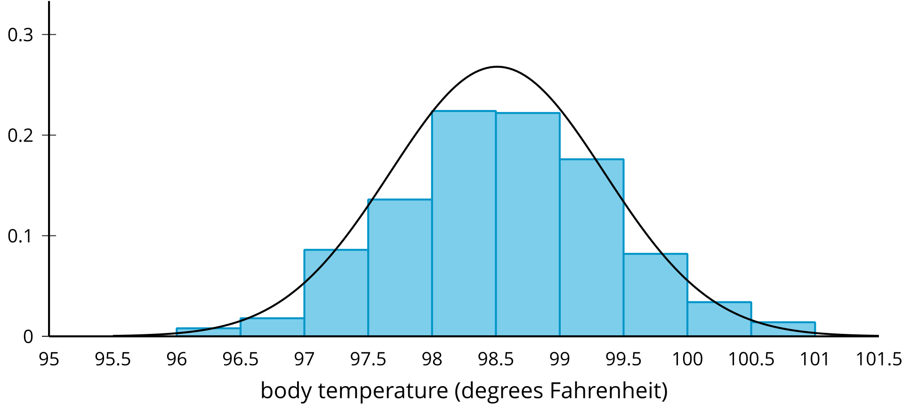
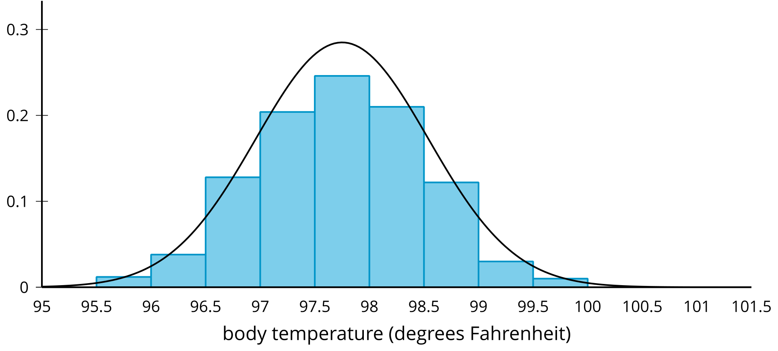

2 Playing a Piano

Student Task Statement
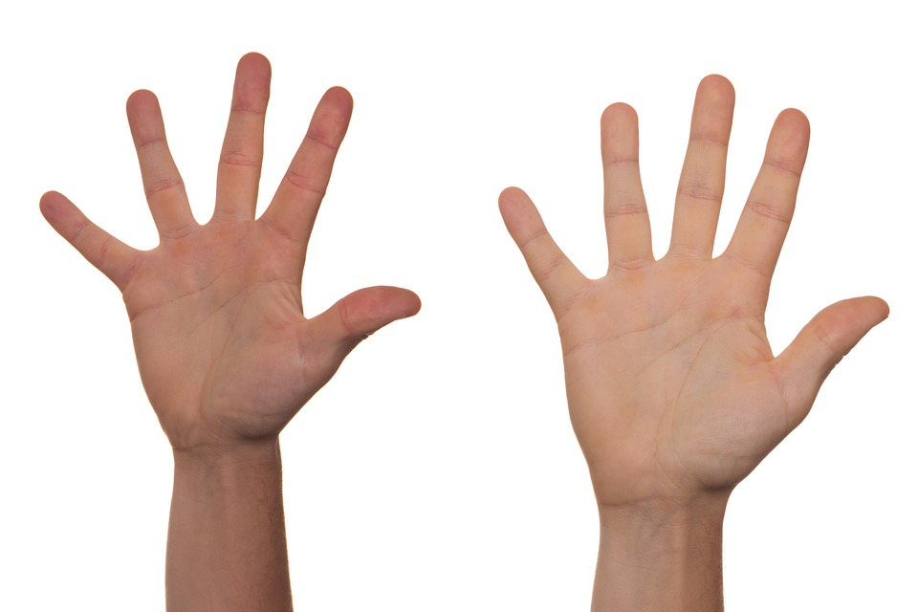
On many piano keyboards, the distance from one white key to the next is 2.39 centimeters. How many of your classmates could reach two notes that are 9 keys apart (21.5 cm) on a keyboard using only one hand?
- Stretch your fingers apart as wide as you can and measure the farthest distance from your thumb to smallest finger. Round your measurement to the nearest tenth of a centimeter.
- Your teacher will collect the measurements from the class. Draw a dot plot or histogram from the class data.
- 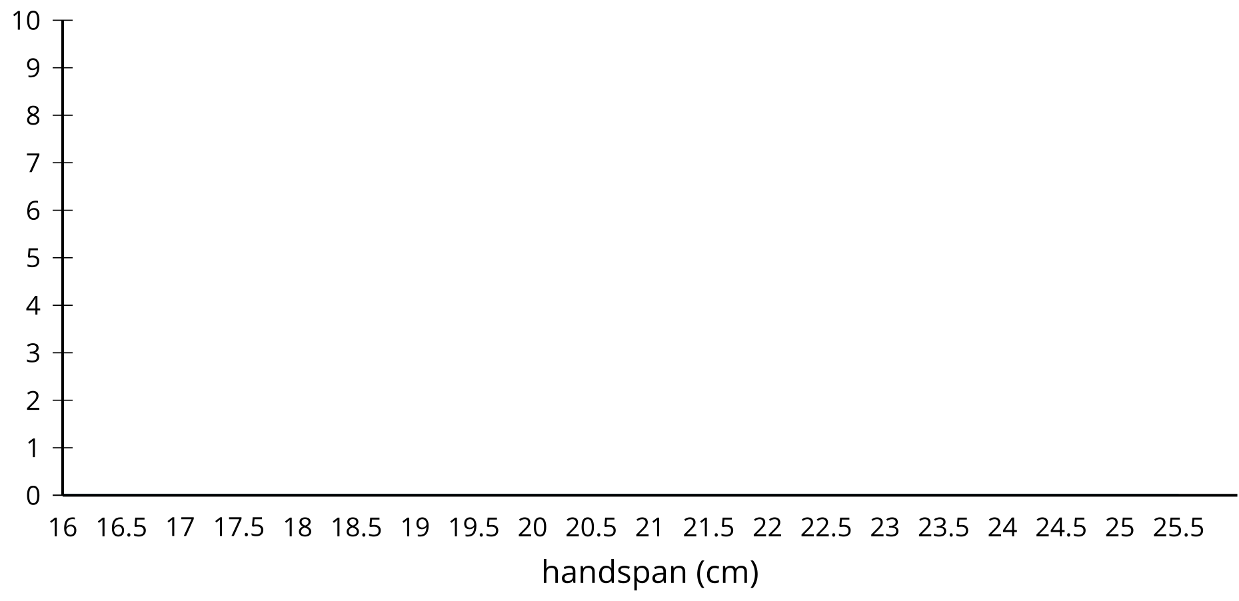
- Describe the distribution you drew using terms such as: symmetric, approximately symmetric, skewed left, skewed right, approximately uniform, uniform, bell-shaped, or bimodal. Estimate the center of your distribution.
- How would you use your distribution to determine how many people in the class can reach the two notes 9 keys apart?

3 Relative Frequency Distribution

Student Task Statement
Manufacturers of butter make sticks of butter that weigh 110 grams on average. A manufacturer suspects the machine that forms the sticks of butter may have a problem, so they weigh each stick of butter the machine produces in an hour.
The weights are grouped into intervals of 0.5 grams and are summarized in a frequency table.
weight (grams) | frequency | relative frequency
107–107.5 | 5
107.5–108 | 17
108–108.5 | 52
108.5–109 | 118
109–109.5 | 172
109.5–110 | 232
110–110.5 | 219
110.5–111 | 172
111–111.5 | 95
111.5–112 | 57
112–112.5 | 23
112.5–113 | 8
113–113.5 | 1
total | 1,171
The same data are summarized in this histogram.
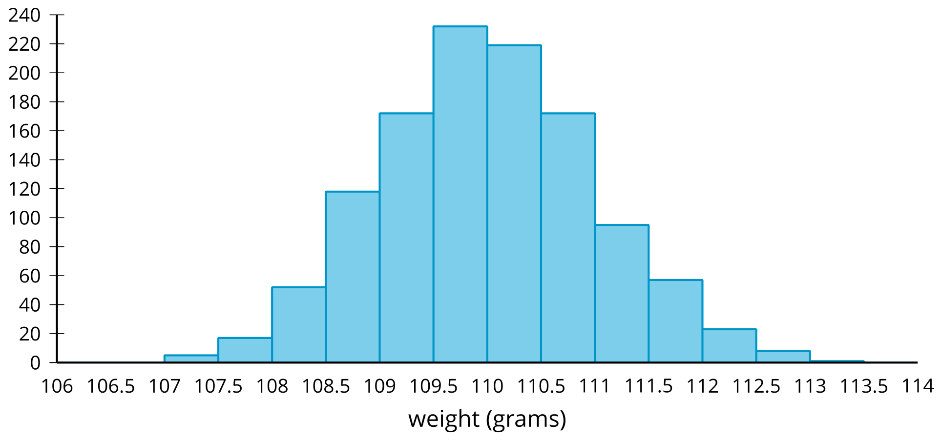
​​​​​
Although this information is useful, it might be more helpful to know the proportion of sticks of butter in each weight interval rather than the actual number of sticks in that weight interval.
- Complete the table by dividing each frequency value by the total number of sticks of butter in the data set. Round each value to 4 decimal places.
- A relative frequency histogram is a histogram in which the height of each bar is the relative frequency. Since the heights of the bars are found by dividing each height by the total number of sticks of butter, the shape of the distribution is the same as a regular histogram, but the labels on the $y$-axis are changed. Label the $y$-axis with the correct values for each mark.
- 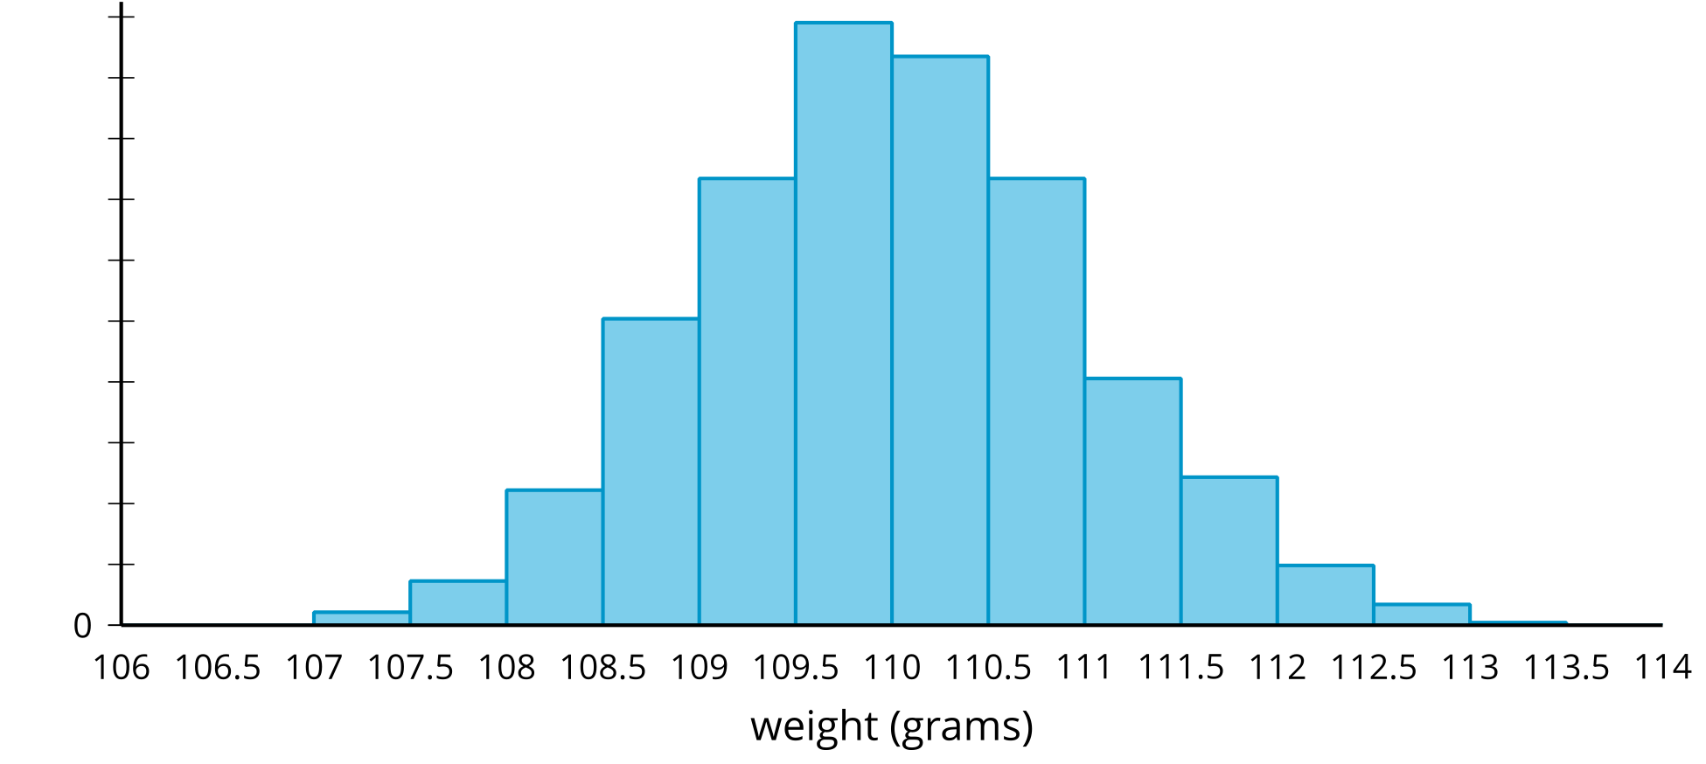
- The manufacturer believes they should replace the machine if more than 25% of the sticks of butter are more than 1 gram away from the intended value of 110 grams.
  - Indicate on the relative frequency histogram the bars that correspond to sticks of butter that are more than 1 gram away from the intended weight of a stick of butter.
  - Should this machine be replaced? Explain or show your reasoning.

4 The Normal Curve

Student Task Statement
These curves represent normal distributions with different means and standard deviations. What do you notice?

mean = 10. standard deviation = 1
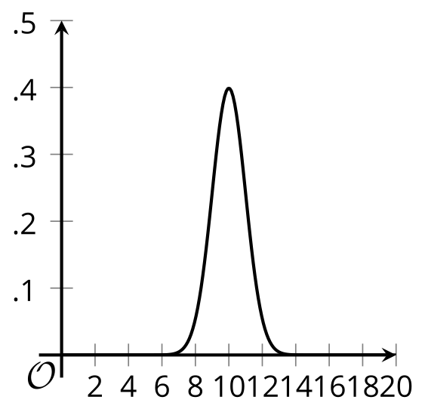

mean = 10. standard deviation = 2
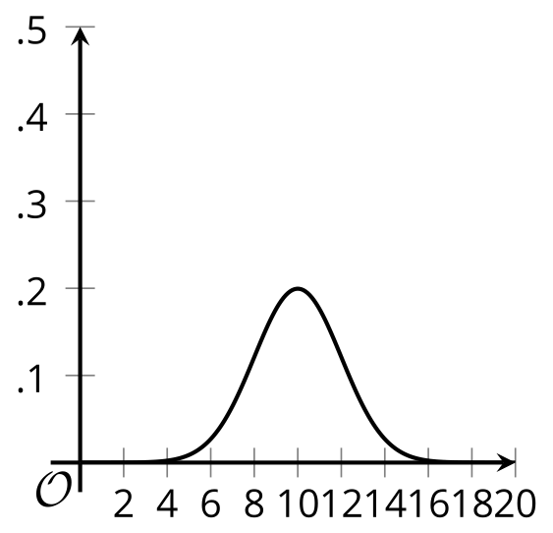

mean = 8. standard deviation = 2
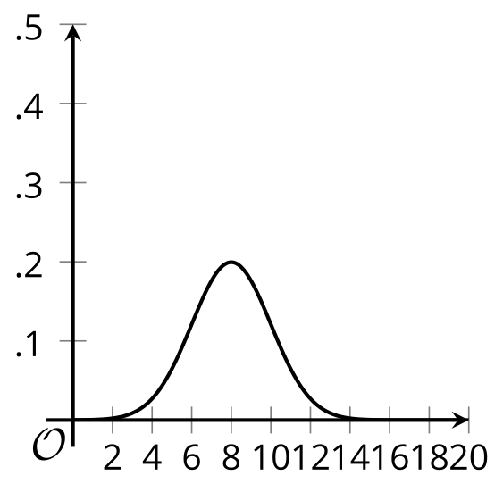

mean = 12. standard deviation = 1
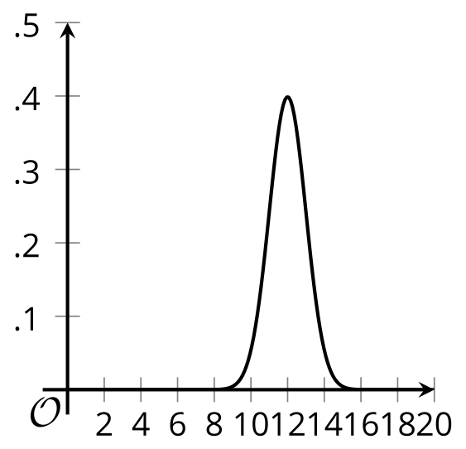

mean = 10. standard deviation = 0.8
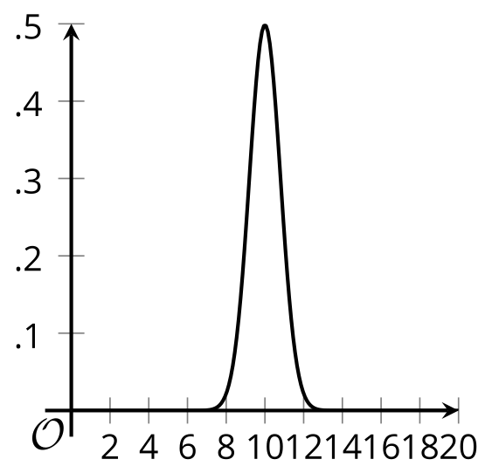
© CC BY 2019 by Illustrative Mathematics®

