Lesson 3: Creating Cross Sections by Dilating
- Let’s create cross sections by doing dilations.

3.1: Dilating, Again
Dilate triangle $BCD$ using center $P$ and a scale factor of 2.
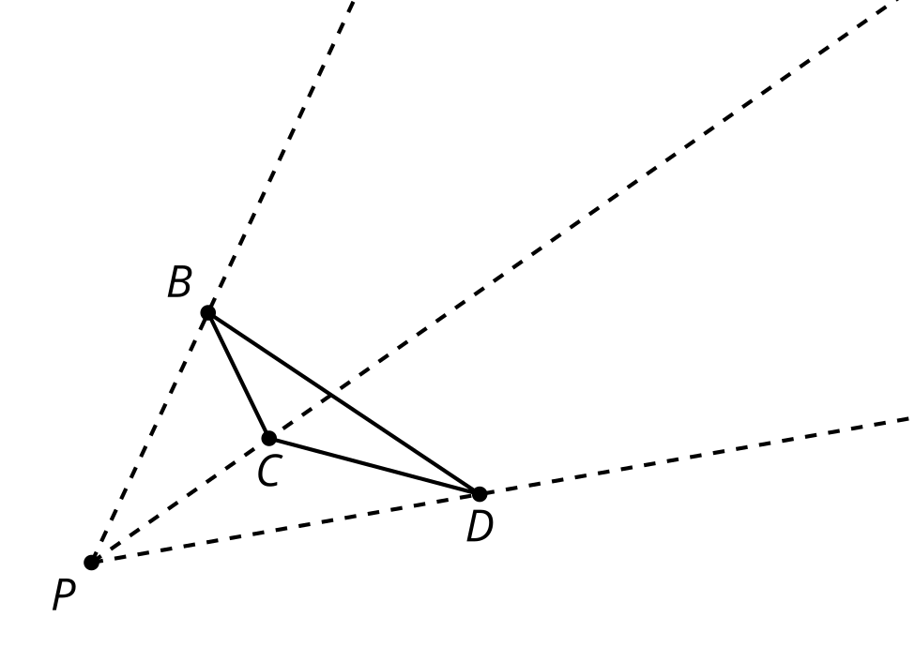
Look at your drawing. What do you notice? What do you wonder?

3.2: Pyramid Mobile
Your teacher will give you sheets of paper. Each student in the group should take one sheet of paper and complete these steps:
- Locate and mark the center of your sheet of paper by drawing diagonals or another method.
- Each student should choose one scale factor from the table. On your paper, draw a dilation of the entire sheet of paper, using the center you marked as the center of dilation.
- Measure the length and width of your dilated rectangle and calculate its area. Record the data in the table.
- Cut out your dilated rectangle and make a small hole in the center.
scale factor, $k$ | length of scaled rectangle | width of scaled rectangle | area of scaled rectangle
$k=0.25$
$k=0.5$
$k=0.75$
$k=1$
Now the group as a whole should complete the remaining steps:
- Cut 1 long piece of string (more than 30 centimeters) and 4 shorter pieces of string. Make 4 marks on the long piece of string an equal distance apart.
- Thread the long piece of string through the hole in the largest rectangle. Tie a shorter piece of string beneath it where you made the first mark on the string. This will hold up the rectangle.
- Thread the remaining pieces of paper onto the string from largest to smallest, tying a short piece of string beneath each one at the marks you made.
- Hold up the end of the string to make your cross sections resemble a pyramid. As a group, you may have to steady the cross sections for the pyramid to clearly appear.

Are you ready for more?
Is dilating a square using a factor of 0.9, then dilating the image using scale factor 0.9 the same as dilating the original square using a factor of 0.8? Explain or show your reasoning.

Lesson 3 Summary
Imagine a triangle lying flat on your desk, and a point $P$ directly above the triangle. If we dilate the triangle using center $P$ and scale factor $k=\frac{1}{2}$ or 0.5, together the triangles resemble cross sections of a pyramid.
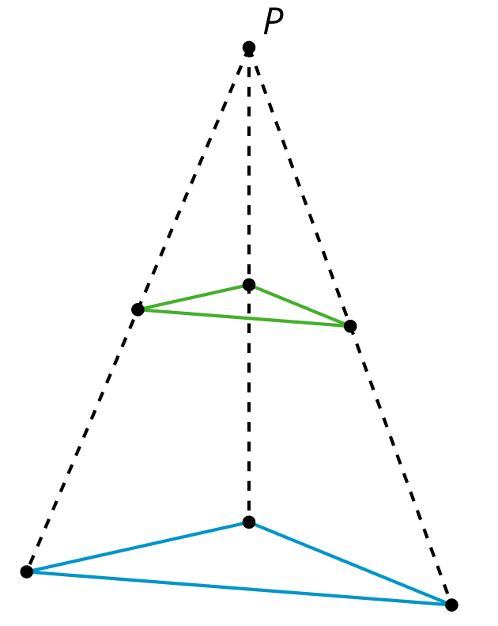
We can add in more cross sections. This image includes two more cross sections, one with scale factor $k=0.25$ and one with scale factor $k=0.75$. The triangle with scale factor $k=1$ is the base of the pyramid, and if we dilate with scale factor $k=0$ we get a single point at the very top of the pyramid.
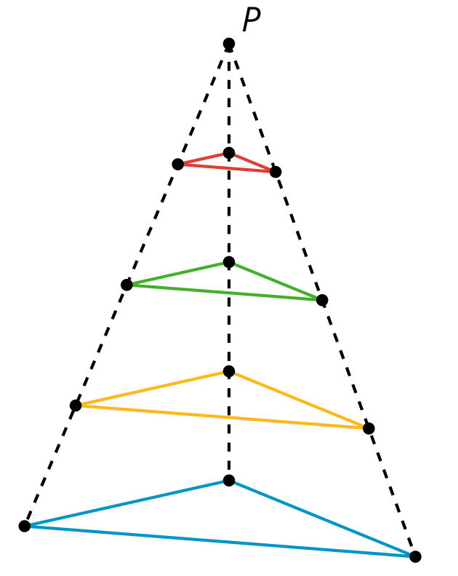
Each triangle’s side lengths are a factor of $k$ times the corresponding side length in the base. For example, for the cross section with $k=\frac{1}{2}$, each side length is half the length of the base’s side lengths.
© CC BY 2019 by Illustrative Mathematics®

