Unit 4 Lesson 7: Build Multiplication Fluency

WU Notice and Wonder: Same Solution (Warm up)

Student Task Statement
What do you notice? What do you wonder?
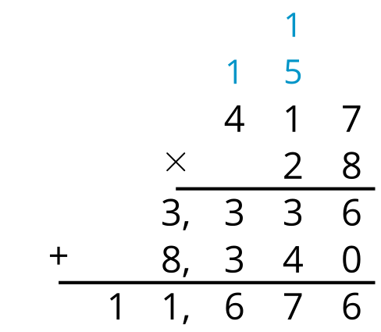
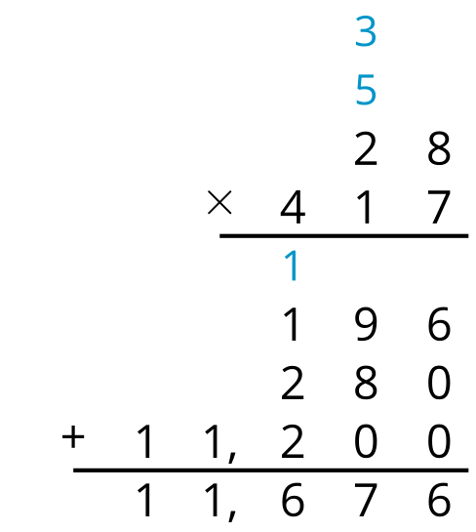

1 Greatest Product

Student Task Statement
Directions:
- Partner A chooses a number card and writes the number in one of the blanks for Round 1.
- Partner B does the same.
- Repeat until each partner has a two-digit by three-digit multiplication problem.
- Find the product.
- The partner with the greater product wins a point.
- The partner with the most points after 5 rounds wins the game.

2 Desperately Seeking 9 New Units (Optional)

Student Task Statement
Tyler notices that when he uses the standard algorithm and composes a new unit, sometimes there is 1 new unit, sometimes 2, all the way up to 8. He has not seen an example with 9 of the new unit.
- For each of these products, how many of each new unit do you compose?
  - $256×5$
  - $587×8$
  - $809×9$
- Do you think it is possible to compose 9 of a new unit with the standard multiplication algorithm?
© CC BY 2021 Illustrative Mathematics®

