Unit 4 Lesson 17: Interpreting Function Parts in Situations

1 Math Talk: Function Evaluation (Warm up)

Student Task Statement
Mentally find the value of $x$ for the given function value using the function: $f(x)=3(x−2)$
$f(x)=9$
$f(x)=210$
$f(x)=10$
$f(x)=0$

2 A Long Car Trip

Student Task Statement
On a long car trip, the distance on the odometer (in miles) is a function of time (in hours after the trip begins) given by the equation $d(t)=34t+45,​233$.
- What is the rate of change for the function? What does it mean in this situation?
- What is the value of $d(0)$? What does it mean in this situation?
- What is the value of $d(\text{-}1)$? What does it mean in this situation?
- When is $d(t)=45,​800$?
- Do each of the values make sense? Explain your reasoning.

3 A Warehouse and Highway

Student Task Statement
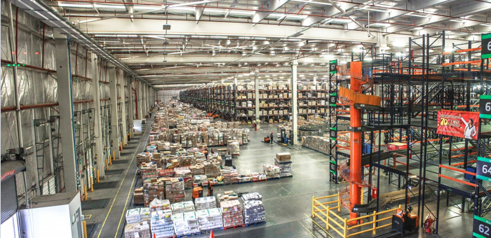
- A warehouse in a factory initially holds 2,385 items and receives all of the items made in production throughout a day. During a particular day, the factory produces 150 items per hour to put into the warehouse. Write a function, $f$, to represent the number of items in the warehouse at time $t$ after production begins for the day.
  - What are the units for $t$?
  - What is the domain of the function? Explain your reasoning.
  - What is the range of the function? Explain your reasoning.
  - What is the value of $t$ when $f(t)=3,​000$? What does that mean in this situation?
- During a focused effort on building new infrastructure for 3 years, a company can build 0.8 miles of highway per day. The company has already built 12 miles of highway before the focused effort. Write a function, $g$, to represent the length of highway built by the company as a function of $t$ during the focused effort.
  - What are the units for $g(t)$?
  - What is the domain of the function? Explain your reasoning.
  - What is the range of the function? Explain your reasoning.
  - What is the value of $t$ when $g(t)=400$? What does that mean in this situation?
© CC BY 2019 by Illustrative Mathematics

