Unit 5 Lesson 21: Multiply More Decimals

WU Estimation Exploration: Central Park (Warm up)

Student Task Statement
Central Park is a large park in Manhattan. It is about 3.85 kilometers long and 0.79 km wide. What is the area of Central Park?
Record an estimate that is:
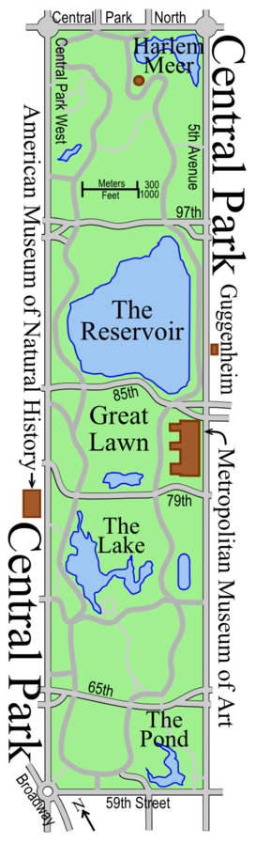
too low | about right | too high

1 Multiply More Decimals

Student Task Statement
- Explain or show why each pair of expressions is equivalent.
  - $7.2×5.3$ and $\left(72×53\right)×0.01$
  - $6.5×2.8$ and $\left(65×28\right)÷100$
  - $31×0.44$ and $\left(31×44\right)×\frac{1}{100}$
- Find the value of the products in the previous problem.

2 Choose Your Strategy

Student Task Statement
Find the value of each product.
- $7.3×4.2$
- $38×0.55$
- $285×0.17$
© CC BY 2021 Illustrative Mathematics®

