Unit 8 Lesson 18: Which One Doesn’t Belong?

WU Which One Doesn’t Belong? Volume (Warm up)

Student Task Statement
Which one doesn’t belong?
A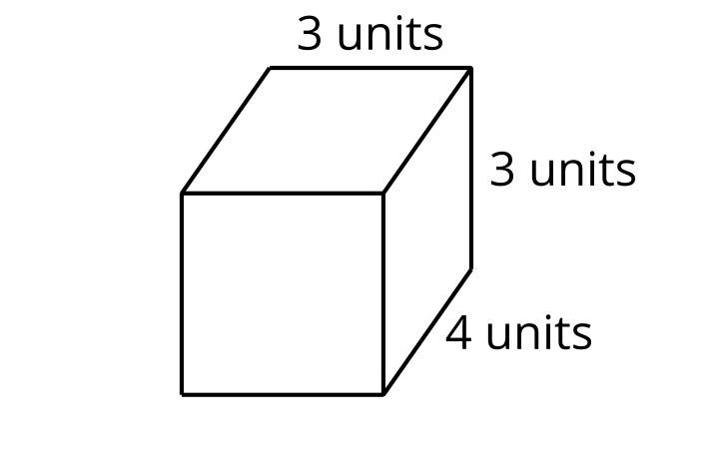
B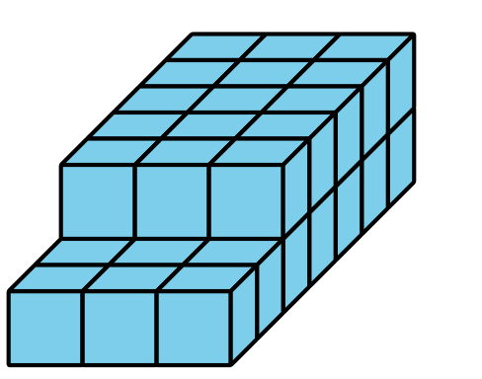
C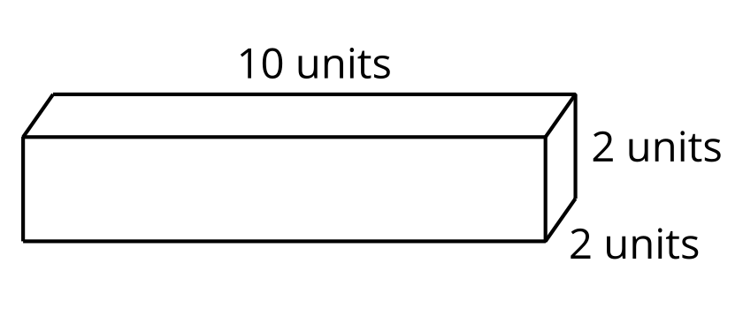
D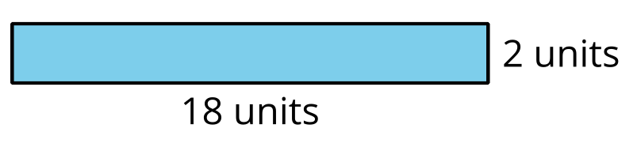

1 Which One Doesn't Belong? Design 1

Student Task Statement
- Choose 3 shapes from the set of cards.
- Draw a fourth shape to complete the Which One Doesn’t Belong.
- For each shape, discuss one reason why it does not belong.
Which one doesn’t belong?
A
B
C
D

2 Which One Doesn't Belong? Design 2

Student Task Statement
- Choose 2 shapes from the set of cards.
- Draw a third and fourth shape to complete the Which One Doesn’t Belong.
- For each shape, discuss one reason why it does not belong.
Which one doesn’t belong?
A
B
C
D

3 Which One Doesn't Belong? Design 3

Student Task Statement
Create your own Which One Doesn’t Belong about any mathematical idea you want others to notice.
Which one doesn't belong?
A
B
C
D
© CC BY 2021 Illustrative Mathematics®

