Lesson 8: Fractions and Whole Numbers
- Let’s work with fractions and whole numbers on the number line.

Warm-up: Number Talk: Divide by 4
Find the value of each expression mentally.
- $12÷4$
- $24÷4$
- $60÷4$
- $72÷4$

8.1: Fractions Located at Whole Numbers
- Locate and label your assigned fractions on the number line. Be prepared to explain your reasoning.
  - $\frac{1}{2},\frac{2}{2},\frac{3}{2},\frac{4}{2},\frac{5}{2},\frac{6}{2},\frac{7}{2},\frac{8}{2},\frac{9}{2},\frac{10}{2}$
  - $\frac{1}{3},\frac{2}{3},\frac{3}{3},\frac{4}{3},\frac{5}{3},\frac{6}{3},\frac{7}{3},\frac{8}{3},\frac{9}{3}$
  - $\frac{1}{4},\frac{2}{4},\frac{3}{4},\frac{4}{4},\frac{5}{4},\frac{6}{4},\frac{7}{4},\frac{8}{4},\frac{9}{4},\frac{10}{4},\frac{11}{4},\frac{12}{4}$
- List all the fractions that were located at a whole number in all three number lines that your group labeled.
- What patterns do you see in all three labeled number lines?
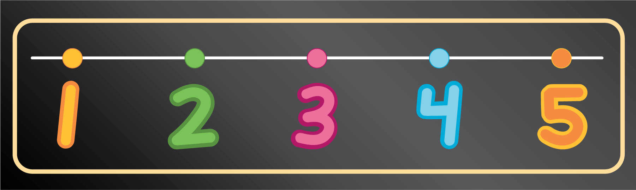

8.2: Locate 1 on the Number Line
- Locate and label 1 on each number line. Be prepared to explain your reasoning.

- How could you locate 2 on the number lines in the previous problem?
© CC BY 2021 Illustrative Mathematics®

