Lesson 15: Off the Line
- Let’s study solutions and non-solutions.

15.1: Estimation: Coin Weight
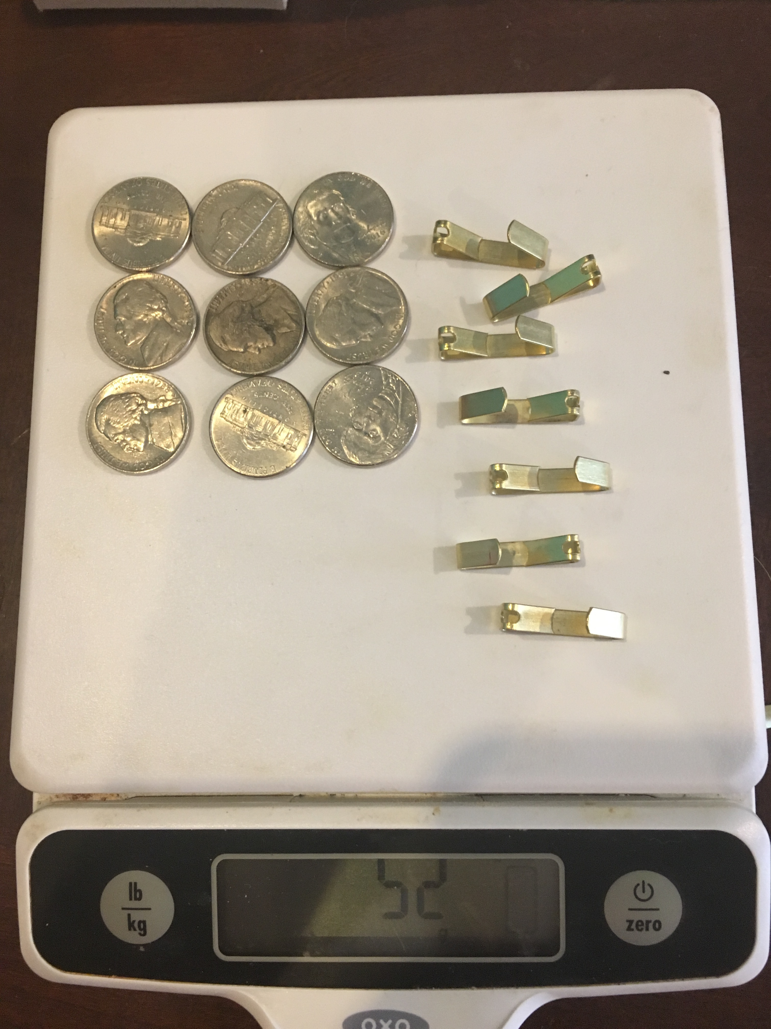
How much does a nickel weigh?
- Record an estimate that is:
- too low | - about right | - too high
- Explain your reasoning.

15.2: Row Game: Equations
Work independently on your column. Partner A completes the questions in column A only and partner B completes the questions in column B only. Your answers in each row should match. Work on one row at a time and check if your answer matches your partner’s before moving on. If you don’t get the same answer, work together to find any mistakes.
Solve each equation.
row | column A | column B
1 | $3x−1=5$ | $6x−2=10$
2 | $4(x+1)=3x−12$ | $4x+4=3(x−4)$
3 | $14x+10=4x+6$ | $7x+5=2x+3$
4 | $6x+3=33$ | $4x+2=22$
5 | $4x+5y=2−4x+5y$ | $4x+9y=2+9y−4x$
6 | $2x+6y=10$ | $5x+15y=25$

15.3: What Were They Thinking?
Read each student’s reasoning and answer the questions.
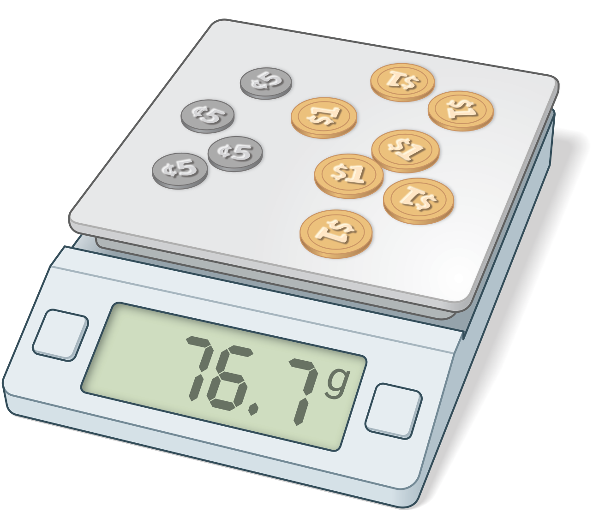
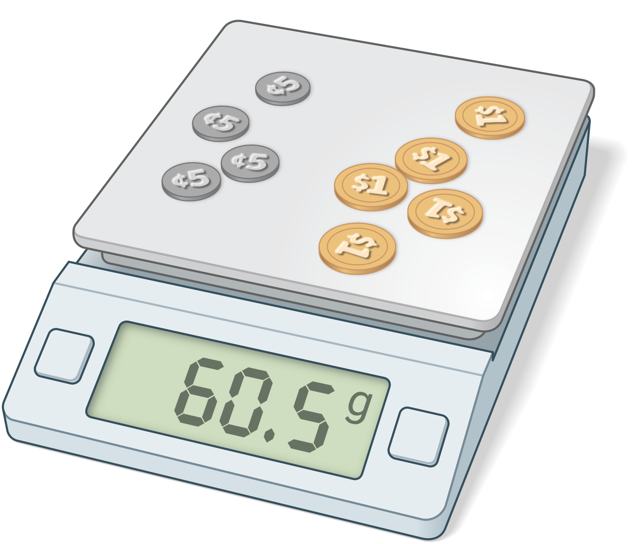
Jada says, “I know 4 nickels and 7 dollar coins weigh 76.7 grams. I know 4 nickels and 5 dollar coins weigh 60.5 grams. Here’s what else I can figure out based on that:
- 2 dollar coins weigh 16.2 grams.
- 1 dollar coin weighs 8.1 grams.
- 5 dollar coins weigh 40.5 grams.
- 4 nickels weigh 20 grams.
- 1 nickel weighs 5 grams.”
- How did Jada figure out that 2 dollar coins weigh 16.2 grams?
- Why might Jada have done that step first?
- After Jada figured out how much 1 dollar coin weighed, why did she calculate how much 5 dollar coins weighed?
- Once Jada knew how much 5 dollar coins weighed, how did she figure out how much 4 nickels weighed?
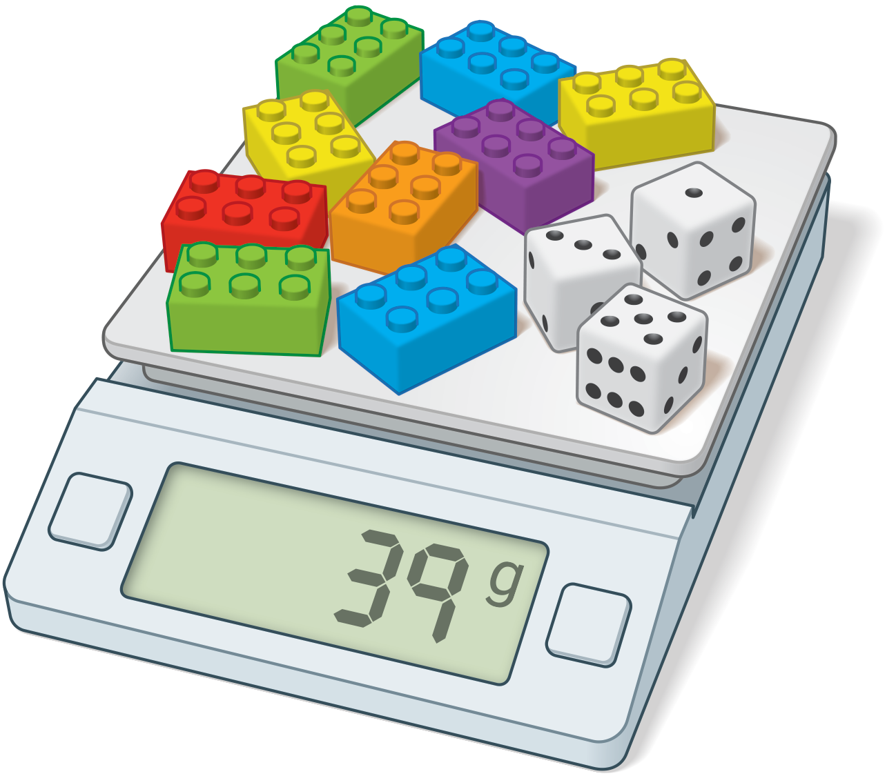
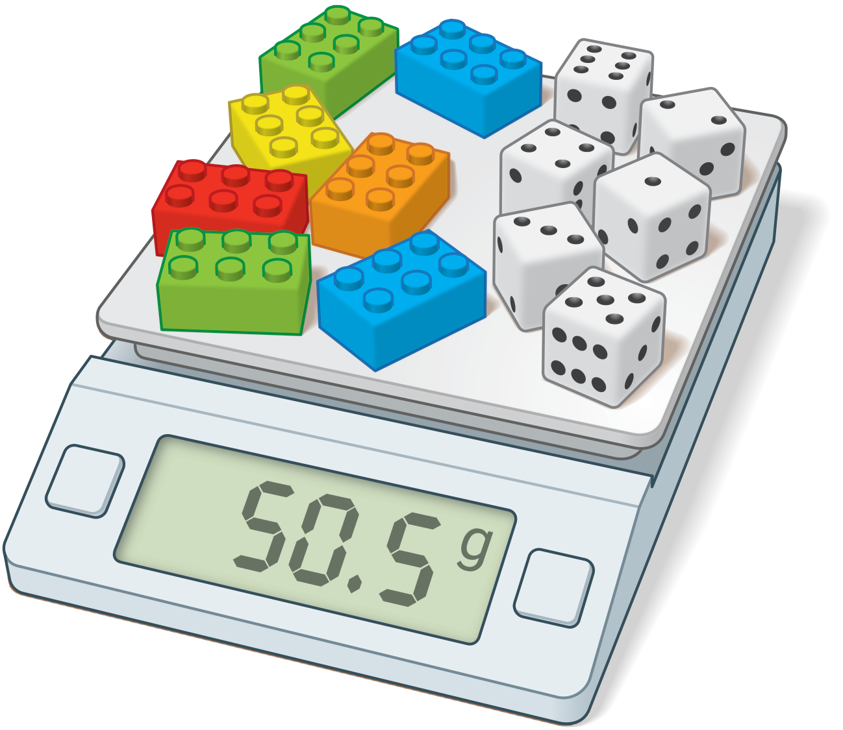
Priya says, “I know 9 plastic bricks and 3 number cubes weigh 39 grams, and 7 plastic bricks and 6 number cubes weigh 50.5 grams. Here’s what I can figure out based on that:
- The weight of 18 plastic bricks and 6 number cubes is 78 grams.
- The weight of 11 plastic brick is 27.5 grams.
- The weight of 1 plastic brick is 2.5 grams.
- The weight of 9 plastic bricks is 22.5 grams.
- The weight of 3 number cubes is 16.5 grams.
- The weight of 1 number cube is 5.5 grams.”
- Why is Priya’s second step only about plastic bricks, not number cubes?
- How does it help Priya to have a statement that’s just about plastic bricks, and not number cubes?
- Why might Priya have started by finding the weight of 18 plastic bricks and 6 number cubes?
- After Priya figured out how much 1 plastic brick weighed, why did she calculate how much 9 plastic bricks weighed?
© CC BY 2019 by Illustrative Mathematics®

