Unit 8 Lesson 7: Count Large Collections

WU What Do You Know About 103? (Warm up)

Student Task Statement
What do you know about 103?

1 Last Number Wins

Student Task Statement

2 Count and Represent

Student Task Statement
How many objects are in your collection?
Represent how many in as many ways as you can.
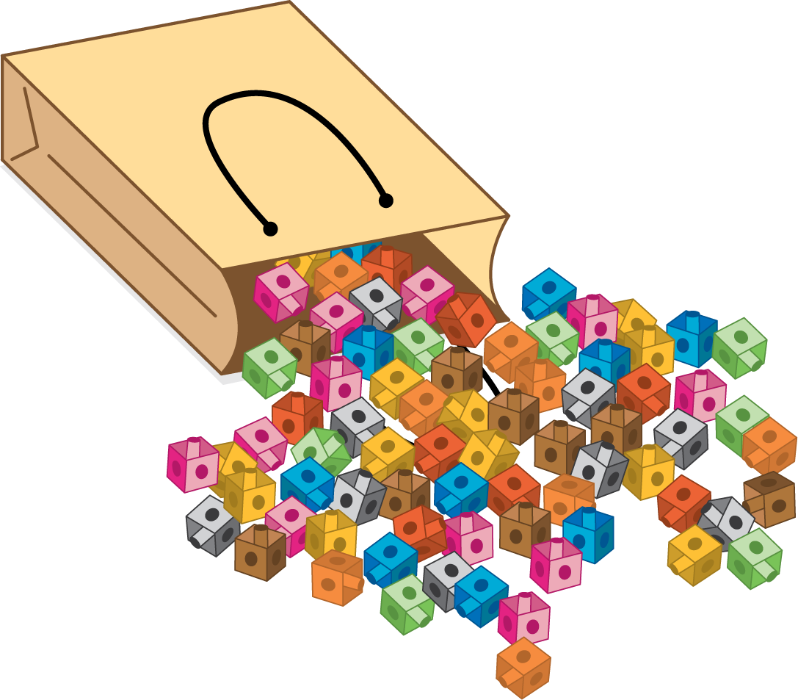

3 How Many Cats?

Student Task Statement
How many cats are there?
There are ____________ cats.
Show your thinking using drawings, numbers, or words.
© CC BY 2021 Illustrative Mathematics®

