Unit 3 Lesson 20: Sticky Notes

WU Which One Doesn’t Belong: Sticky Notes (Warm up)

Student Task Statement
Which one doesn’t belong?
A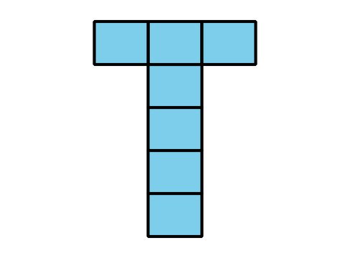
B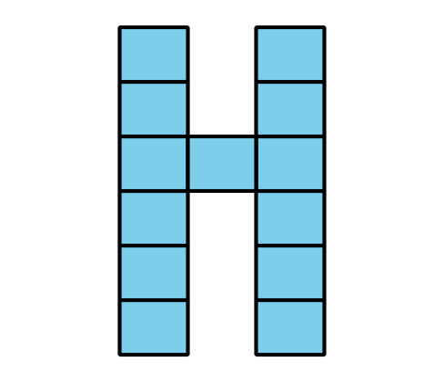
C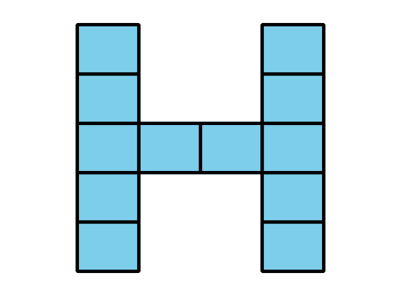
D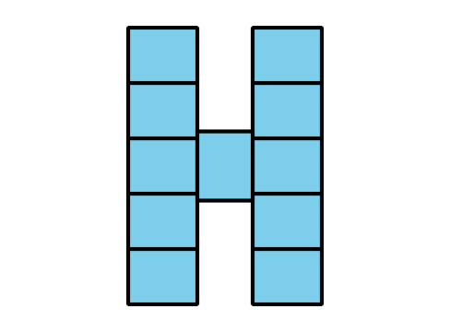

1 Estimation Exploration: Sticky Notes

Student Task Statement
- How many sticky notes will fit across the top or the side of the page?
- Record an estimate that is:
- too low | - about right | - too high
- What information do you need to help you make a better estimate?
- With the new information you have now, make a better estimate. Show or explain your reasoning.
- Write an expression that represents your estimate that shows how many sticky notes fit across or on the side of the paper.

2 Design Your Initial

Student Task Statement
Design your initial with sticky notes.
- Plan your design and determine the number of sticky notes that you need.
- Write at least two equations that show your design will fit on a piece of paper.
- Take turns sharing your design with your partner.
- Get the supplies and make your design.
© CC BY 2021 Illustrative Mathematics®

