Lesson 2: Sums and Differences of Fractions

Standards Alignments
Addressing | 4.NF.A.1, 4.NF.A.2, 4.NF.B.3.a, 4.NF.B.3.b, 4.NF.B.3.c, 4.NF.B.3.d
Building Towards | 5.NF.A.1

Teacher-facing Learning Goals
- Add and subtract fractions and mixed numbers with like denominators.
- Compare fractions and mixed numbers by reasoning about equivalence.

Student-facing Learning Goals
- Let’s practice solving problems involving fractions.

Lesson Purpose
The purpose of this lesson is for students to represent and solve problems involving the addition and subtraction of fractions. Students also reason about equivalence to compare fractions and make sense of problems.
In this lesson, students apply what they know about equivalence and addition and subtraction of fractions to solve problems. Throughout the lesson, students have opportunities to reason quantitatively and abstractly as they connect their representations, including equations, to the situations (MP2) and to compare their reasoning with others' (MP3).
The work of this lesson helps prepare students for adding and subtracting with unlike denominators in grade 5. If students need additional support with the concepts in this lesson, refer back to Unit 3, Section B in the curriculum materials.

Access for:

Students with Disabilities
- Action and Expression (Activity 2)

English Learners
- MLR8 (Activity 1)

Instructional Routines
Number Talk (Warm-up)

Lesson Timeline
Warm-up | 10 min
Activity 1 | 15 min
Activity 2 | 20 min
Lesson Synthesis | 10 min
Cool-down | 5 min

Teacher Reflection Question
What strategies were students using to solve problems? What evidence did students show that they were reasoning about equivalence as they solved the problems?

Cool-down
(to be completed at the end of the lesson) 5min
The Flagpole

Standards Alignments
Addressing | 4.NF.B.3.c, 4.NF.B.3.d

Student-facing Task Statement
The school flagpole is placed about $3\frac{2}{6}$ feet into the ground. Students can see $12\frac{4}{6}$ feet of the flagpole.
How long is the entire flagpole? Show your reasoning.
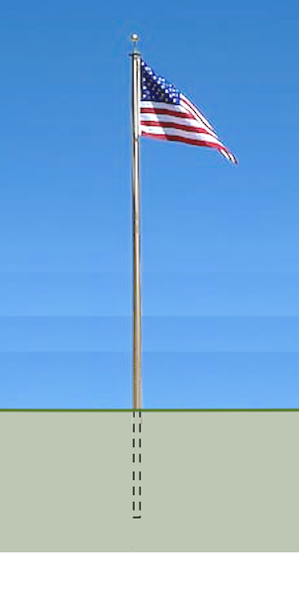

Student Responses
16 feet, because $12\frac{4}{6}+3\frac{2}{6}=16$.

