Unit 7 Lesson 14: Distances on a Coordinate Plane

1 Coordinate Patterns (Warm up)

Student Task Statement
Plot points in your assigned quadrant and label them with their coordinates.
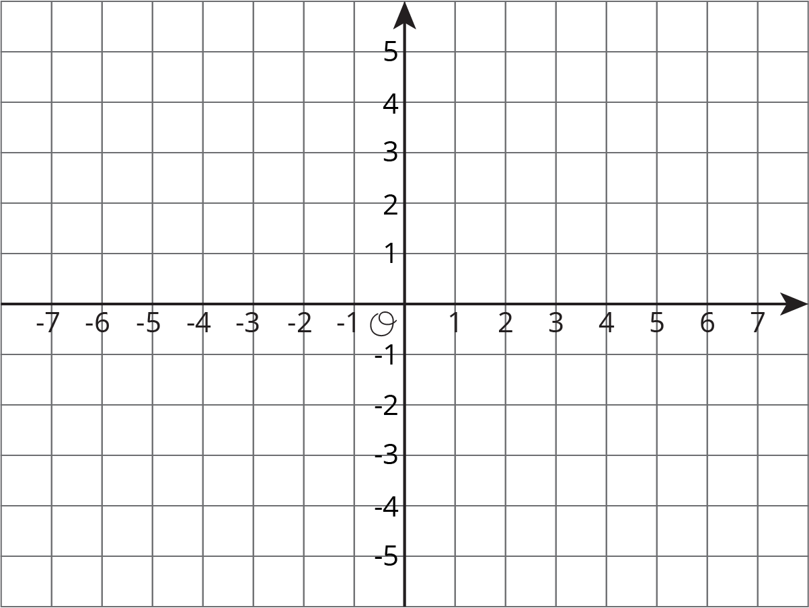

2 Signs of Numbers in Coordinates

Student Task Statement
- Write the coordinates of each point.
- 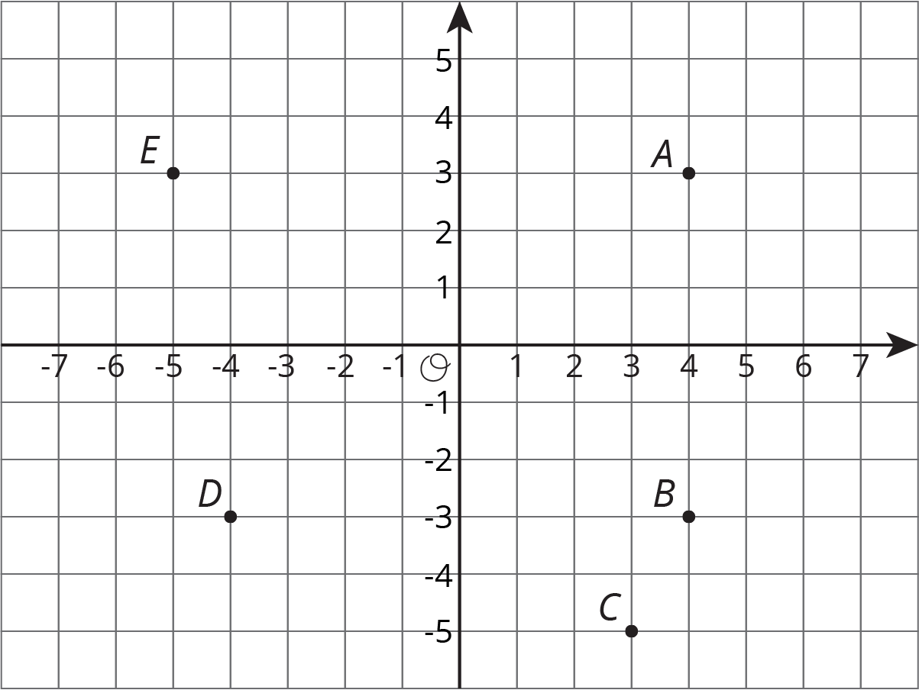

- $A=$
- $B=$
- $C=$
- $D=$
- $E=$
- Answer these questions for each pair of points.
  - How are the coordinates the same? How are they different?
  - How far away are they from the y-axis? To the left or to the right of it?
  - How far away are they from the x-axis? Above or below it?
  - $A$ and $B$
  - $B$ and $D$
  - $A$ and $D$
- Pause here for a class discussion.
- Point $F$ has the same coordinates as point $C$, except its $y$-coordinate has the opposite sign.
  - Plot point $F$ on the coordinate plane and label it with its coordinates.
  - How far away are $F$ and $C$ from the $x$-axis?
  - What is the distance between $F$ and $C$?
- Point $G$ has the same coordinates as point $E$, except its $x$-coordinate has the opposite sign.
  - Plot point $G$ on the coordinate plane and label it with its coordinates.
  - How far away are $G$ and $E$ from the $y$-axis?
  - What is the distance between $G$ and $E$?
- Point $H$ has the same coordinates as point $B$, except its both coordinates have the opposite sign. In which quadrant is point $H$?

3 Finding Distances on a Coordinate Plane

Student Task Statement
- Label each point with its coordinates.
- 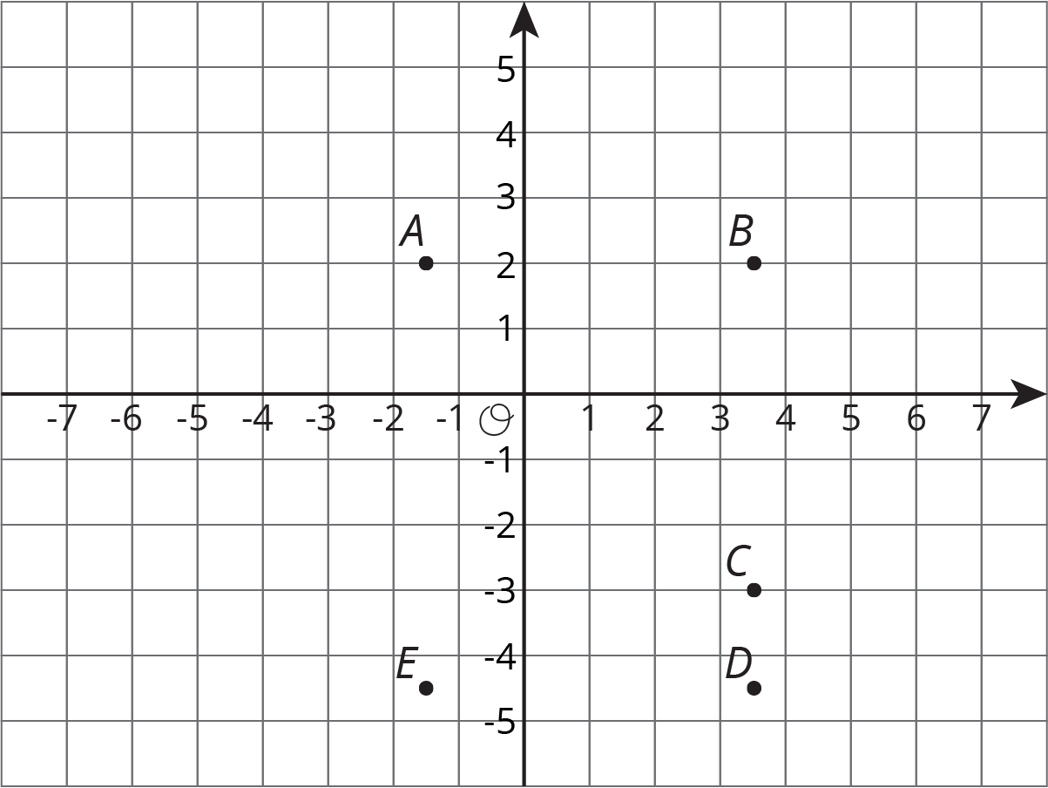
- Find the distance between each of the following pairs of points.
  - Point $B$ and $C$
  - Point $D$ and $B$
  - Point $D$ and $E$
- Which of the points are 5 units from $\left(\text{-}1.5,\text{-}3\right)$?
- Which of the points are 2 units from $\left(\text{0}.5,\text{-}4.5\right)$?
- Plot a point that is both 2.5 units from $A$ and 9 units from $E$. Label that point $M$ and write down its coordinates.
© CC BY Open Up Resources. Adaptations CC BY IM.

