Unit 6 Lesson 10: Complete Equations

WU What do you know about 15? (Warm up)

Student Task Statement
What do you know about 15?

1 What Is Missing?

Student Task Statement
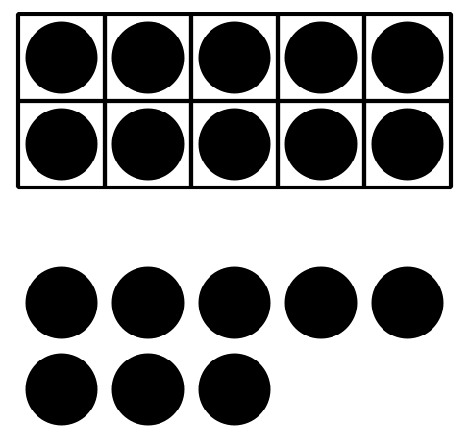
$10+8=\underset{_}{}$
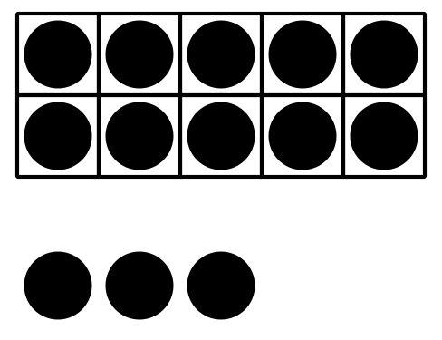
$10+3=\underset{_}{}$
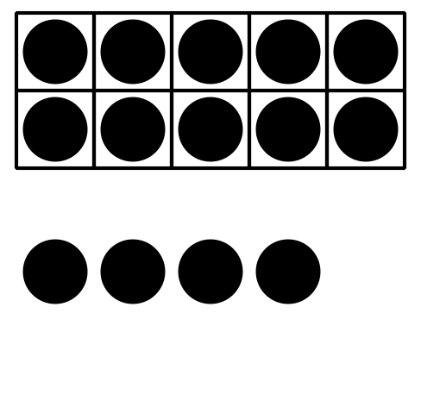
$10+4=\underset{_}{}$
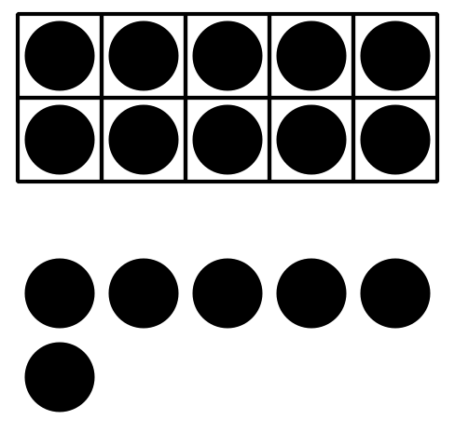
$\underset{_}{}+\underset{_}{}=16$
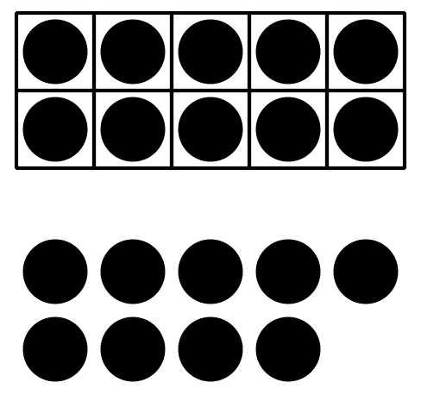
$\underset{_}{}+\underset{_}{}=19$
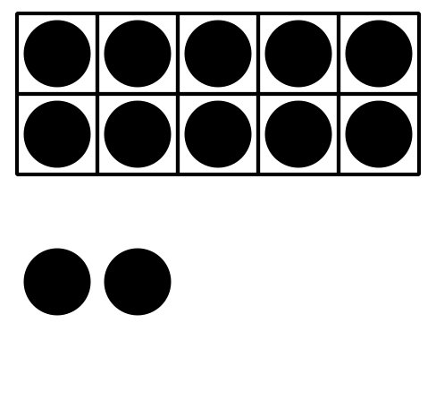
$\underset{_}{}+\underset{_}{}=12$

2 Make the Equations True

Student Task Statement
- $10+5=\underset{_}{}$
- $\underset{_}{}+\underset{_}{}=16$
- $\underset{_}{}+\underset{_}{}=19$
- $\underset{_}{}+\underset{_}{}=13$
- $\underset{_}{}+\underset{_}{}=17$
- $10+1=\underset{_}{}$

3 Centers: Choice Time

Student Task Statement
Choose a center.
Bingo
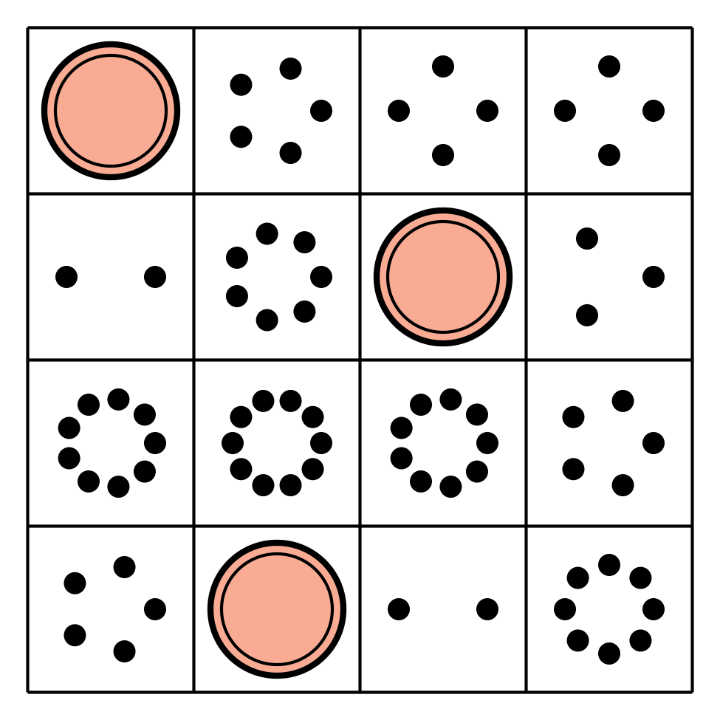
Number Race
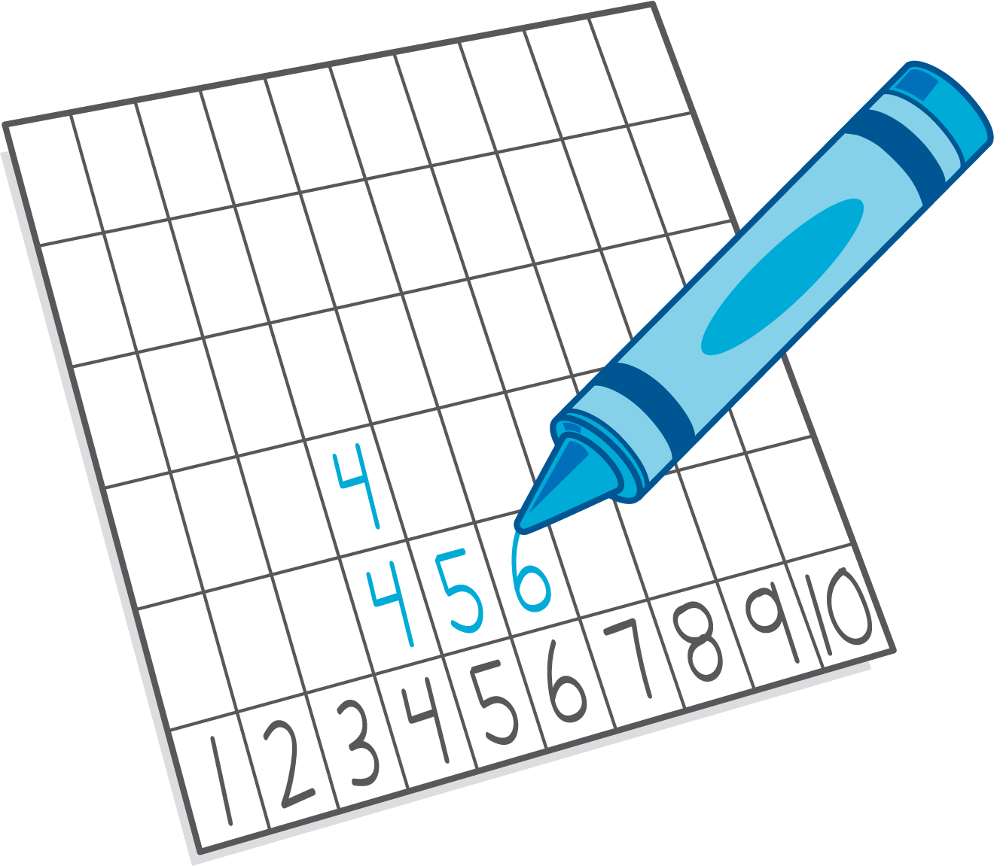
Grab and Count
Make or Break Apart Numbers
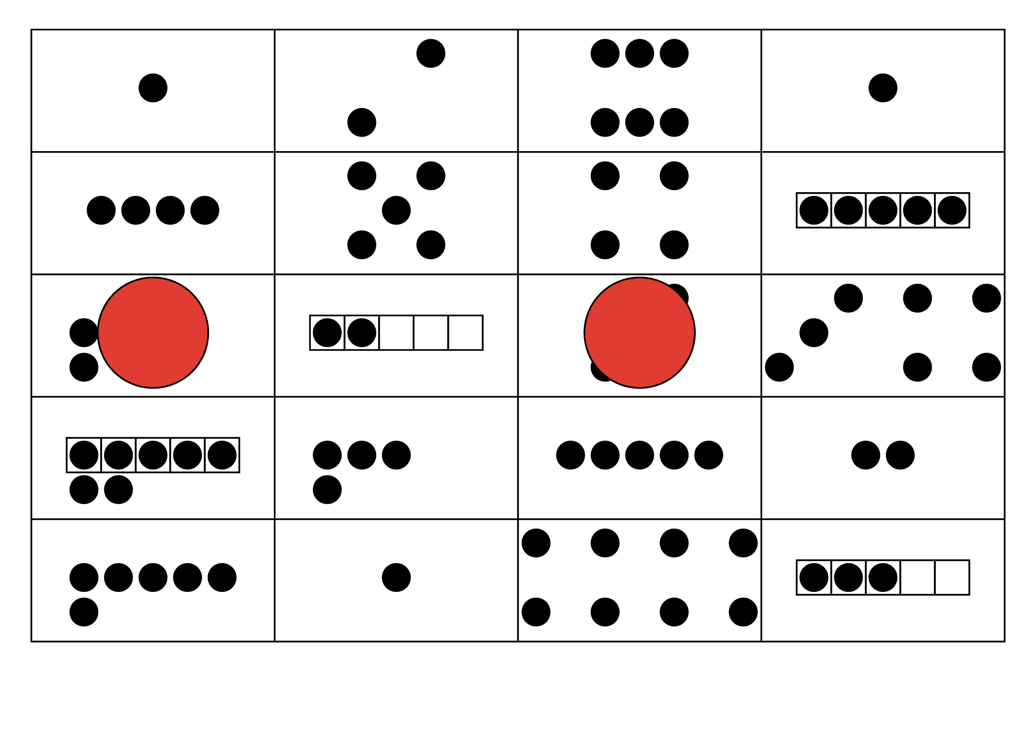
Tower Build
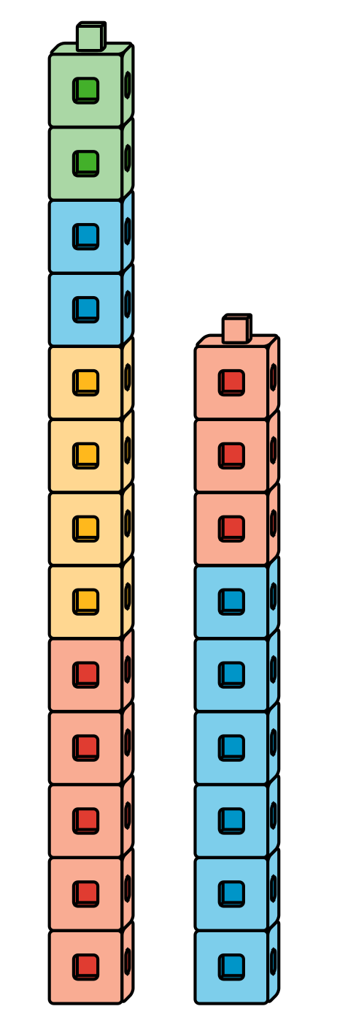
© CC BY 2021 Illustrative Mathematics®

