Unit 7 Lesson 24: Using Quadratic Equations to Model Situations and Solve Problems

1 Equations of Two Lines and A Curve (Warm up)

Student Task Statement
- Write an equation representing the line that passes through each pair of points.
  - $\left(3,3\right)$ and $\left(5,5\right)$
  - $\left(0,4\right)$ and $\left(\text{-}4,0\right)$
- Solve this equation: $x+1={\left(x−2\right)}^{2}−3$. Show your reasoning.

2 The Dive

Student Task Statement
The function $h$, defined by $h\left(t\right)=\text{-}5t^{2}+10t+7.5$, models the height of a diver above the water (in meters), $t$ seconds after the diver leaves the board. For each question, explain how you know.
- How high above the water is the diving board?
- When does the diver hit the water?
- At what point during her descent toward the water is the diver at the same height as the diving board?
- When does the diver reach the maximum height of the dive?
- What is the maximum height the diver reaches during the dive?

Activity Synthesis
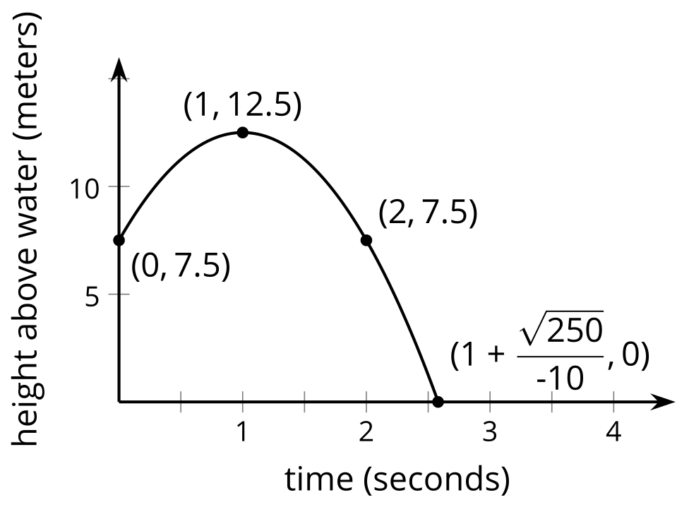

3 A Linear Function and A Quadratic Function

Student Task Statement
Here are graphs of a linear function and a quadratic function. The quadratic function is defined by the expression ${\left(x−4\right)}^{2}−5$.
Find the coordinates of $P,Q$, and $R$ without using graphing technology. Show your reasoning.
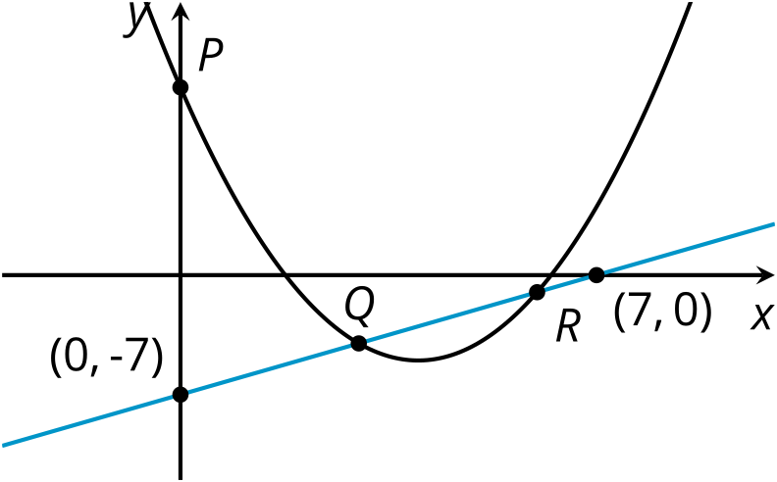

© CC BY 2019 by Illustrative Mathematics®

