Unit 5 Lesson 25: Divide Decimals by Decimals

WU Number Talk: Same/Different (Warm up)

Student Task Statement
Find the value of each expression mentally.
- $20÷2$
- $2÷0.2$
- $50÷2$
- $5÷0.2$

1 Dividing by a Tenth and a Hundredth

Student Task Statement
- To find the value of $1.6÷0.1$, Jada drew this diagram.
  - Describe how the diagram shows 1.6.
  - 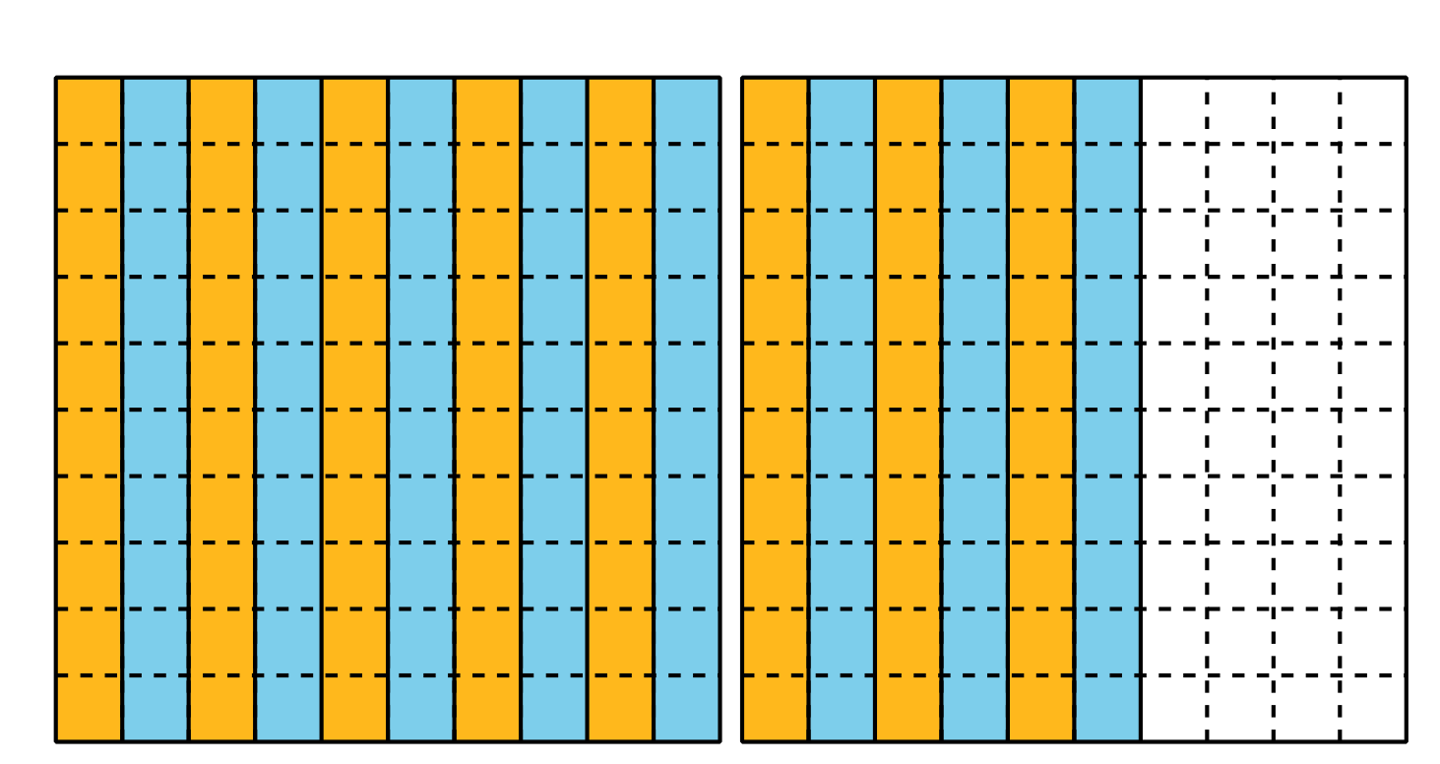
  - Describe how the diagram shows 16 groups of 1 tenth.
  - Describe how the diagram shows the value of $1.6÷0.1$.
  - Describe how the diagram also represents the expression $160÷10$.
- Explain how this diagram represents $1.3÷0.01$.
- 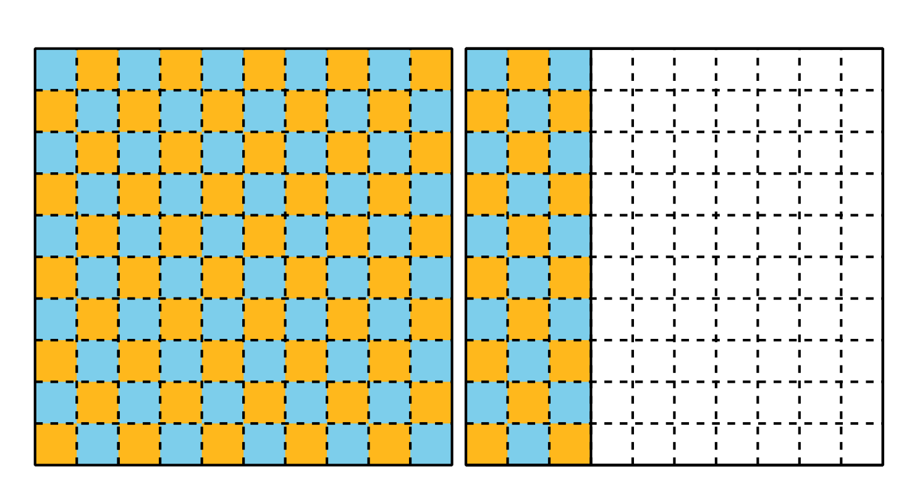
  - What is the value of $1.3÷0.01$? Explain or show your reasoning.

2 Divide Decimals by Decimals

Student Task Statement
Find the value of each expression. Explain or show your reasoning.
- $5÷0.1$
- $5÷0.01$
- $0.5÷0.1$
- $0.5÷0.01$
- $0.02÷0.01$
- $1.53÷0.01$
© CC BY 2021 Illustrative Mathematics®

