Lesson 3: Volumes of Prism Drawings

Standards Alignments
Building On | 3.OA.C.7
Addressing | 5.MD.C.4
Building Towards | 5.MD.C.5

Teacher-facing Learning Goals
- Find the volume of a rectangular prism using its layered structure.

Student-facing Learning Goals
- Let's use layers to find volume.

Lesson Purpose
The purpose of this lesson is for students to find the volume of a rectangular prism using its layered structure.
In previous lessons, students built objects, including rectangular prisms, with unit cubes and counted the number of cubes. In this lesson, students continue to count the number of unit cubes needed to build a rectangular prism, but now they are presented with images of prisms instead of the objects themselves. To encourage students to develop a systematic way to count the cubes, they are shown prisms made from larger numbers of cubes. As students use horizontal or vertical layers to measure the volume, they make use of the layered structure of prisms (MP7).
Math Community
Tell students that, at the end of the lesson, they will be asked to identify specific actions from their “Doing Math” list (both teacher and student sections) they personally experienced.

Access for:

Students with Disabilities
- Representation (Activity 2)

English Learners
- MLR8 (Activity 1)

Instructional Routines
Number Talk (Warm-up)

Materials to Gather
- Connecting cubes: Activity 1
- Connecting cubes: Activity 2

Materials to Copy
- Card Sort Rectangular Prism Cards (groups of 2): Activity 1

Lesson Timeline
Warm-up | 10 min
Activity 1 | 20 min
Activity 2 | 15 min
Lesson Synthesis | 10 min
Cool-down | 5 min

Teacher Reflection Question
What connections did students make between the different strategies they used to build the prisms and determine the volume? What questions did you ask to help make the connections more visible?

Cool-down
(to be completed at the end of the lesson) 5min
Jada's Prism

Standards Alignments
Addressing | 5.MD.C.4

Student-facing Task Statement
Jada’s prism has 4 layers and each layer has 9 cubes.
- Circle the prism that is Jada's.
- A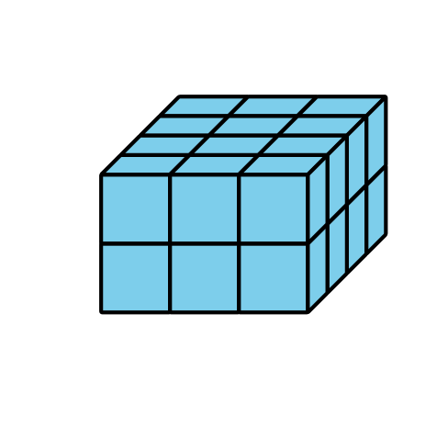
- B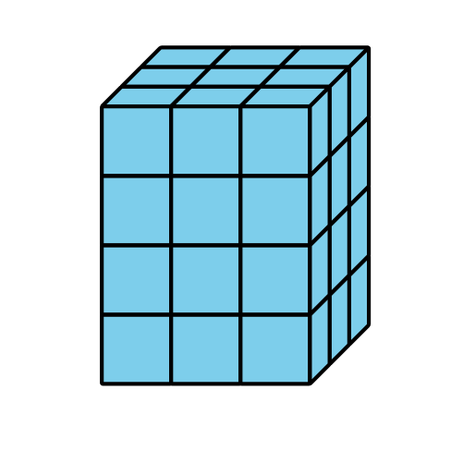
- C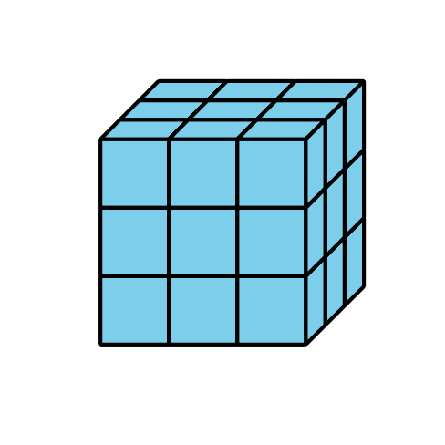
- D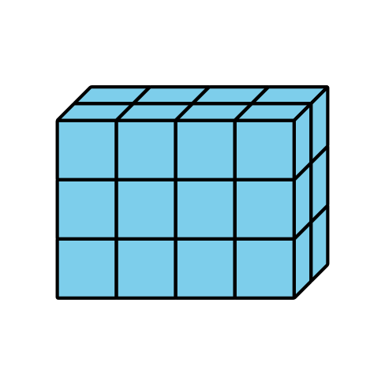
- Find the volume of Jada’s prism. Explain or show your reasoning.

Student Responses
- B
- 36 cubes. There are 4 layers with 9 cubes in each layer so there are 36 cubes, $4×9=36$.

