Lesson 15: Create Line Plots

Standards Alignments
Addressing | 2.MD.A.1, 2.MD.D.9, 2.NBT.B.5

Teacher-facing Learning Goals
- Represent numerical data in a line plot.

Student-facing Learning Goals
- Let’s represent data in line plots.

Lesson Purpose
The purpose of this lesson is for students to create line plots to represent numerical data.
In an earlier lesson, students learned about the features of a line plot. They interpreted a line plot that represented data from measurements they made in inches.
In this lesson, students measure the lengths of pencils in centimeters and represent the data on their own in a line plot. In Activity 2, students make sense of line plots that do not start at 0. They choose an appropriate starting and ending number based on the data (MP6). In the lesson synthesis, students interpret the data presented in a line plot with a scale that does not start at 0.

Access for:

Students with Disabilities
- Action and Expression (Activity 1)

Instructional Routines
MLR8 Discussion Supports (Activity 2), Number Talk (Warm-up)

Materials to Gather
- Objects of various lengths: Activity 1
- Rulers (centimeters): Activity 1

Materials to Copy
- Line Plot Template (groups of 1): Activity 1

Lesson Timeline
Warm-up | 10 min
Activity 1 | 15 min
Activity 2 | 20 min
Lesson Synthesis | 10 min
Cool-down | 5 min

Teacher Reflection Question
What did you say, do, or ask to support students in creating a line plot based on an understanding of the representation, rather than following a procedure?

Cool-down
(to be completed at the end of the lesson) 5min
Hand Spans of Mai’s Group

Standards Alignments
Addressing | 2.MD.D.9

Student-facing Task Statement
- Mai made these statements about the lengths of hand spans for students in her group.
  - Four students have a hand span of 18 cm.
  - Two students have a hand span of 16 cm.
  - Two students have a hand span of 19 cm.
  - One student has a hand span of 20 cm.
- Complete the line plot so it matches Mai’s data.
- 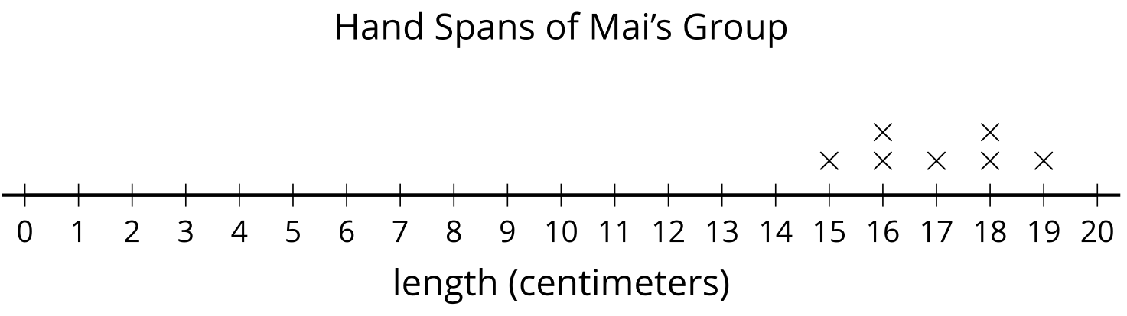

Student Responses

- 