Lesson 1: How Do We Compose a Hundred?

Standards Alignments
Addressing | 2.NBT.A.1, 2.NBT.A.1.a, 2.NBT.A.2
Building Towards | 2.NBT.A.1

Teacher-facing Learning Goals
- Recognize that each hundred is composed of 100 ones or 10 tens.

Student-facing Learning Goals
- Let’s compose a hundred.
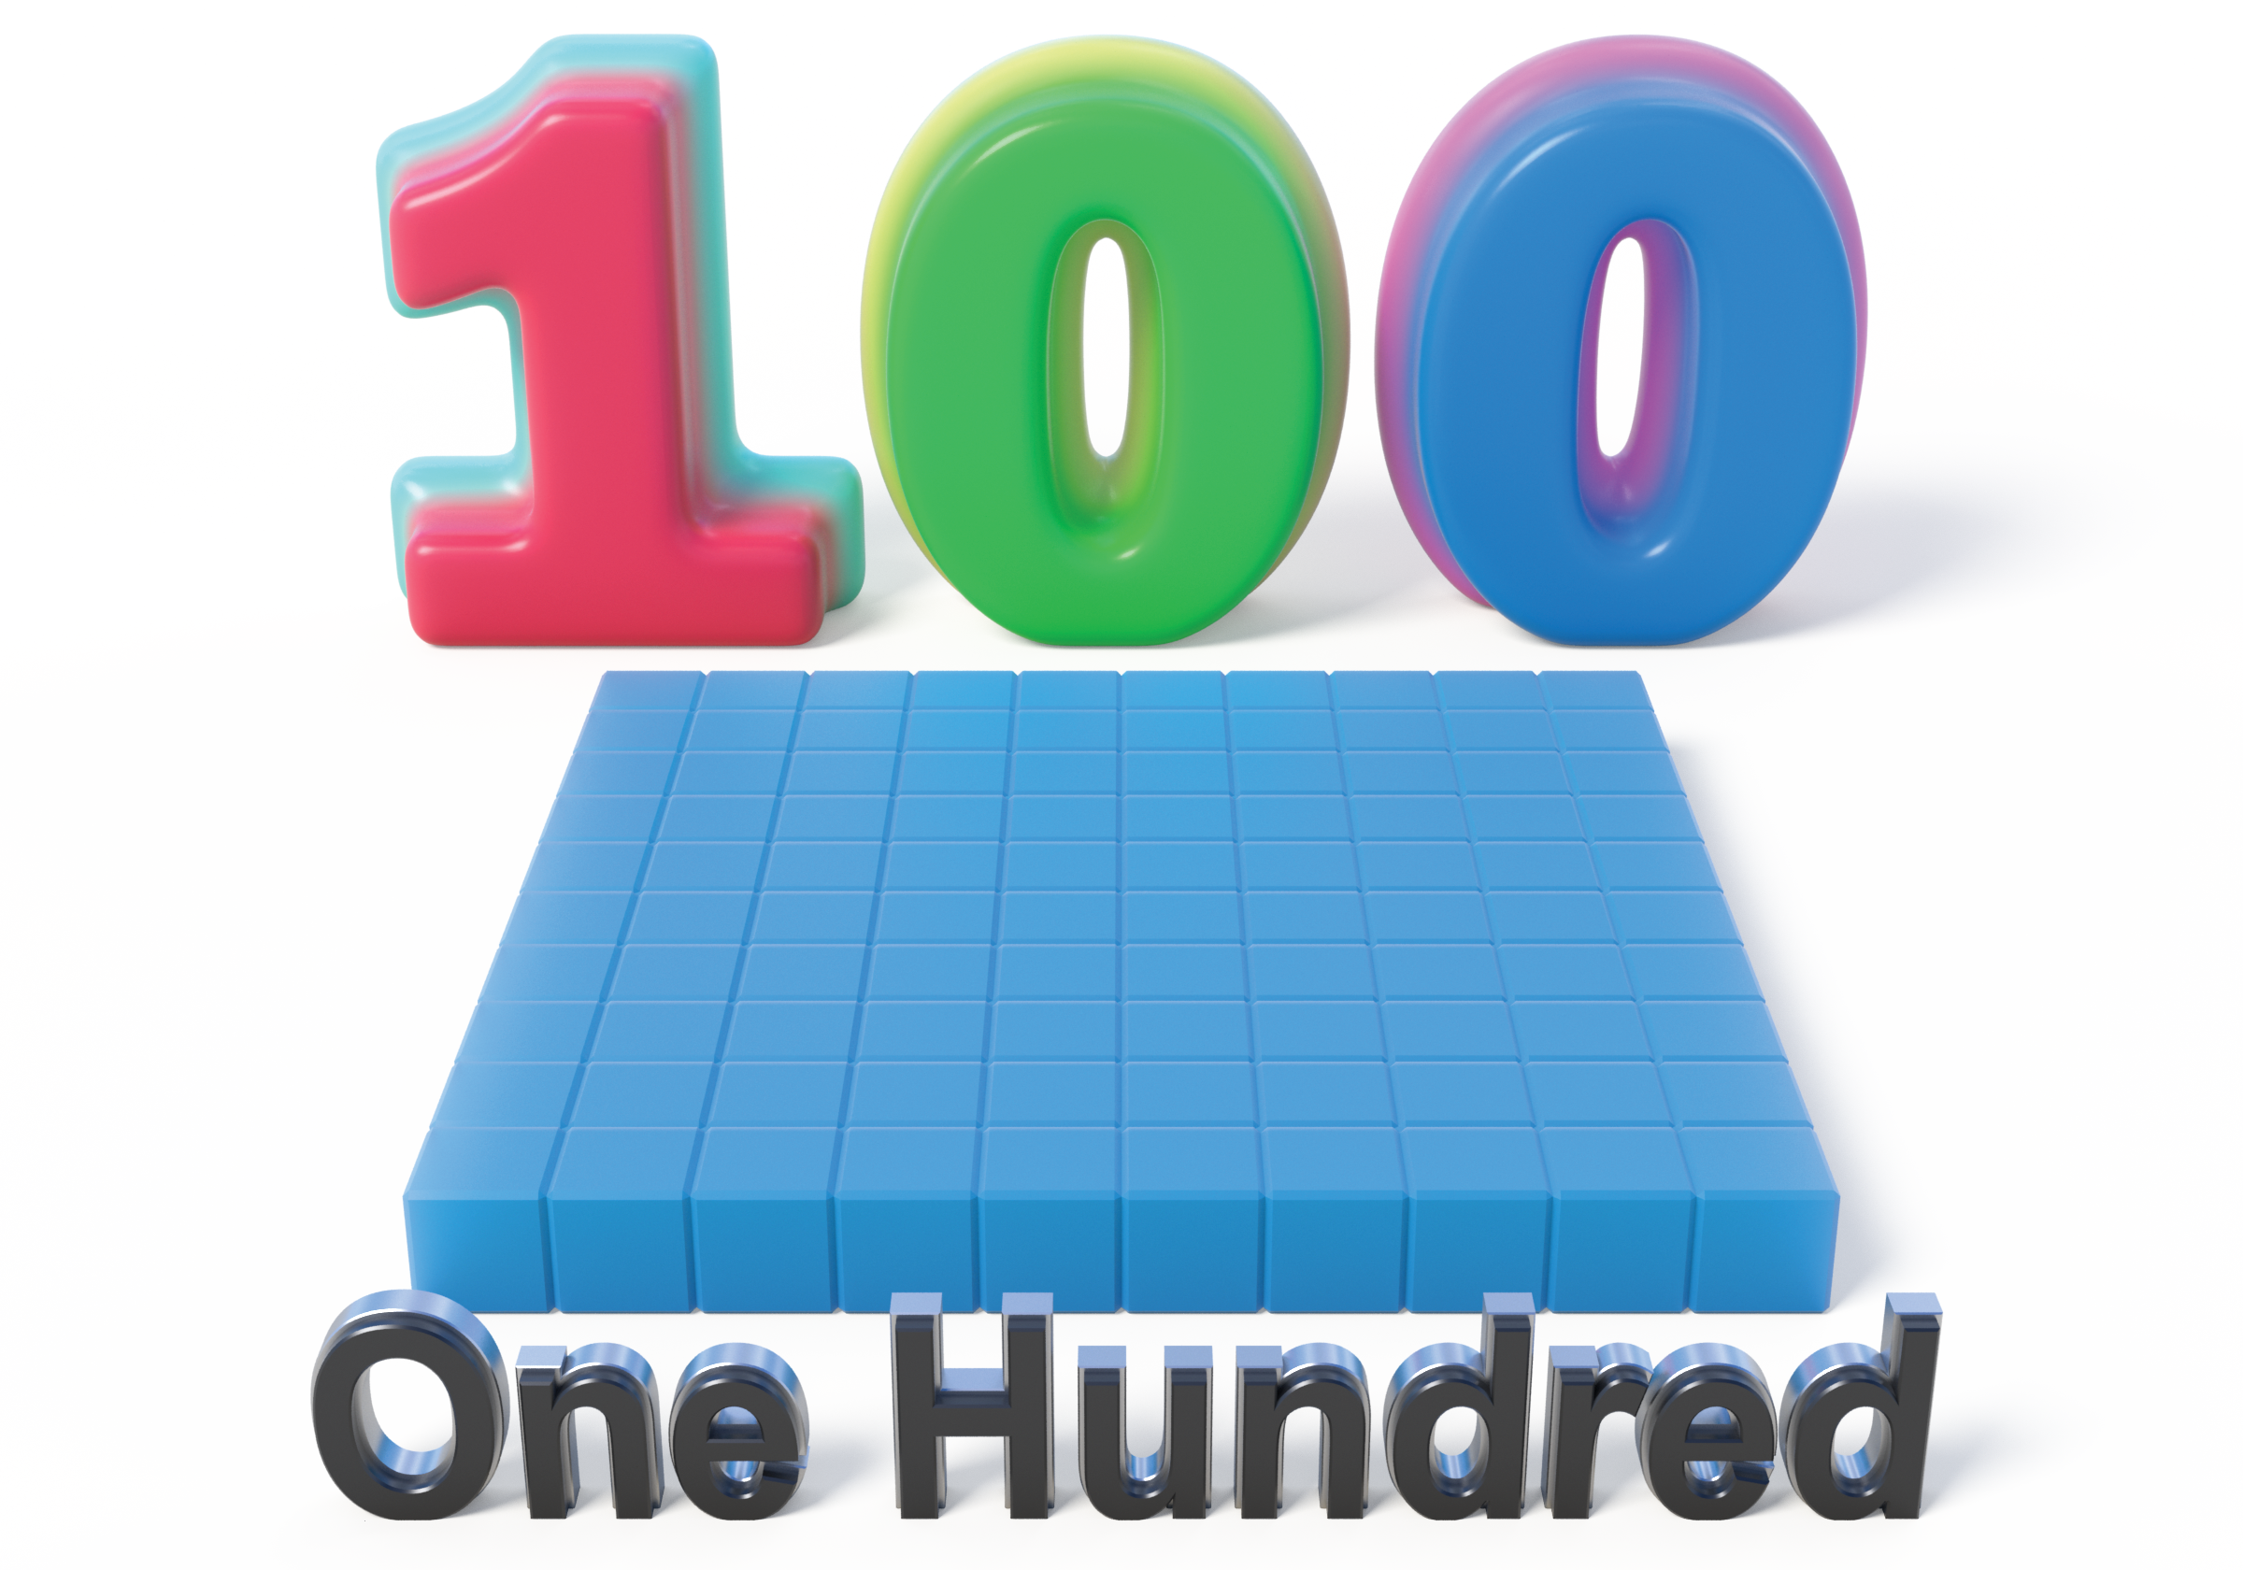

Lesson Purpose
The purpose of this lesson is for students to make sense of a hundred as a unit composed of 10 tens or 100 ones.
In grade 1, students were introduced to a ten as a unit made of 10 ones. They used that understanding to represent two-digit numbers and add within 100. Students used connecting cubes to make and break apart two-digit numbers. In previous units in grade 2, students used the words compose and decompose as they made and broke apart tens when they added and subtracted within 100.
In this lesson, students are introduced to the unit of a hundred. Building on the understanding that they can use 10 ones to compose a ten, students learn they can compose a hundred using 10 tens.

Access for:

Students with Disabilities
- Engagement (Activity 1)

English Learners
- MLR8 (Activity 2)

Instructional Routines
Choral Count (Warm-up)

Materials to Gather
- Base-ten blocks: Activity 1, Activity 2

Lesson Timeline
Warm-up | 10 min
Activity 1 | 20 min
Activity 2 | 15 min
Lesson Synthesis | 10 min
Cool-down | 5 min

Teacher Reflection Question
What unfinished learning or misunderstandings do your students have about composing tens and place value? How did you leverage those misconceptions in a positive way to further the understanding of the class?

Cool-down
(to be completed at the end of the lesson) 5min
Fewer Blocks

Standards Alignments
Addressing | 2.NBT.A.1, 2.NBT.A.1.a

Student-facing Task Statement
Andre represented a number with base-ten blocks.
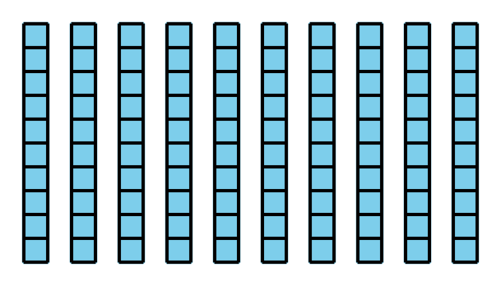
- What number did Andre represent?
- How could he represent this number with fewer blocks? Show your thinking with words or a base-ten diagram.

Student Responses
- 100
- Sample responses:
  - Student draws a large square to represent a 1 hundred.
  - He could use 1 hundred block. It’s the same as 10 tens.

