Lesson 9: Subtraction Algorithms (Part 2)

Standards Alignments
Building On | 2.NBT.B.7
Addressing | 3.NBT.A.2
Building Towards | 3.NBT.A.2

Teacher-facing Learning Goals
- Analyze and use a subtraction algorithm with the numbers written in expanded form.

Student-facing Learning Goals
- Let’s learn more about our first subtraction algorithm.

Lesson Purpose
The purpose of this lesson is for students to subtract within 1,000 using a subtraction algorithm that records numbers in expanded form.
Previously, students learned to record subtraction using an algorithm in which the numbers are written in expanded form. They made connections between the structure and steps of the algorithm to those of base-ten diagrams that represent the same subtraction. In this lesson, students take a closer look at the algorithm and use it to find differences. They also examine a common error in subtracting numbers when decomposition of a place value unit is required. When students discuss shown work, they construct viable arguments and critique the reasoning of others (MP3).

Access for:

Students with Disabilities
- Engagement (Activity 2)

English Learners
- MLR8 (Activity 2)

Instructional Routines
True or False (Warm-up)

Materials to Gather
- Base-ten blocks: Activity 1, Activity 2

Lesson Timeline
Warm-up | 10 min
Activity 1 | 15 min
Activity 2 | 20 min
Lesson Synthesis | 10 min
Cool-down | 5 min

Teacher Reflection Question
Today students were able to analyze a common error when subtracting within 1,000 before they used an algorithm to subtract. How did the analysis of the error affect their work with subtracting within 1,000?

Cool-down
(to be completed at the end of the lesson) 5min
How Did Andre Subtract?

Standards Alignments
Addressing | 3.NBT.A.2

Student-facing Task Statement
Andre found the value of $739−255$. His work is shown.
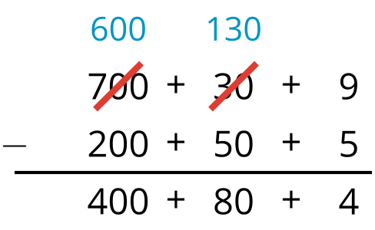
Explain how he subtracted and the value he found for $739−255$.

Student Responses
Sample response: First, Andre wrote 739 and 255 in expanded form and stacked them. Then, he subtracted 5 from 9 and got 4. Then, he realized he didn’t have enough tens to subtract 50 from 30 so he decomposed a 100 from the 700 into 10 tens to get 130. 130 minus 50 is 80 and 600 minus 200 is 400. His answer is 484.

