Lesson 1: Build It

1.1: The Right Tool
- Copy this figure using only a pencil and no other tools.
- 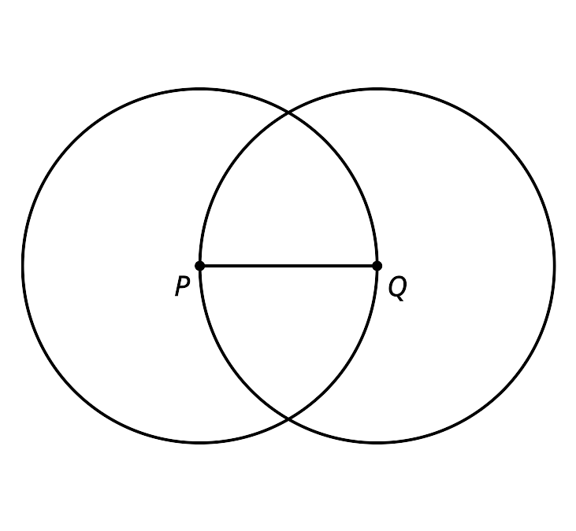

- Familiarize yourself with your straightedge and compass by drawing a few circles of different sizes, a few line segments of different lengths, and extending some of those line segments in both directions.
- Complete these steps with a straightedge and compass:
  - Draw a point and label it $A$.
  - Draw a circle centered at point $A$ with a radius of length $PQ$.
  - Mark a point on the circle and label it $B$.
  - Draw another circle centered at point $B$ that goes through point $A$.
  - Draw a line segment between points $A$ and $B$.

1.2: Illegal Construction Moves
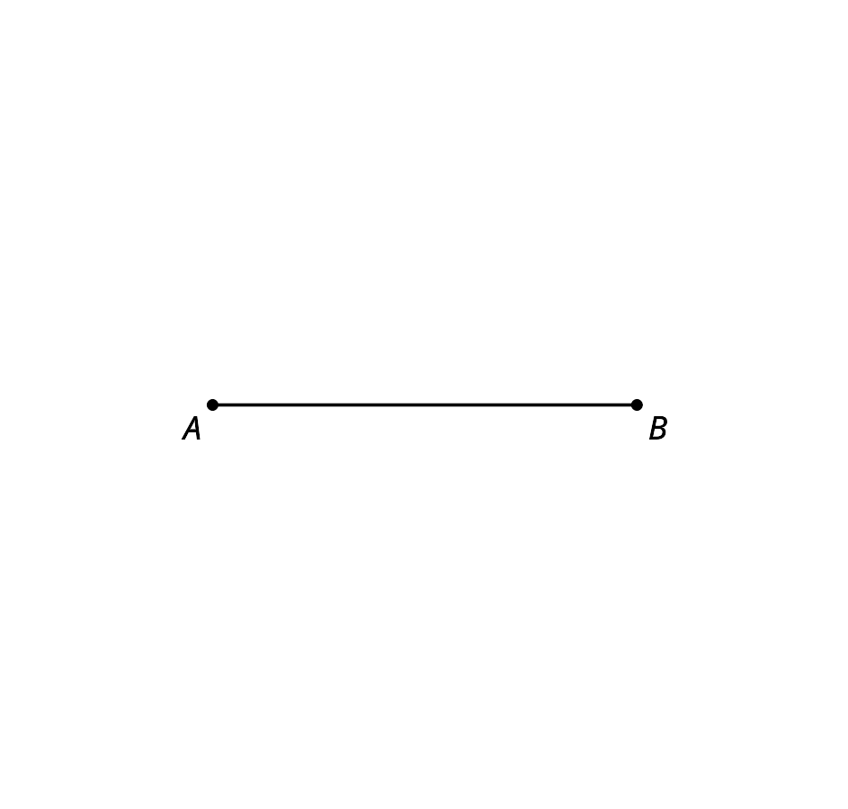
- Create a circle centered at $A$ with radius $AB$.
- Estimate the midpoint of segment $AB$ and label it $C$.
- Create a circle centered at $B$ with radius $BC$. This creates 2 intersection points. Label the one toward the top of the page as $D$ and the one toward the bottom as $E$.
- Use your straightedge to connect points $A$, $D$, and $E$ to make triangle $ADE$ and lightly shade it in with your pencil.

1.3: Can You Make a Perfect Copy?
Here is a hexagon with all congruent angles and all congruent sides (called a regular hexagon).
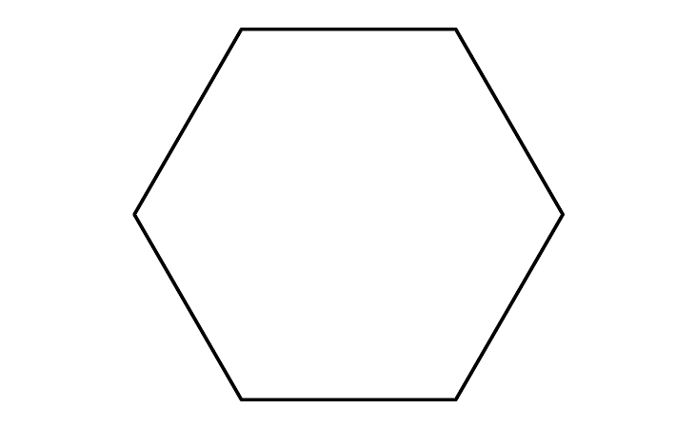

- Draw a copy of the regular hexagon using only your pencil and no other tools. Trace your copy onto tracing paper. Try to fold it in half. What happened?
- Here is a figure that shows the first few steps to constructing the regular hexagon. Use straightedge and compass moves to finish constructing the regular hexagon. Trace it onto tracing paper and confirm that when you fold it in half, the edges line up.
- 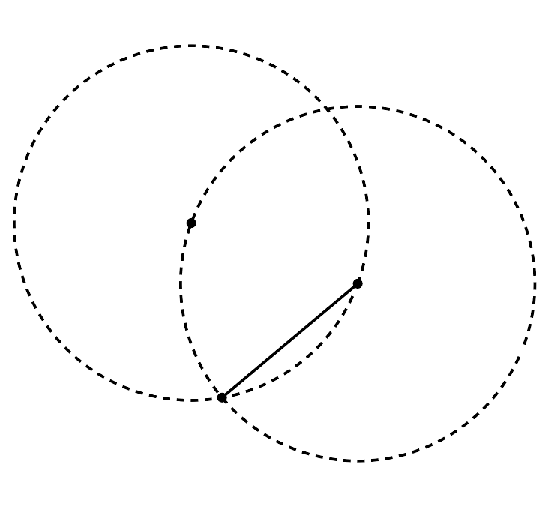
- How do you know each of the sides of the shape are the same length? Show or explain your reasoning.

Are you ready for more?
Why does the construction end up where it started? That is, how do we know the central angles go exactly 360 degrees around?

Lesson 1 Summary
To construct geometric figures, we use a straightedge and a compass. These tools allow us to create precise drawings that someone else could copy exactly.
- We use the straightedge to draw a line segment, which is a set of points on a line with 2 endpoints.
- We name a segment by its endpoints. Here is segment $AB$, with endpoints $A$ and $B$.
- We use the compass to draw a circle, which is the set of all points the same distance from the center.
- We describe a circle by naming its center and radius. Here is the circle centered at $F$ with radius $FG$.
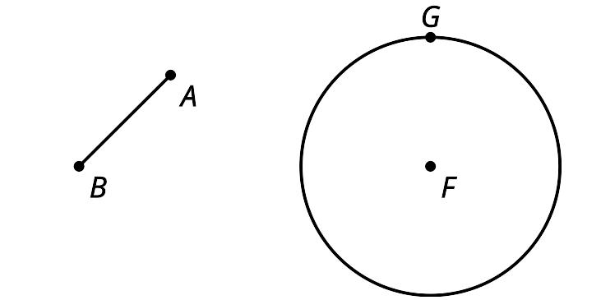
Early mathematicians noticed that certain properties of shapes were true regardless of how large or small they were. Constructions were used as a way to investigate what has to be true in geometry without referring to numbers or direct measurements.
© CC BY 2019 by Illustrative Mathematics

