Unit 6 Lesson 10: Solve Problems Involving Time (Part 1)

WU Choral Count: Fifteens (Warm up)

Student Task Statement

1 Time at the Bus Stop

Student Task Statement
- Kiran arrived at the bus stop at 3:27 p.m., as shown on this clock. He waited 24 minutes for his bus to arrive.
- What time did his bus arrive? Show your thinking. Organize it so it can be followed by others.
- 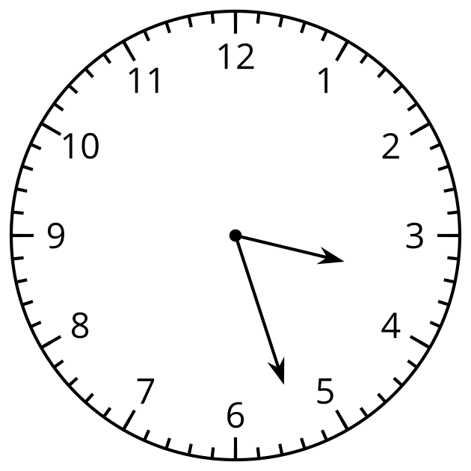
- Elena arrived at the bus stop at 3:45 p.m. She also waited 24 minutes for her bus to arrive.
- What time did the bus arrive? Show your thinking. Organize it so it can be followed by others.
- 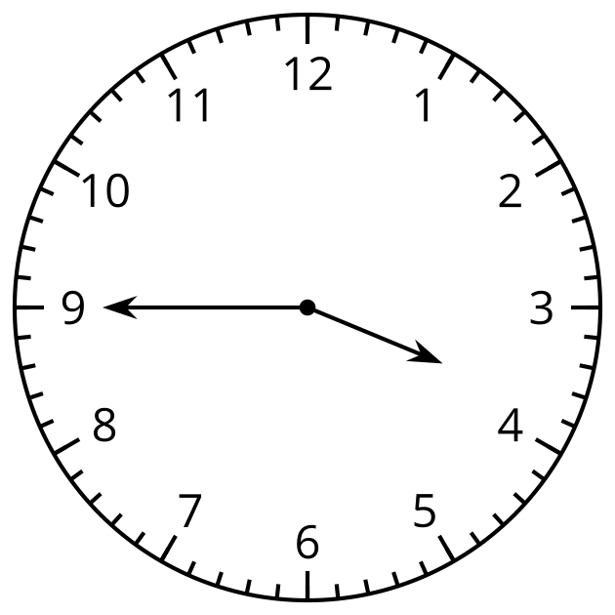

2 Time on the Bus

Student Task Statement
Here’s another problem about time:
At 6:32 p.m., Elena got on a bus to go home. She got off the bus at 7:10 p.m. How long was her bus ride?
Which strategy or representation would you use when solving a problem like this? Explain your reasoning.
© CC BY 2021 Illustrative Mathematics®

