Unit 7 Lesson 3: Two or More Lines

WU How Many Do You See: A Curious Figure (Warm up)

Student Task Statement
How many line segments do you see? How do you see them?
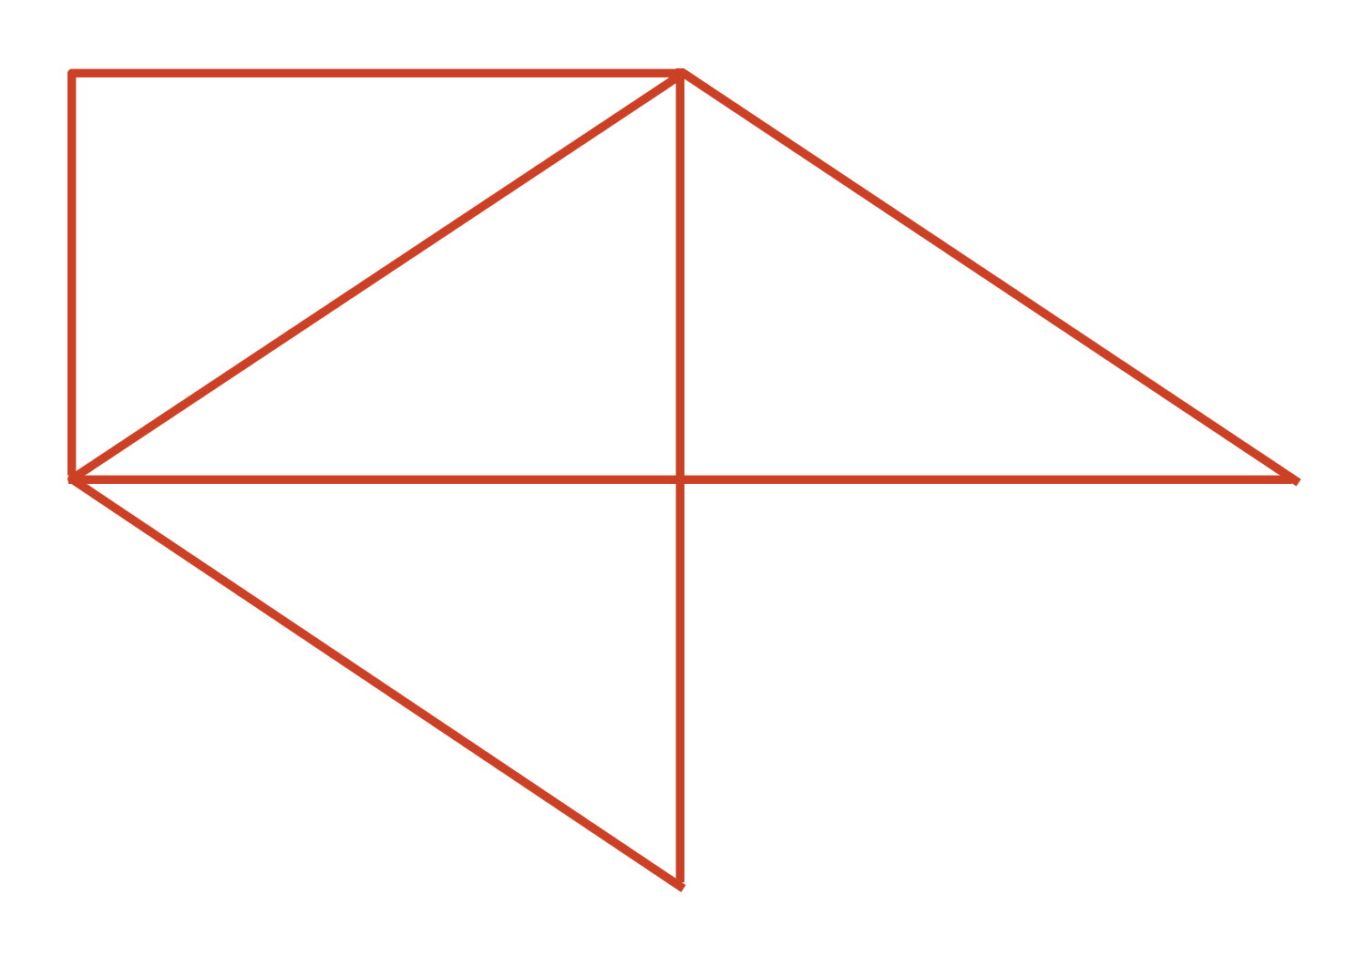

1 Four Lines

Student Task Statement
- Three lines on a field of dots intersect (cross), forming a triangle. Can you draw a fourth line so that the four lines form a quadrilateral?
- Use the drawing to show your reasoning, or explain why it cannot be done.
- 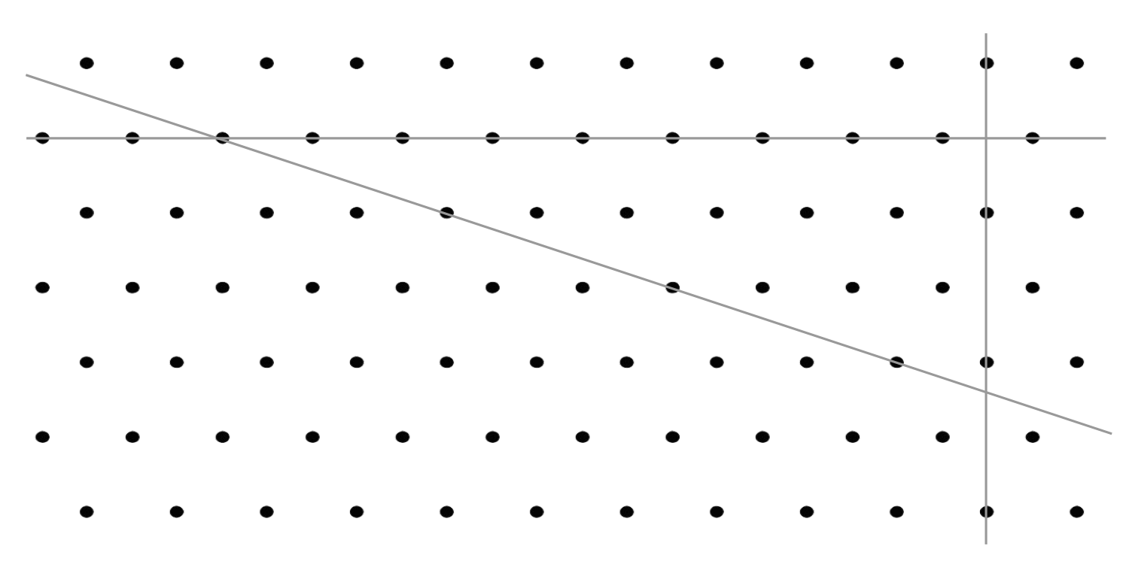
- Here is a copy of the same drawing. Can you draw a fourth line to form a rectangle?
- Use the drawing to show your reasoning, or explain why it cannot be done.
- Discuss your drawings with your group. Check if they agree with your conclusions on both questions.

Activity Synthesis
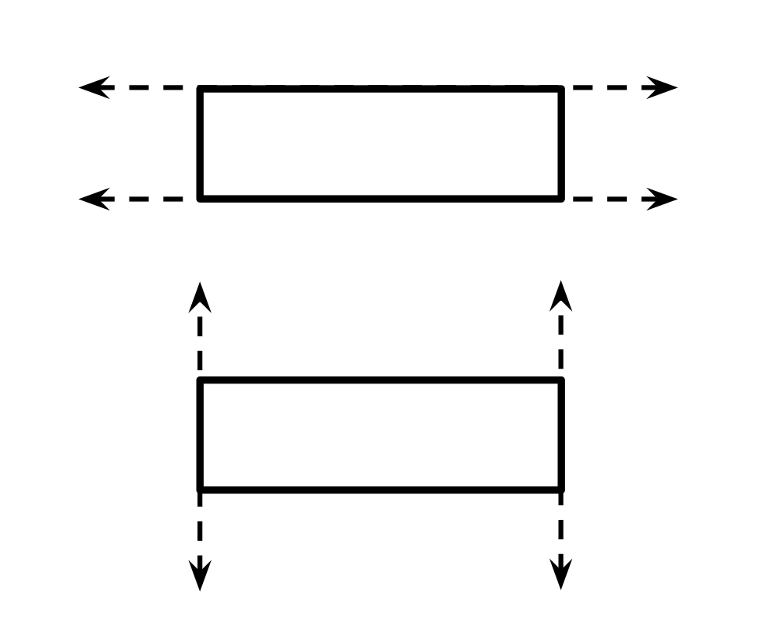

2 To Cross or Not to Cross

Student Task Statement
Here is another field of dots. Each dot represents a point.
- Draw a line through at least 2 points. Label it line $h$.
- Draw another line that goes through at least 2 points and intersects your first line. Label it line $g$.
- Can you draw a new line that you think would never intersect:
  - line $h$?
  - line $g$?
- If so, draw the line. Be prepared to explain or show how you know the lines would never cross. If not, explain or show why it can’t be done.
- Here is a trapezoid.
- Do you think its top and bottom sides are parallel? What about its left and right sides? Explain or show how you know.
- 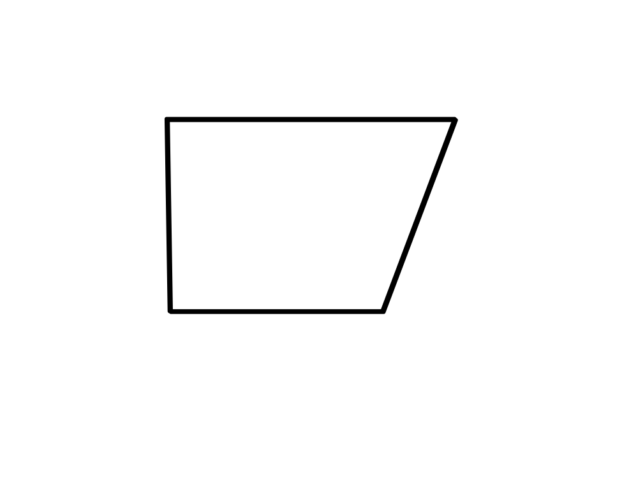
If you have time: Can you draw a new line that you think would never intersect either line $h$ or line $g$? If so, draw the line and be prepared to explain or show how you know the lines would never cross. If not, explain why it can’t be done.

Images for Activity Synthesis
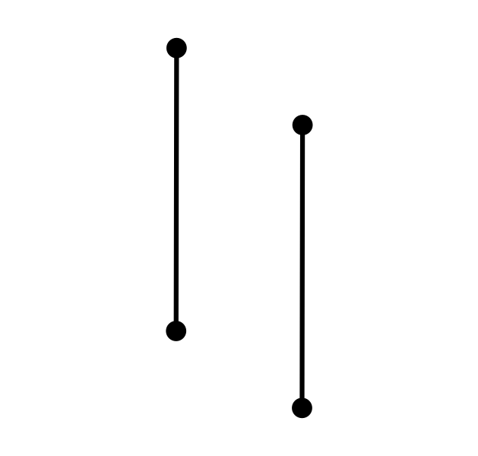
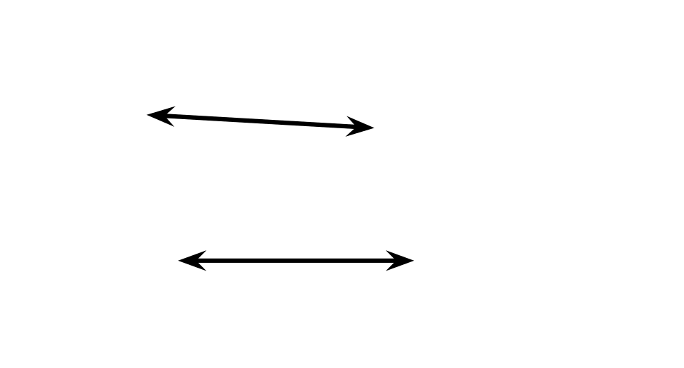
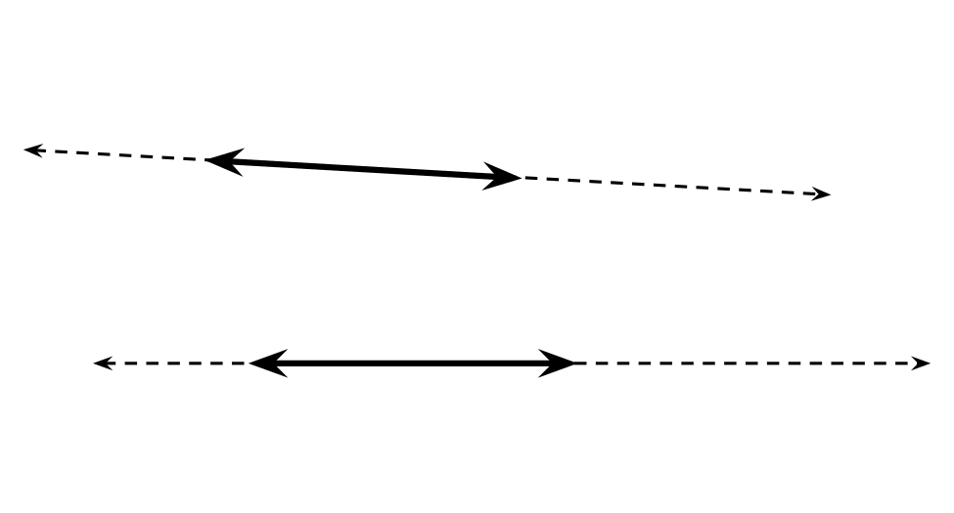
© CC BY 2021 Illustrative Mathematics®

