Lesson 6: What’s the Quotient?

Standards Alignments
Addressing | 4.NBT.B.6

Teacher-facing Learning Goals
- Divide up to four-digit numbers by single digit numbers using place value strategies.

Student-facing Learning Goals
- Let’s find some quotients of multi-digit numbers.

Lesson Purpose
The purpose of this lesson is to reinforce students’ understanding of division algorithms that use partial quotients and build their fluency in using it to divide multi-digit numbers by a single-digit divisor. Students also consider different strategies for dividing and their merits.
In an earlier unit, students learned to use partial quotients to divide whole numbers up to four digits by single-digit divisors. In this lesson, students deepen their understanding of algorithms that use partial quotients and continue to build their fluency with multiplication and division. Students also analyze different ways to divide whole numbers and consider how to improve their efficiency.
If students need additional support with the concepts in this lesson, refer back to Unit 6, Section C in the curriculum materials.

Access for:

Students with Disabilities
- Engagement (Activity 1)

English Learners
- MLR2 (Activity 2)

Instructional Routines
Number Talk (Warm-up)

Lesson Timeline
Warm-up | 10 min
Activity 1 | 15 min
Activity 2 | 20 min
Lesson Synthesis | 10 min
Cool-down | 5 min

Teacher Reflection Question
How effective were your questions in supporting students to compare and connect different methods for division? What did students say or do that showed they were effective?

Cool-down
(to be completed at the end of the lesson) 5min
Divide Like a Pro

Standards Alignments
Addressing | 4.NBT.B.6

Student-facing Task Statement
- Here are two different ways to start finding the value of $8,​435÷7$. Choose one way and complete the calculation.
- 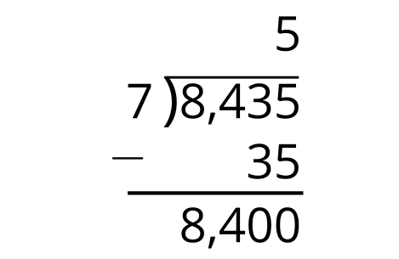
- 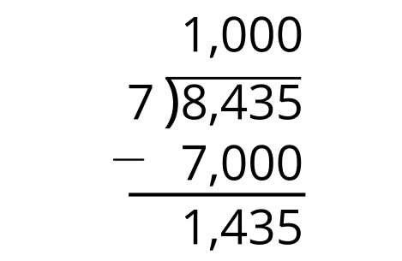
- Find the value of $1,​038÷6$. Try to use as few steps as possible.

Student Responses
- 1,205. See sample response.
- 173. See sample response.
