Lesson 13: Numbers in Many Ways
- Let’s figure out how many things there are.

Warm-up: How Many Do You See: Different Arrangements of 4
How many do you see?
How do you see them?
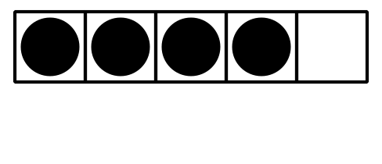

13.1: Matching Groups of Images and Numbers

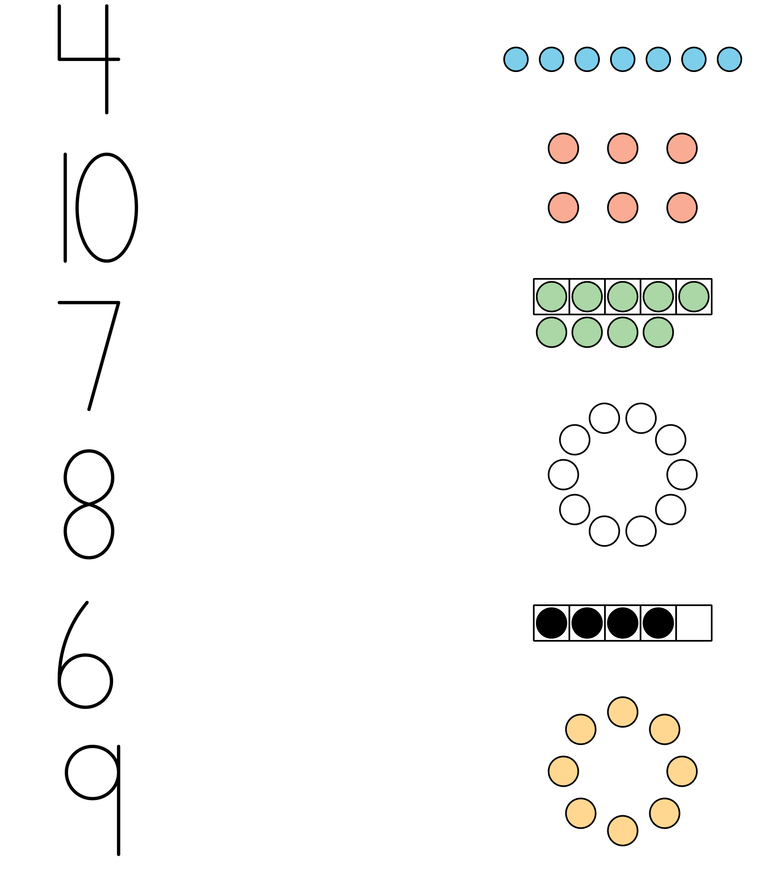

13.3: Centers: Choice Time
Choose a center.
Number Race
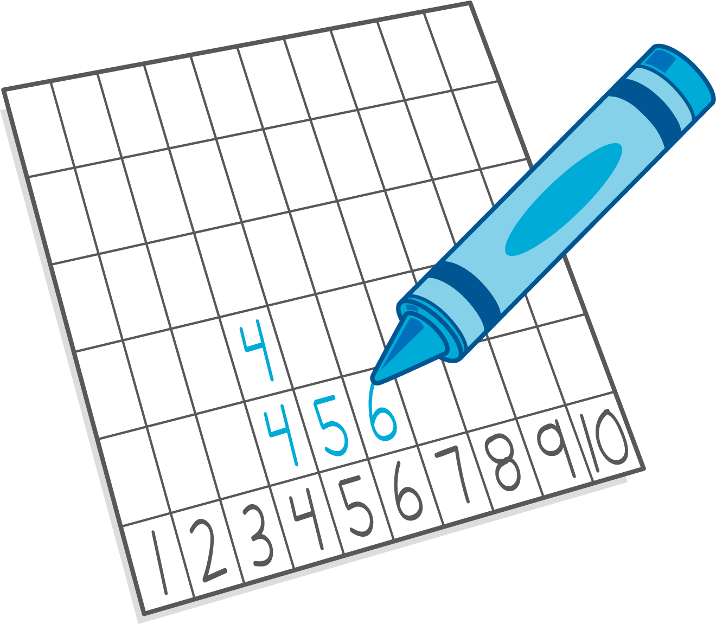
Geoblocks
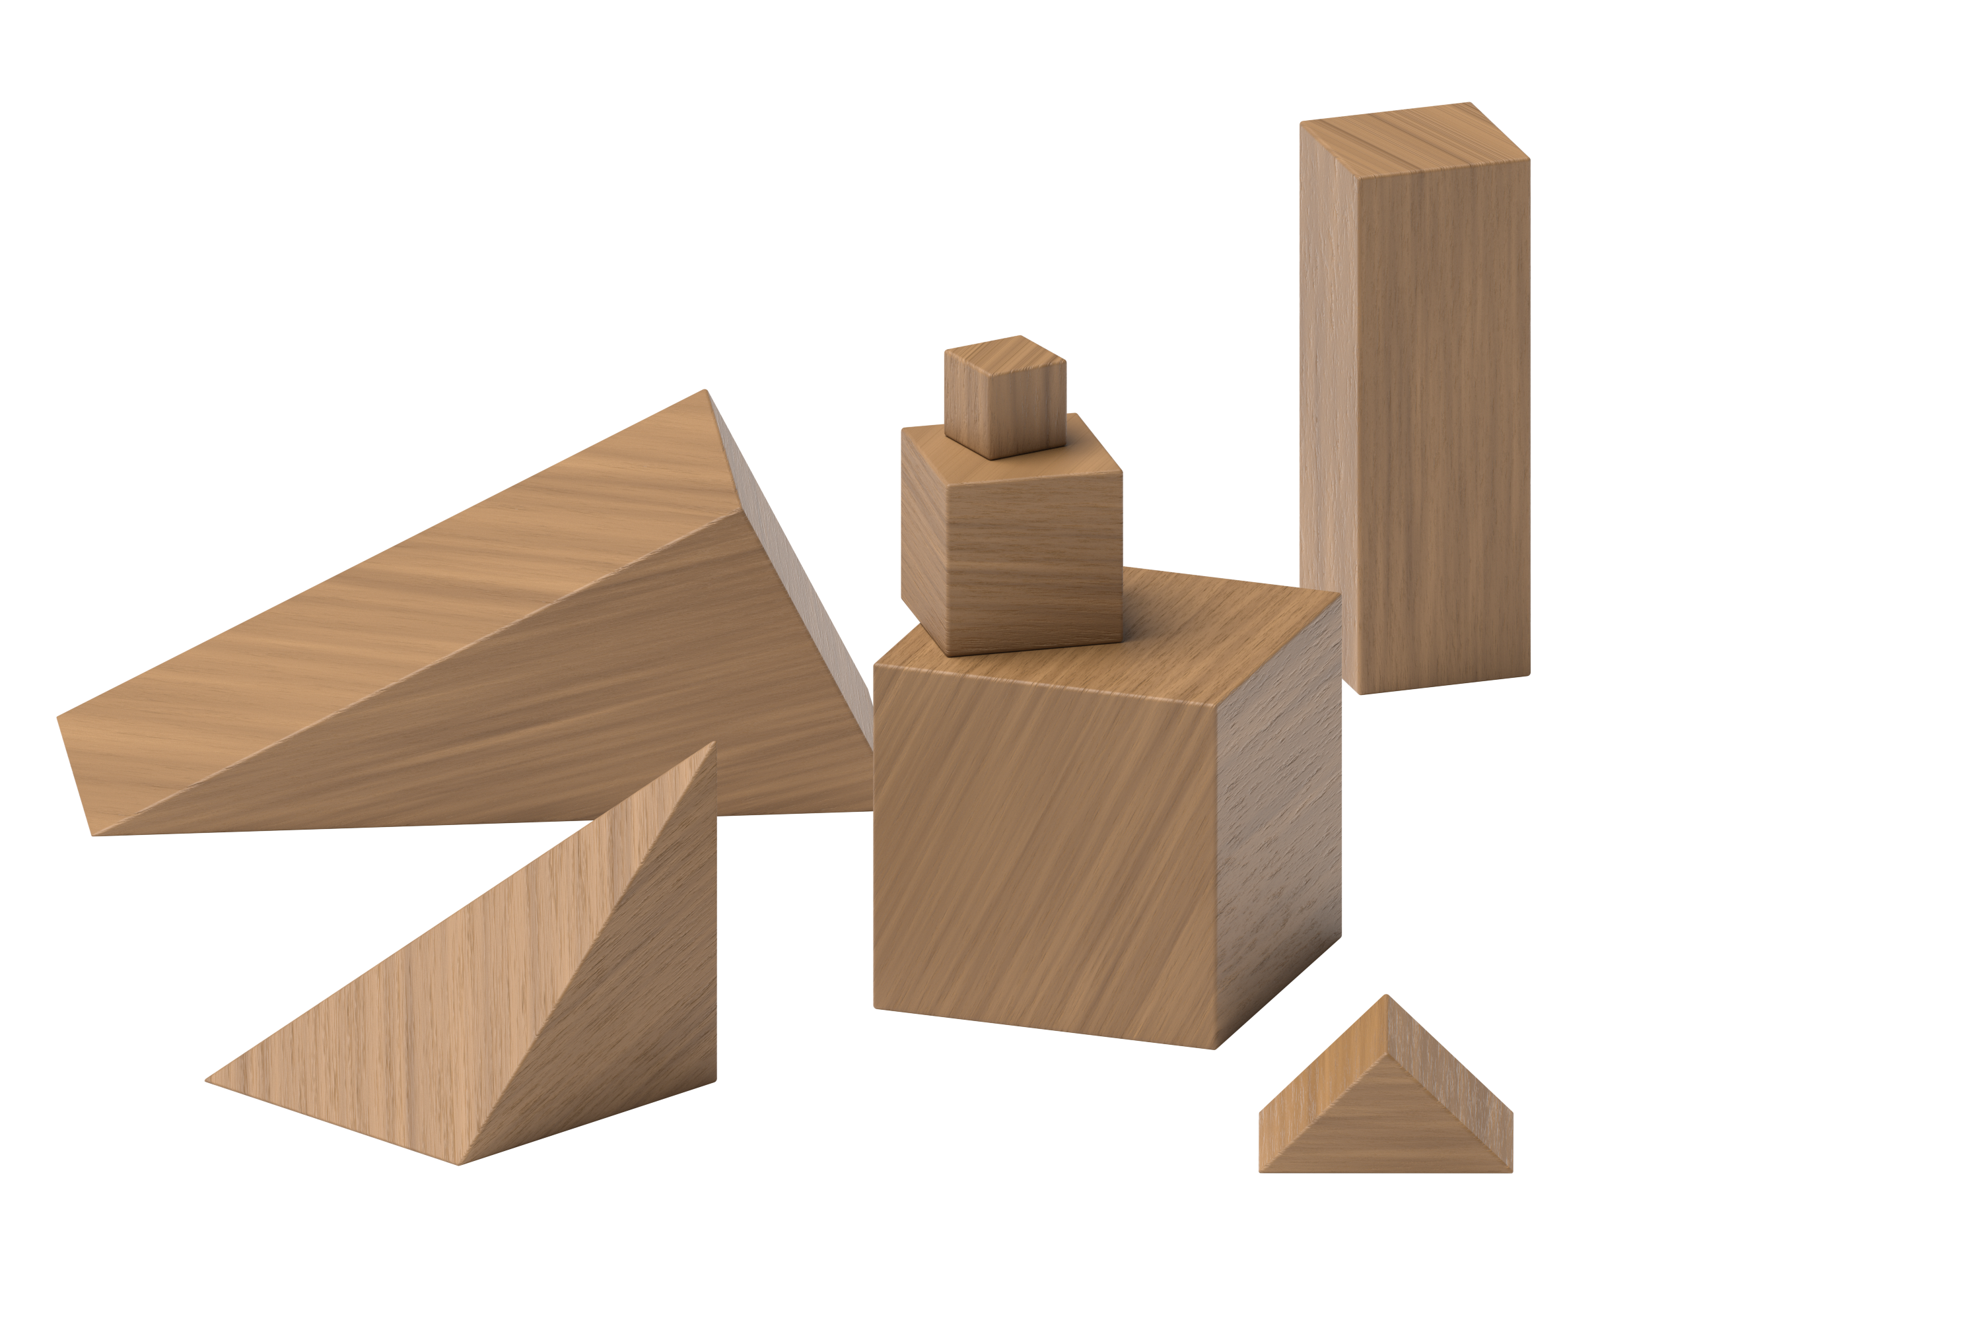
Math Fingers
© CC BY 2021 Illustrative Mathematics®

