Unit 6 Lesson 7: Make Numbers with 10 and Some More (Part 1)

WU Choral Count: Two Groups (Warm up)

Student Task Statement

1 Put Together Numbers 11–19

Student Task Statement

2 Add More Counters

Student Task Statement
number
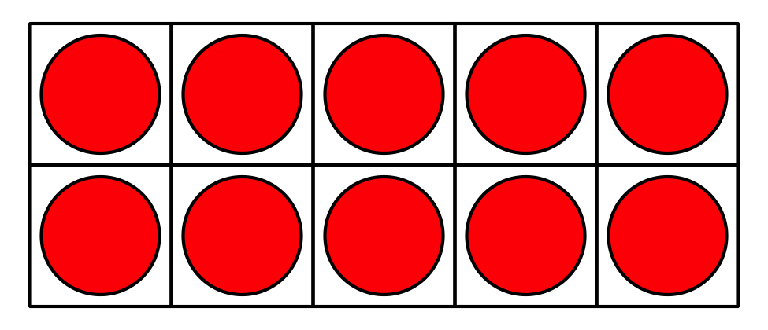
_______________
_______________
_______________
_______________
_______________

3 Centers: Choice Time

Student Task Statement
Choose a center.
Number Race
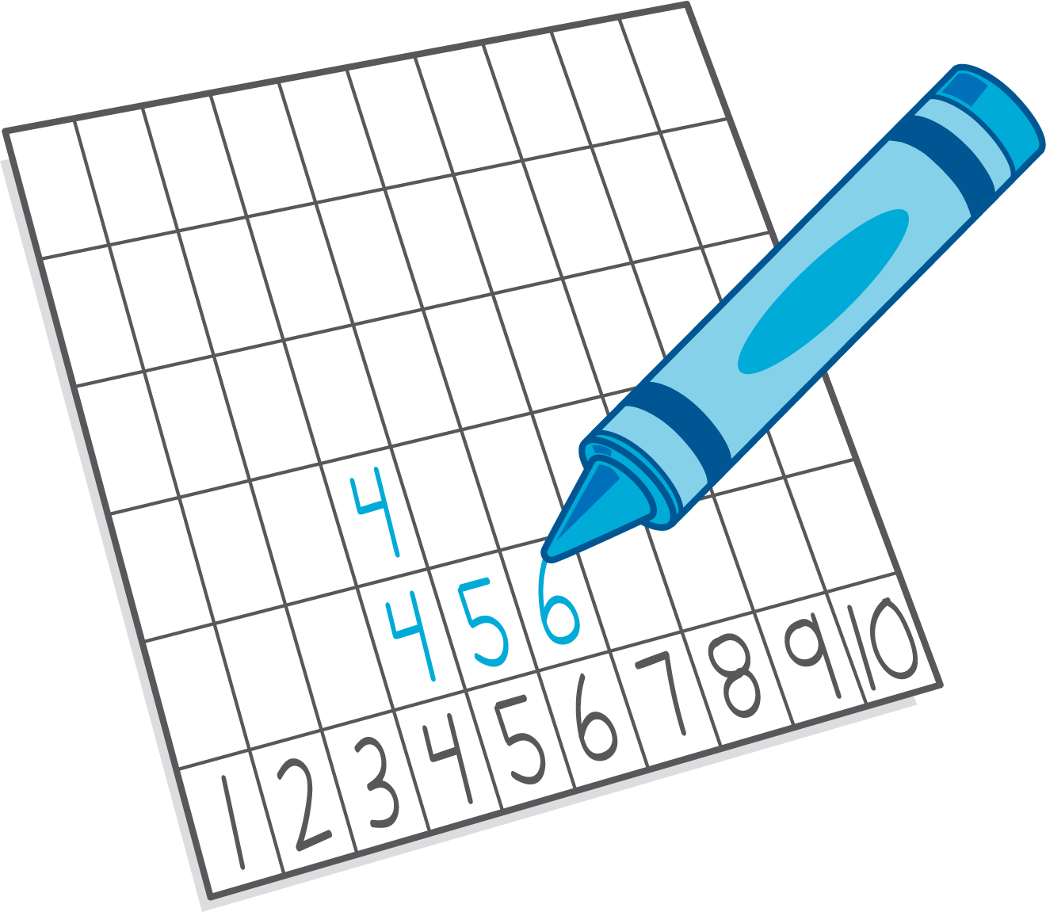
Grab and Count
Find the Pair
Tower Build
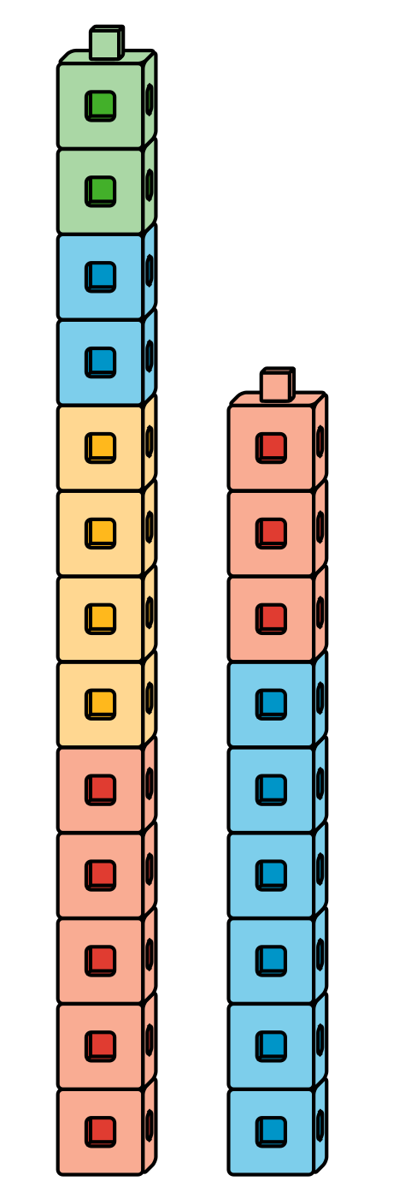
© CC BY 2021 Illustrative Mathematics®

