Lesson 13: Absolute Value Functions (Part 1)
- Let’s make some guesses and see how good they are.

13.1: How Good Were the Guesses?
Before this lesson, you were asked to guess the number of objects in the jar. The guesses of all students have been collected. Your teacher will share the data and reveal the actual number of objects in the jar.
Use that number to calculate the absolute guessing error of each guess, or how far the guess is from the actual number. Suppose the actual number of objects is 100.
- If your guess is 75, then the absolute guessing error is 25.
- If your guess is 110, then the absolute guessing error is 10.
Record the absolute guessing error of at least 12 guesses in Table A of the handout from your teacher (or elsewhere as directed).

13.2: Plotting the Guesses
Refer to the table you completed in the warm-up, which shows your class' guesses and absolute guessing errors.
- Plot at least 12 pairs of values from your table on the coordinate plane on the handout (or elsewhere as directed by your teacher).
- Write down 1–2 other observations about the completed scatter plot.
- Is the absolute guessing error a function of the guess? Explain how you know.

Are you ready for more?
Suppose there's another guessing contest that comes with a prize. Each class can submit one guess. It is up to the students to decide on the number to be submitted. Here are some ideas that have been proposed on how to decide on that number:
- Option A: Ask the person or persons who did really well in the previous guessing game to make a guess.
- Option B: Ask everyone to make a guess and have a discussion to narrow the list and then choose a number.
- Option C: Ask everyone to make a guess and find the mean of all the guesses.
- Option D: Ask everyone to make a guess and find the middle point between the largest number and the smallest number.
Which approach do you think would give your class the best chance of winning? Explain your reasoning.

13.3: Oops, Try Again!
Earlier, you guessed the number of objects in a container and then your teacher told you the actual number.
Suppose your teacher made a mistake about the number of objects in the jar and would like to correct it. The actual number of objects in the jar is $\underset{_}{}$.
- Find the new absolute guessing errors based on this new information. Record the errors in Table B of the handout (or elsewhere as directed by your teacher).
- Make 1–2 observations about the new set of absolute guessing errors.

  - Predict how the scatter plot would change given the new actual number of objects. (Would it have the same shape as in the first scatter plot? If so, what would be different about it? If not, what would it look like?)
  - Use technology to plot the points and test your prediction.
- Can you write a rule for finding the output (absolute guessing error) given the input (a guess)?

Lesson 13 Summary
Have you played a number guessing game where the guess that is closest to a target number wins?
In such a game, it doesn’t matter if the guess is above or below the target number. What matters is how far off the guess is from the target number, or the absolute guessing error. The smaller the absolute guessing error, or the closer it is to 0, the better.
Suppose eight people made these guesses for the number of pretzels in a jar: 14, 15, 19, 21, 23, 24, 26, and 28. If the actual number of pretzels is 22, the absolute guessing error of each number is as shown in the table.
guess | 14 | 15 | 19 | 21 | 23 | 24 | 26 | 28
absolute guessing error | 8 | 7 | 3 | 1 | 1 | 2 | 4 | 6
In this case, 21 and 23 are both winning guesses. Even though one number is an underestimate and the other an overestimate, 21 and 23 are both 1 away from 22. Of all the absolute guessing errors, 1 is the smallest one.
If we plot the guesses and the guessing errors on a coordinate plane, the points would form a V shape. Notice that the V shape is above the horizontal axis, suggesting that all the vertical values are positive.
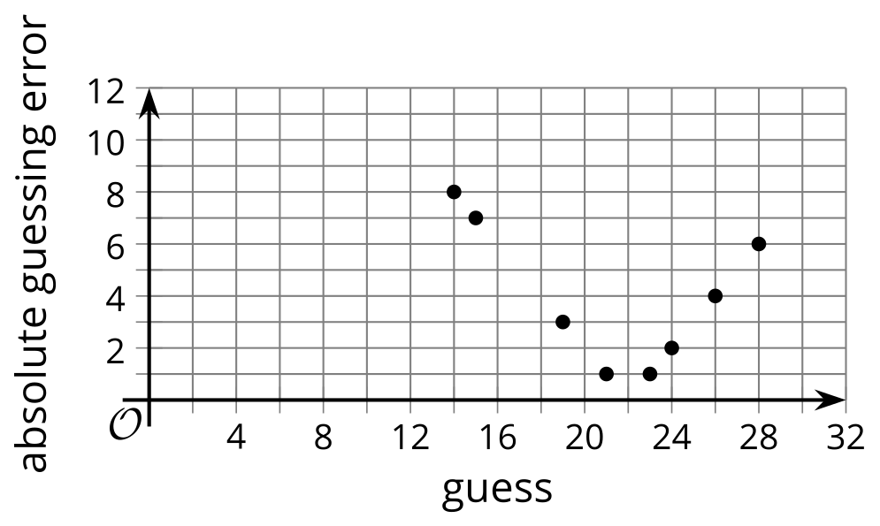
Suppose the actual number of pretzels is 19. The absolute guessing errors of the same eight guesses are shown in this table.
guess | 14 | 15 | 19 | 21 | 23 | 24 | 26 | 28
absolute guessing error | 5 | 4 | 0 | 2 | 4 | 5 | 7 | 9
Notice that all the errors are still non-negative. If we plot these points on a coordinate plane, they are also on or above the horizontal line and form a V shape.
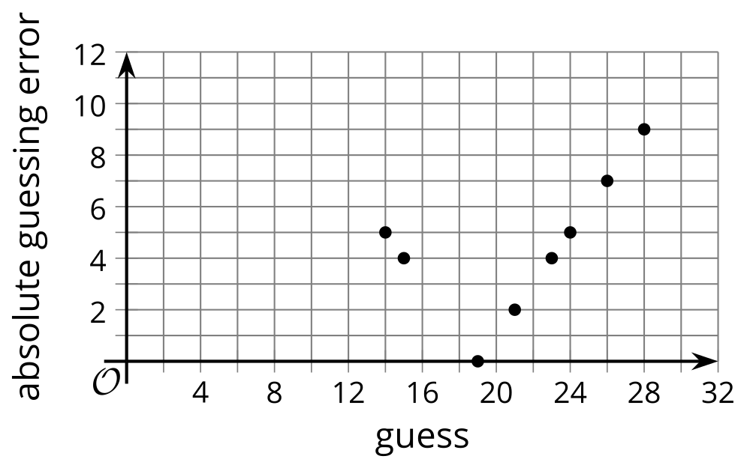
Why does the relationship between guesses and absolute guessing errors always have this kind of graph? We will explore more in the next lesson!
© CC BY 2019 by Illustrative Mathematics®

