Unit 4 Lesson 8: Multiplication Fluency

WU Number Talk: The Distributive Property (Warm up)

Student Task Statement
Find the value of each expression mentally.
- $6×15$
- $6×17$
- $6×2\frac{1}{3}$
- $6×2\frac{2}{3}$

1 Fluency Practice Choice Time

Student Task Statement
Choose a game.
- Greatest Product
- Number Puzzles: Multiplication and Division

2 Targeted Products

Student Task Statement
- Using the digits 3, 5, 6, 8, and 9 make a product whose value is close to 50,000.
- 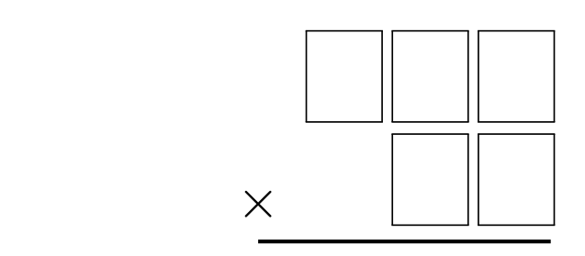
- Using the digits 3, 5, 6, 8, and 9 make a product whose value is close to 20,000.
© CC BY 2021 Illustrative Mathematics®

