Unit 4 Lesson 18: Modeling Price Information

1 What’ll It Be? (Warm up)

Student Task Statement
The points on the graph represent the average resale price of a toy in dollars as a function of time.
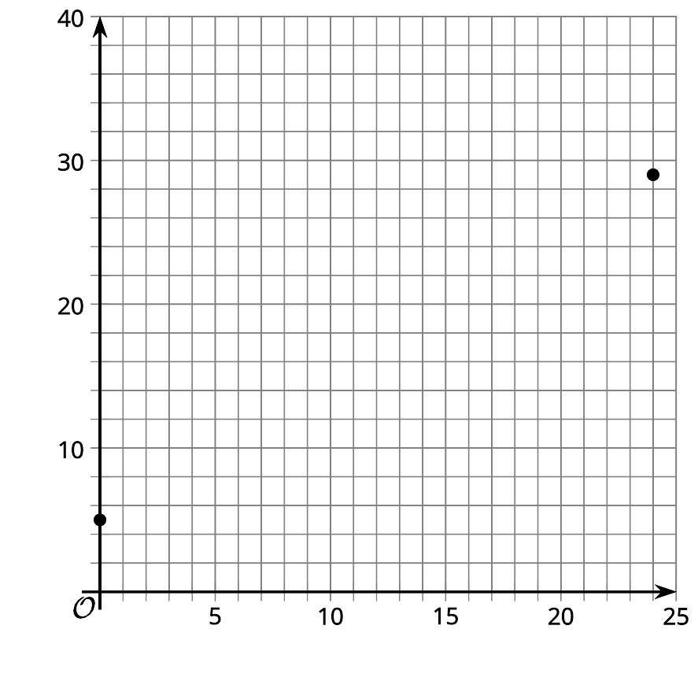
- Use the information to predict the average resale price of the toy on day 12. Explain your reasoning.
- How confident are you in your predictions? Explain your reasoning.

2 Collectable Toy Price

Student Task Statement
The graph shows the average resale price for a toy in dollars as a function of time in days.
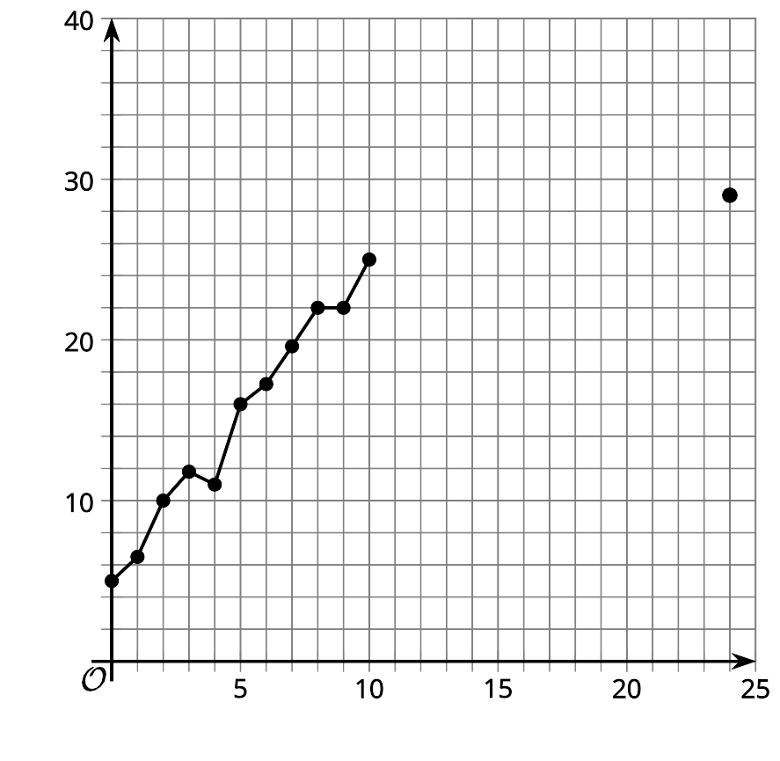
- Estimate the average rate of change for the first 10 days.
- Estimate the rate of change for the last 2 days shown.
- Write a linear function, $f$, that models the data.
- Predict the price of the toy after 12 days.

3 More Information

Student Task Statement
After a few more days, a graph of the average price of the toy looks like this.
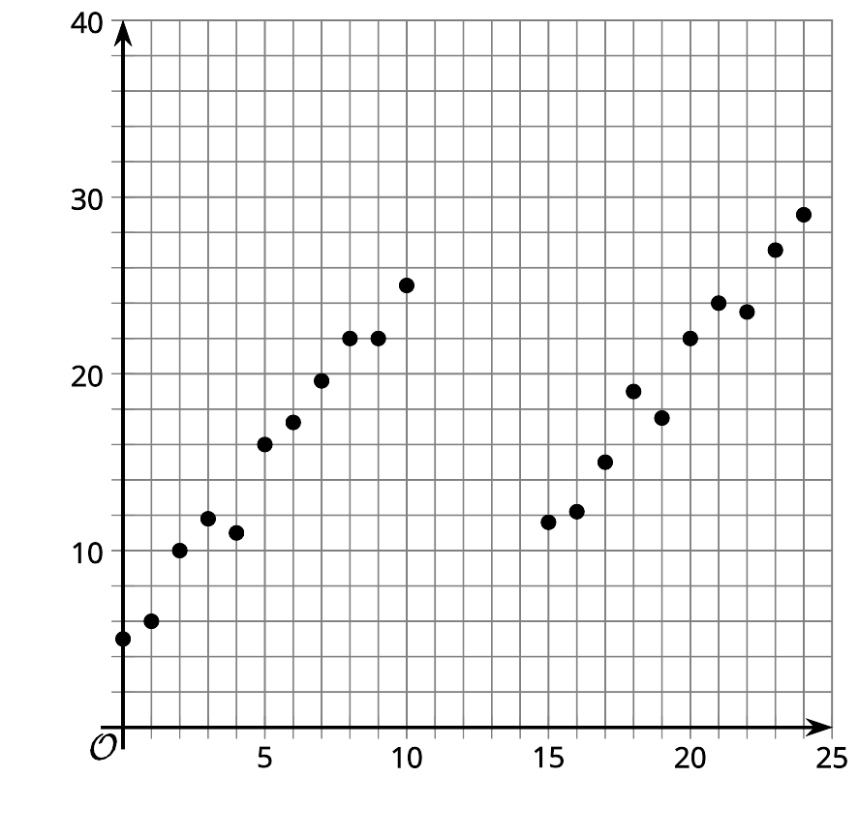
- Draw a function (it does not need to be linear) that could model the data.
- Use your graph to predict the average price of the toy after 12 days. How confident are you in this answer?
- Pause here to get additional information from your teacher about the price of the toy. Based on the new information, do you have a new prediction for what happens to the average price of the toy after 12 days? Explain your reasoning.
© CC BY 2019 by Illustrative Mathematics

