Unit 5 Lesson 22: Divide Whole Numbers by 0.1 and 0.01

WU Number Talk: Remember Division of Unit Fractions (Warm up)

Student Task Statement
Find the value of each expression mentally.
- $1÷\frac{1}{10}$
- $2÷\frac{1}{10}$
- $1÷0.01$
- $2÷0.01$

1 Patterns in Dividing by Decimal Units

Student Task Statement
- Find the value of each expression. Explain or show your reasoning. Use a diagram if it is helpful.
  - $3÷0.1$
  - $3÷0.01$
  - $4÷0.1$
  - $4÷0.01$
- What patterns do you notice?

2 Divide Whole Numbers by Decimals

Student Task Statement
- Describe how you can find the value of any whole number divided by 0.1. Use a diagram if it is helpful.
- Describe how you can find the value of any whole number divided by 0.01. Use a diagram if it is helpful.
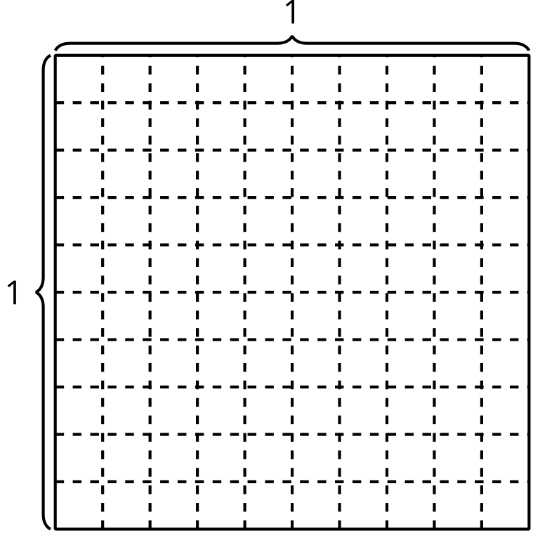
© CC BY 2021 Illustrative Mathematics®

