Lesson 9: All Kinds of Numbers on the Number Line
- Let’s locate numbers on the number line when we are given the location of one fraction.

Warm-up: Which One Doesn’t Belong: Many Number Lines
Which one doesn’t belong?
A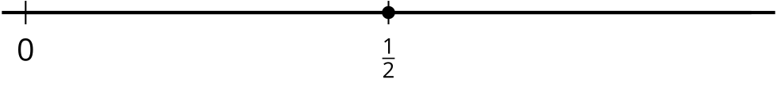
B
C
D

9.1: Locate 1 Again
- Locate and label 1 on each number line.

- Use any of the number lines to explain how you located 1.
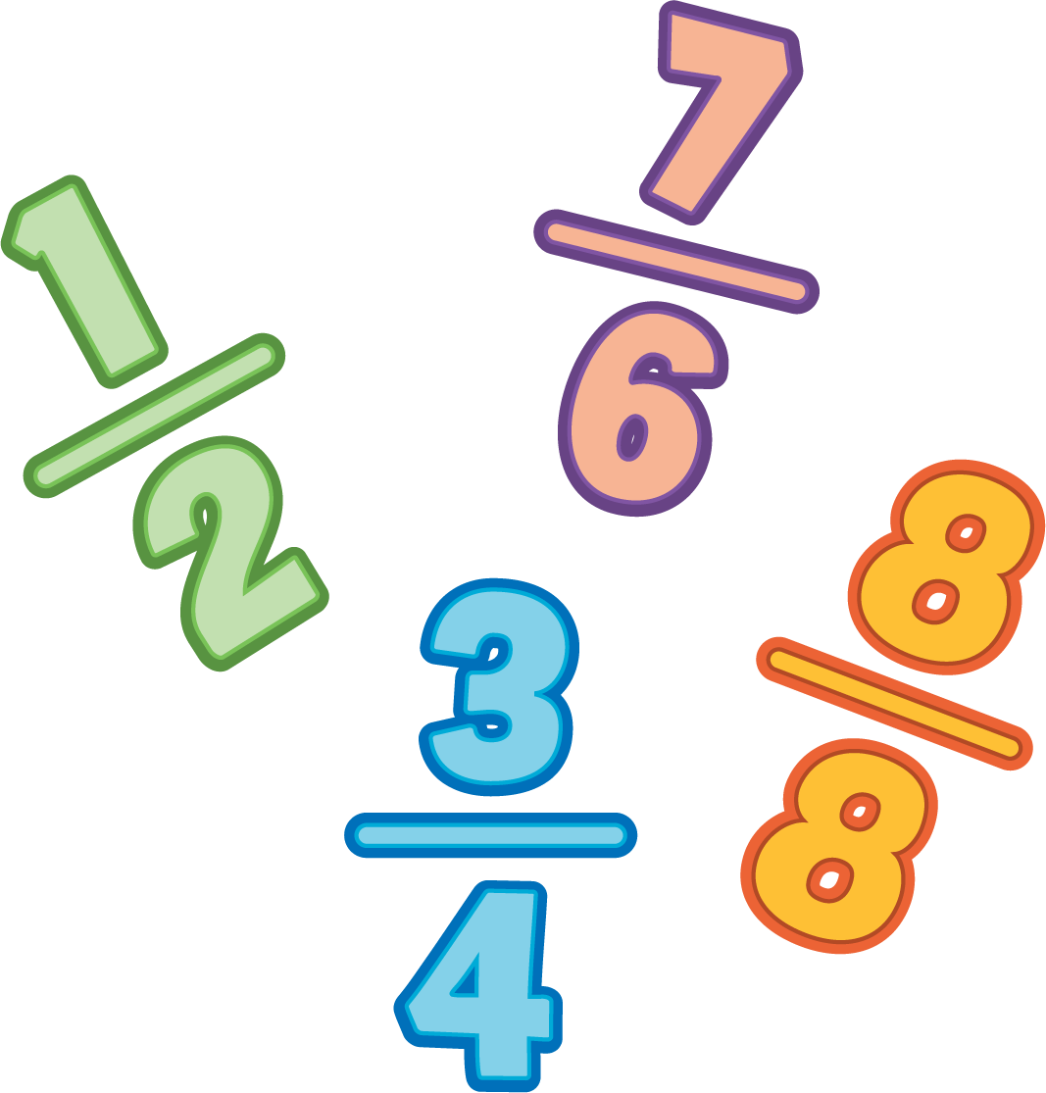

9.2: Locate $\frac{3}{4}$
Locate and label $\frac{3}{4}$ on the number line. Be prepared to explain your reasoning.

Section Summary
Section Summary
In this section, we located and labeled fractions on the number line. We learned how to partition the number line from 0 to 1 to locate unit fractions.
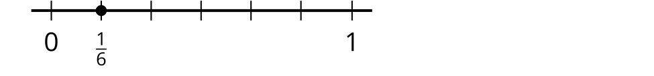
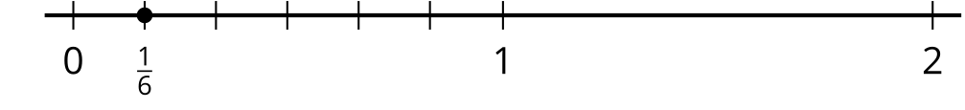
Then we used the location of unit fractions to locate other fractions.
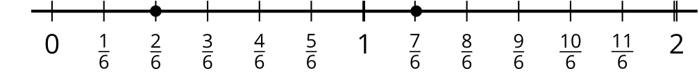
We also learned that some fractions are at the same location as whole numbers on the number line. Here, we can see that $\frac{6}{6}$ shares the same location as 1 and $\frac{12}{6}$ shares the same location as 2.
At the end of the section, we used our understanding of unit fractions to locate 1 on the number line when we only knew the location of a fraction.
© CC BY 2021 Illustrative Mathematics®

