Unit 8 Lesson 8: Show Me All the Ways

WU Estimation Exploration: Tens and Ones (Warm up)

Student Task Statement

- 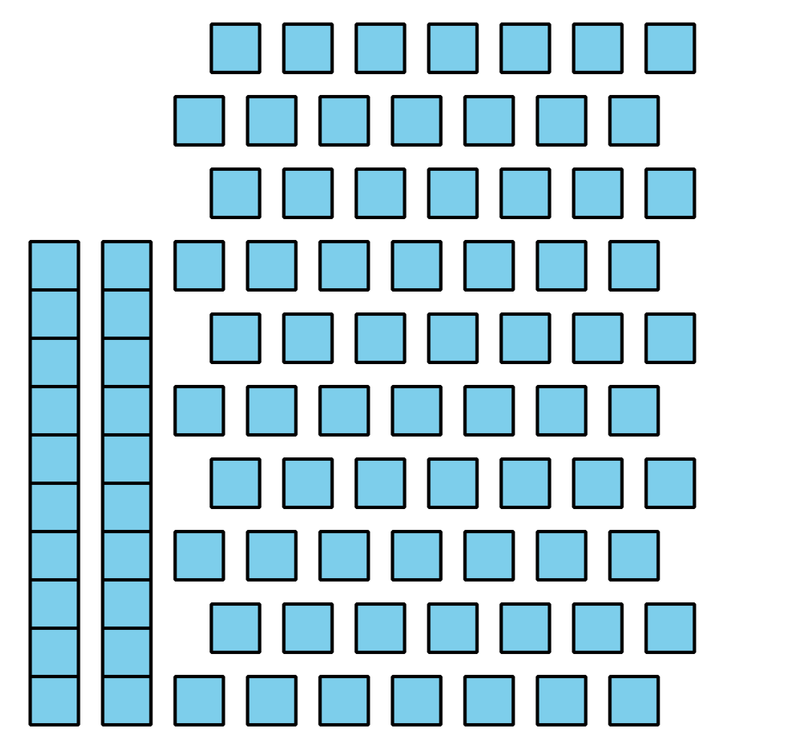
- Record an estimate that is:
- too low | - about right | - too high

- 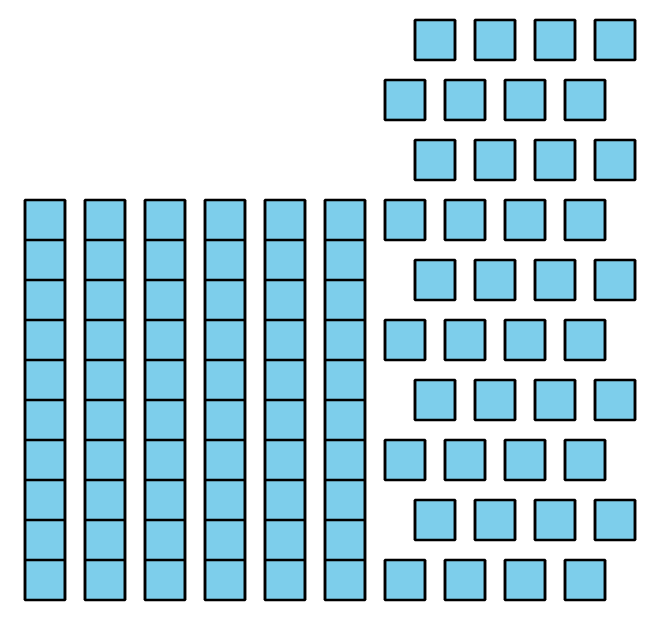
- Record an estimate that is:
- too low | - about right | - too high

1 Represent Our Favorite Numbers

Student Task Statement

2 Gallery Walk: Our Favorite Numbers

Student Task Statement

3 Centers: Choice Time

Student Task Statement
Choose a center.
Compare
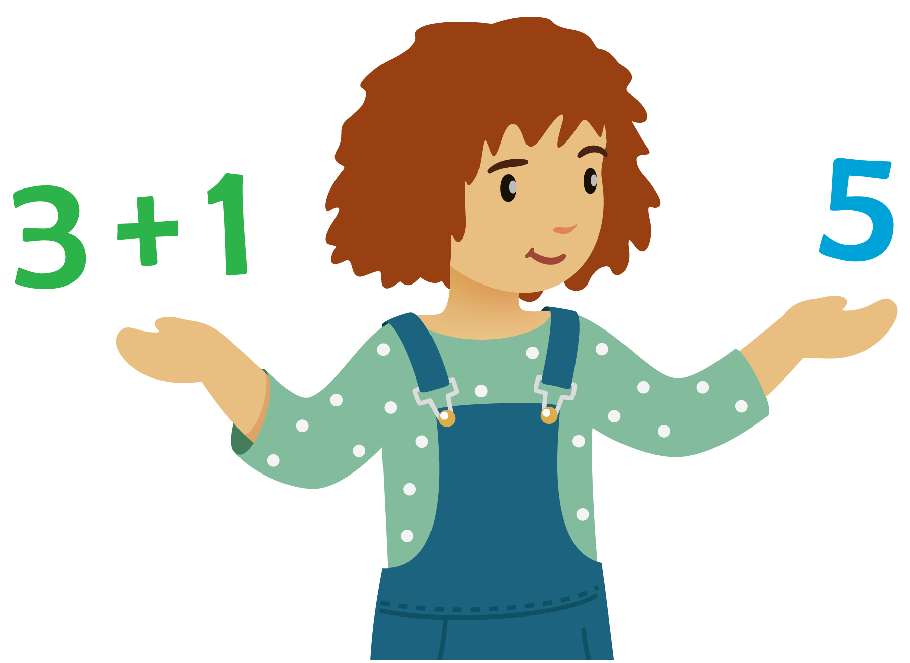
How Close?
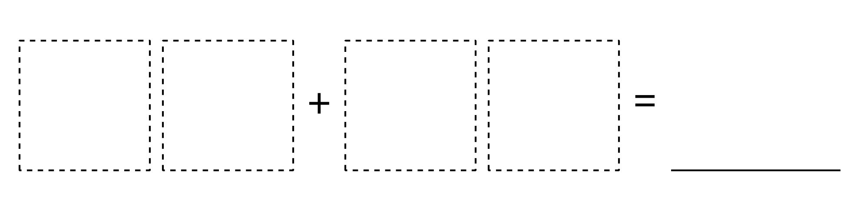
Write Numbers
© CC BY 2021 Illustrative Mathematics®

