Unit 7 Lesson 3: Comparing Positive and Negative Numbers

1 Which One Doesn’t Belong: Inequalities (Warm up)

Student Task Statement
Which inequality doesn’t belong?
- $\frac{5}{4}<2$
- $8.5>0.95$
- $8.5<7$
- $10.00<100$

2 Comparing Temperatures

Student Task Statement
Here are the low temperatures, in degrees Celsius, for a week in Anchorage, Alaska.
day | Mon | Tues | Weds | Thurs | Fri | Sat | Sun
temperature | 5 | -1 | -5.5 | -2 | 3 | 4 | 0
- Plot the temperatures on a number line. Which day of the week had the lowest low temperature?
- The lowest temperature ever recorded in the United States was -62 degrees Celsius, in Prospect Creek Camp, Alaska. The average temperature on Mars is about -55 degrees Celsius.
  - Which is warmer, the coldest temperature recorded in the USA, or the average temperature on Mars? Explain how you know.
  - Write an inequality to show your answer.
- On a winter day the low temperature in Anchorage, Alaska, was -21 degrees Celsius and the low temperature in Minneapolis, Minnesota, was -14 degrees Celsius.
- Jada said, “I know that 14 is less than 21, so -14 is also less than -21. This means that it was colder in Minneapolis than in Anchorage.”
- Do you agree? Explain your reasoning.

Activity Synthesis
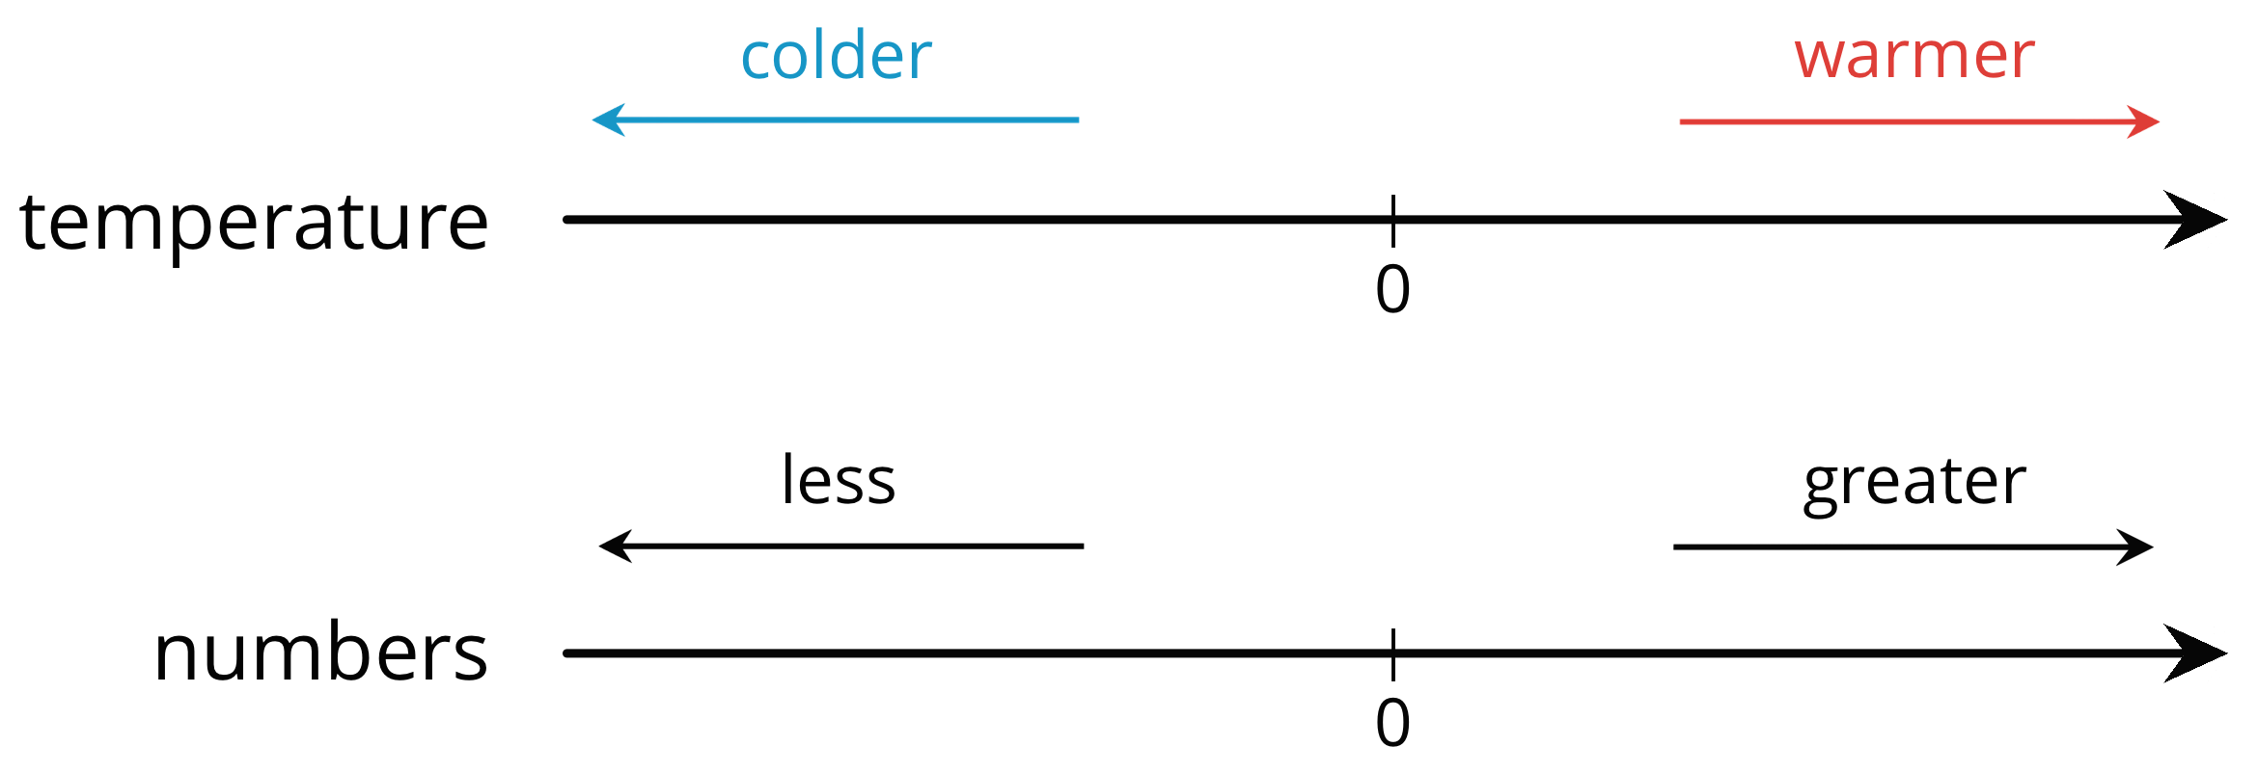

3 Rational Numbers on a Number Line

Student Task Statement
- Plot the numbers -2, 4, -7, and 10 on the number line. Label each point with its numeric value.
- Decide whether each inequality statement is true or false. Be prepared to explain your reasoning.
  - $\text{-}2<4$
  - $\text{-}2<\text{-}7$
  - $4>\text{-}7$
  - $\text{-}7>10$
- Andre says that $\frac{1}{4}$ is less than $\text{-}\frac{3}{4}$ because, of the two numbers, $\frac{1}{4}$ is closer to 0. Do you agree? Explain your reasoning.
- Answer each question. Be prepared to explain how you know.
  - Which number is greater: $\frac{1}{4}$ or $\frac{5}{4}$?
  - Which is farther from 0: $\frac{1}{4}$ or $\frac{5}{4}$?
  - Which number is greater: $\text{-}\frac{3}{4}$ or $\frac{5}{8}$?
  - Which is farther from 0: $\text{-}\frac{3}{4}$ or $\frac{5}{8}$?
  - Is the number that is farther from 0 always the greater number? Explain your reasoning.

Activity Synthesis
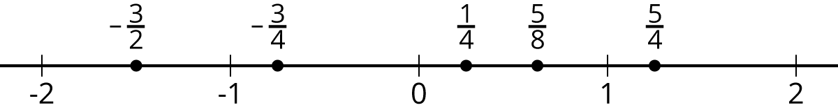

Images for Activity Synthesis
© CC BY Open Up Resources. Adaptations CC BY IM.

